ELEVENTH MEETING OF PARTNERS OF THE EAST ASIAN – AUSTRALASIAN FLYWAY PARTNERSHIP
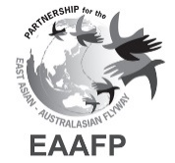
Brisbane, Queensland, Australia, 12-17 March 2023

Draft Document 6
Report from the Chair of the Management Committee,
Technical Sub-Committee, and Finance Sub-Committee

Submitted by the Management Committee, Technical Sub-Committee, and Finance Sub-Committee

Introduction

- The establishment of a Management Committee (MC) for the East Asian – Australasian Flyway Partnership (EAAFP) to provide guidance to the Secretariat was agreed at the 3rd Meeting of the Partners (MoP9, Incheon, 2008). The Terms of Reference for the Committee was adopted at MoP5 (Siem Reap 2010, Agenda item 6.4) and revised at MoP9 (Singapore 2017, Decision MoP9/D6).

- The general function of the MC is to provide general policy, operational and financial direction to the Secretariat concerning the implementation and the expansion of the Partnership.

3. MoP10 elected a new MC to oversee Partnership matters during the biennium until MoP10 with the USA as its Chair and Singapore as Vice-Chair. The present composition of the MC reflects that as mandated by Decision MoP9/D6, outlined below:

Chair of the Partnership: United States of America
Vice-Chair of the Partnership: Singapore
Host Government Partner: Republic of Korea
Intergovernmental Partner (1): Convention on Migratory Species
Government Partner (1): Thailand
Non-government Partners (2): Wildfowl and Wetlands Trust
Wetland International

4. At the invitation of the Chair, any person or representative of any Partner, or other country or organization, may participate in meetings of the Committee as an observer without the right to vote.

5. In the present report, only the main issues the MC has dealt with are highlighted, from December 2018 (the close of the MoP10) to the end of February 2023.

Summary of the main items considered, and the decisions taken
6. Following Mr. Pete Probasco (USA) stepping down as Chair in December 2020, Mr. Robert Kaler (USA) becoming the next Chair in January 2021, the MC met eight times through holding conference calls from February 2019 to March 2023:

- 19 March 2019
- 20 June 2019
- 29 July 2019
- 03 October 2019
- 16 December 2019
- 24 June 2020
- 21 October 2020
- 01 April 2021
- 16 December 2021
- 08 September 2022
- 23 February 2023
- 02 March 2023

Summary of Key Topics, 2019-2023

7. Following the passing of Dr. Lew Young, the MC coordinated with the Secretariat staff to take next step to hire a Chief Executive (CE). In the Interim, the Deputy and Program Coordinator would assist with fill CE roles. By July 2019, after a hiring panel interviewed applicants, a candidate was selected with the hope to bring on the CE in October 2019. In October 2019, Mr. Doug Watkins began as the new EAAFP Chief Executive.

8. By June 24 2020, the COVID 19 pandemic had shutdown travel and Secretariat staff were on “work from home” basis. Prior to COVID restrictions, Secretariat staff were able to attend several important meetings (e.g., CMS CoP13 in India, Indo-Burma Ramsar Regional Initiative). Several Small Grant programs projects which had public events or international travel were able to adapt to comply with local requirements. In other cases, funds were reallocated with input from Working Group/Task Force Chairs and support by the Chair of the Technical Sub-Committee (TsC).

9. In October 2020, in consultation with Australian Government, the timing of MOP11 was delayed owing to the COVID pandemic. A provisional date in late 2021 was set and to be revisited later in early 2021.

10. The Asian Development Bank (ADB) held a webinar in October 2020 to discuss ideas for an biodiversity initiative supported by ADB and coordinated with Birdlife International and the EAAFP Secretariat.

11. After a change in U.S. Fish and Wildlife staffing, Robb Kaler (U.S.A.) became the new MC Chair and held the first MC meeting in April 2021. In May 2021, the MC Chair provided opening and closing remarks at the Paulson Institute’s launch of “Saving a Flyway”, wonderful film about conservation efforts in the Yellow Sea region created by the Paulson Institute and the Cornell Lab of Ornithology.
12. In October-December 2021, there were many activities for ADB Regional Flyway Initiative (RFI) launch:
1) EAAFP Webinar for RFI Government Focal Points on the ADB Regional Flyway Initiative on 6 October 2021
2) The RFI official launching at 15th Conference of the Parties of the Convention on Biological Diversity (CBD COP15) in Kunming, People’s Republic of China on 14 October 2021
3) The second RFI launching at UNFCCC COP26 in Glasgow, UK on 2 November 2021
4) A presentation at a webinar “Discussing The East Asian – Australasian Flyway Initiative” with CEO of GEF, CEO of Birdlife International and ADB on 10 November 2021
5) RFI Technical Assistance Inception Workshop on 6-7 December 2021, over 100 people attending and opening remarks provided by the EAAFP Chair.

13. In December, the MC conducted a review in preparation of renewing the CE contract. The CE had highly positive evaluations from all MC members and the CE contract was renewed my March 2022. In early April 2022, the CE informed the MC that following MOP11 in Brisbane, he would likely step down as CE. In October 2022, CE advised the MC to initiate a Hiring Committee to recruit a new CE.

Conclusions and acknowledgements

13. As Chair of the Management Committee I would like to thank all the members of the Committee and the Secretariat for their strong support during the course of the past four years. Their active commitment and their constructive attitude to the work of the Partnership have contributed significantly to the progress of its tasks.

14. Additionally, the Management Committee would like to thank Doug Watkins for his excellent work and dedication to the success of the Secretariat while serving as the Chief Executive

Technical Sub-committee (TSc) report to EAAFP MOP11

Background and history
1. The establishment of an EAAFP Technical Committee was first introduced at EAAFP MOP9 (Singapore, 2017), which adopted MOP9 Decision 7 (Establishment of the Technical Committee of the East Asian – Australasian Flyway Partnership). This Decision established initial Terms of Reference and Rules of Procedure for the newly established Technical Committee.
2. MOP9 Decision 7 recognised that prior to this the Partnership had agreed to establish an increasing number of thematic and species-specific Working Groups and Task Forces, which reported directly to Partners at each MOP (NB this is still the case).
3. Amongst other things, MOP9 Decision 7 “Instructs the Secretariat and Management Committee, in consultation with Partners, to develop a selection process, seek nominations of qualified experts and appoint, on an interim basis, a Technical Committee as soon as practicable following the 9th Meeting of the Partners”. Initial Terms of Reference and Rules of Procedure were adopted by MOP9 Decision 7.
4. Accordingly, an interim Technical Committee membership was established inter-sessionally before MOP10. Nine members of the interim Technical Committee were approved by the Management Committee in March 2018. Subsequently Prof Nick Davidson was appointed as Chair of the interim Committee.
5. At MOP10 (China, 2018), MOP10 Decision 4 approved amended Technical Committee Terms of Reference and Rules of Procedure and fully appointed Technical Committee members on the basis of nominations by Partners.
6. MOP10 Decision 4 formally established the Technical Committee (as a Sub-committee of the Management Committee) and its ToR/RoP, on the basis that its composition is:
- Up to 10 Technical Committee members, nominated by EAAFP Partners are appointed by MOP decision.
- Technical Committee members are appointed in their own right for their expertise, and do not represent either their organisation or their country affiliation.
7. At MOP10, nine Technical Committee members were appointed (Annex 1), and subsequently the members appointed Prof Nick Davidson as Chair and Mr David Melville as Vice-Chair.
8. After MOP10, an appointment was proposed to fill the vacant (10th) TSc member place. However, after reviewing the TSc Rules of Procedure it became clear that this was not possible. In the event, it was agreed that the TSc Chair could invite such a person as an “invited expert” and this was done. MOP11 DD3 proposes amendments to the TSc RoP so as to facilitate such intersessional appointments to the TSc.
9. In parallel to the MOP10 discussions on Technical Committee composition and processes, during MOP10 there was considerable debate on the overall EAAFP organisational structure and interactions between the various different EAAFP mechanisms, which led to the adoption MOP10 Decision 3.
10. The adopted organisational structure in MOP10 Decision DD.03 is reproduced below. This recognised that both the Technical Committee and Finance Committee should be treated as sub-Committees of the overarching Management Committee. Hence the technical committee is now called the EAAFP Technical Sub-committee (TSc).
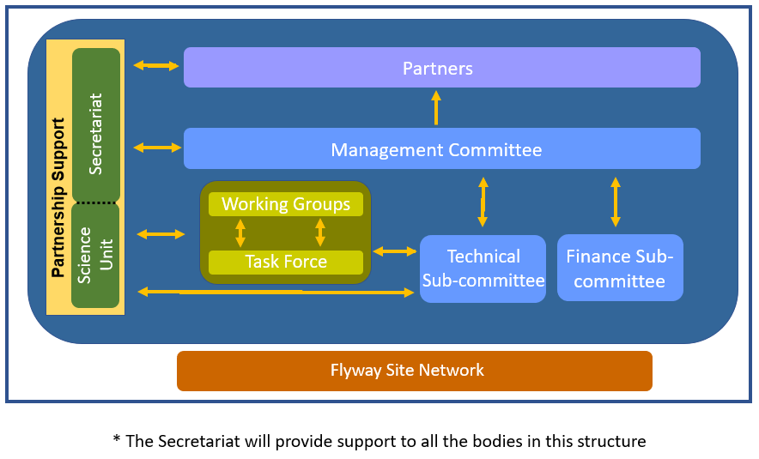
11. The organisational structure approved in MOP10 Decision 3 shows several processes relevant to the work of the TSc:
- First, the TSc is shown as responsible to, and reports to and through, the inter-sessional Management Committee (hence this report to MOP11 is provided through the Management Committee);
- Second, the MOP10 organisational structure diagram shows that Working Groups and Task Forces should report to and through the TSc to the Management Committee and MOP. A mechanism for this has not yet been considered, established or agreed, but is needed. Currently EG/TF reports are still requested separately by the Secretariat to report to MOPs. Furthermore, the text accompanying the organisational structure chart in MOP10 Decision 3 appears to be inconsistent and ambiguous concerning this issue:
“The EAAFP Working Groups and Task Forces support the Partners and the Partnership in the implementation of the Strategic Plan. They are required to develop and present their work plans at each MoP and to report on their results through the Report on Implementation prior to the following MoP. These Working Groups and Task Forces also need to report to the Management Committee on an as need basis between MoP’s.”
12. At MOP11 Partners need to further discuss and decide how to resolve these inconsistencies, so as to provide clear and consistence guidance to all the Partnership bodies as to how they should better interact and work together.
TSc initial activities following MOP10
13. Following MOP10 and as instructed by MOP10 Decision 4, the TSc compiled a comprehensive list of tasks instructed of it from a) the TSc Terms of Reference (MOP10 Decision 4); b) the Strategic Plan 2019-2028 (MOP10 Decision 1), c) other MOP10 Decisions; and d) TSc meeting discussions, and the role(s) of the TSc and other FP mechanisms in task delivery.
This task list, including proposed priorities for different tasks, was submitted to the Secretariat (including its newly-established Beijing-based Science Unit (SU)) and the Management Committee, including with recommendations for the priority for each task, in 2019.
14. In relation to this long ‘wish list’ of tasks, Partners should recall that under its Terms of Reference the TSc is essentially a body responsible for providing scientific and technical guidance and advice to the Partnership. However, note that the ToRs are silent as to what form(s) such advice can or should take.
15. EAAFP Partners must keep in mind that as a small group of waterbird and wetland experts appointed for their expertise in their own right, and working largely pro bono (i.e. providing their time free of charge to the Partnership) the TSc does not have the capacity or resources to lead preparation of substantive work tasks – there is no core budget allocation for any such work to be undertaken, so such tasks cannot be progressed unless additional funding is provided by Partners or other third-parties, and work undertaken either by the Secretariat, or commissioned of consultants by the Secretariat. The TSc’s role if such work can be resourced is to advise on the scope of such work, guide and oversee implementation of the work, and to review and approve work outputs.
16. Although entitled “TSc Work Plan 2019-2020” it needs to be understood that this very long list of tasks, a considerable number of which require substantial investment of FP capacity and resources to fully deliver, is recognised as being well beyond the remit and capacity of the TSc. Note also that such instructions for further substantive work by the TSc is being instructed in some MOP11 Draft Decisions (DDs). At MOP11 the TSc will be raising and addressing these issues.
17. In parallel to the 2018/19 development by the TSc of its Work Plan task list, the Incheon-based Secretariat was working with the recently established Science Unit of the Secretariat to separately develop a work plan for the Science Unit. However, in the light of the identification by the TSc of what tasks it could and could not undertake, it became clear that there was a need better to harmonise and coordinate what the TSc and SU should each be doing to deliver tasks task on the list.
18. In December 2019 the Chair and Vice-Chair of the TSc had the opportunity to meet with senior Incheon Secretariat staff and Science Unit staff in Nanching, China, in the sidelines of a Poyang Lake and Siberian Crane celebration event. This meeting helped to better define the relative roles of the SU and the TSc.
19. At that time we were planning to have a face-to-face TSc meeting, hosted by the Science Unit in Beijing, so as to finalise work plans and progress other scientific and technical matters. In the event, that could not happen because of two events out of the TSc’s control, which have limited what the TSc has been able to deliver since then to MOP11. These were:
a. COVID-19 and all the consequent implications of lockdowns and travel restrictions over the past couple of years or more, and its impact (pandemic loss of motivation etc.) on the capacity and motivation of everyone to keep going on progressing work; and
b. much less resourcing and capacity in the Science Unit than was anticipated at MOP10, limiting the capacity of the SU to deliver the range of tasks previously expected by MOP10 Decisions.
TSc task delivery MOP10 to MOP11
20. Given the consequences of COVID lockdowns and travel restrictions since 2020, since then the TSc has had to work intersessionally through electronic communication mechanisms only.
21. So, and despite all of these recent challenges, what has the TSc been able to deliver to MOP11? Several, and important, priority areas of advice and guidance under the TSc “work plan” have been progressed. Highlights include:
A. Small Grants Fund for Working Groups and Task Forces
Annually, following initial screening by Secretariat and assessment by relevant WG/TF Chairs/leads, members of the TSc undertake a comparative assessment of all valid project proposals and make recommendations to the EAAFP Secretariat on the proposals which should receive available funding. The outcomes of SGF project funding for 2018-2022 are summarised by the Secretariat in MOP11 Doc. 9. Note that some approved projects could not be delivered because of COVID restrictions.
Since 2018, and in the light of their experience in assessing project proposals, the TSc team has also made recommendations for improvements for clarity to various aspects of the project proposal form, and has also identified that projects which focus on CEPA (Communications, Education, Participation & Awareness) are challenging to assess comparatively with those with a focus on waterbird scientific research issues.
At the time of preparing this report, the TSc team is preparing to review the 20 project proposals submitted for the 2023 SGF cycle. Currently the team is awaiting the initial review results from the leads of the relevant Working Groups/Task Forces. These are essential to have available so as to inform the TSc’s reviews, since for any submitted proposal it must be absolutely clear that its implementation will contribute directly to the WG/TF work plan and objectives.
B. Site Information Sheets (SIS) for new Flyway Network Sites (FNS) and updates to existing FNSs
Following initial checking by the EAAFP Secretariat (Science Unit) of SISs submitted by Partners, the TSc role is to check, review and advise on the scientific and technical content of each SIS, and in particular to confirm that the site qualifies under the designation Criteria, and should be designated.
Members of the TSc team have, since 2018, undertaken this role of reviewing and subsequently approving the scientific and technical content of SISs for FNS designation (see also MOP11 Doc.12). The TSc understands that currently several other FNS SISs are in the pipeline but have not yet reached the TSc for evaluation.
Requests had been made at MOP10 and previously for consideration of revisions to the SIS to simplify its structure so as to make it easier for Partners to complete for future FNS designations and SIS updates.
In undertaking a review in 2022 of the SIS structure and content, TSc members and the Secretariat have further identified a number of other related problems and discrepancies in the current (2017 version) of the SIS, and which from review of the experience of Partner’s challenges of correctly filling in the SIS need to be addressed so as to streamline and clarify aspects the FNS designation process.
In the light of this review, proposals for SIS re-structuring and amendment have been submitted to Partners as MOP11 DD.5. In support of this, further details of the background and rationales for these amendments are provided in MOP11 Doc. 13.
C. 1st edition of EAAFP Conversation Status Review (CSR1)
The CSR1 was requested as a very high priority by Partners during MOP10, and likewise recognised by the TSc in its ‘Work Plan”, given that many EAAFP populations have been reported as being in decline, but that the ‘latest’ estimates available (WPE5) were now in many cases decades out-of-date.
However, despite this high priority, at the time of MOP10 there was no core budget nor any voluntary additional contributions pledged to fund this very substantial piece of priority work. So how was this key work resourced so as to deliver its results prior to MO11? It is understood that no EAAFP Partner provided any funds towards this work: the only government contribution was from Norway (Norwegian Environment Agency– NEA), facilitated by the TSc.
However, as a consequence of COVID and the consequent lockdowns and travel restrictions, the TSc understands that underspends in other Secretariat budget lines were identified, and that the Finance sub-Committee and Management Committee agreed to the reallocation of these funds to the CSR1 work. This is very much appreciated, but raises warning signals concerning the future capacity of the Partnership to deliver multiple instructions from Partners with often substantial resourcing and capacity requirements, but no funding.
The Secretariat commissioned Wetlands International to undertake the CSR1 work, the approach for which has been modelled closely on WI’s experience of successful delivery of Conservation Status Reviews for the African Eurasian Migratory waterbird Agreement (AEWA): to date there have been eight such AEWA CSRs delivered.
Members of the EAAFP TSc have been involved throughout in the CSR1 preparation process, in advising on its structure and content, in line with the CSR1 work plan and schedule agreed in 2019/2020. Also, in line with this agreed work plan in mid-2022 the TSc was requested to review and approve the final draft CSR1. This it did in July 2022, subject to addressing some final editorial matters.
The TSc also advised that, as a technical report, the CSR1 should be issued without further delay, particularly given the urgent need to make the updated biogeographic population estimates and 1% thresholds available to partners in their designations and updating of Flyway Network Sites. Such approval of technical materials is wholly in line with inter alia the TSc’s role in approving new and updated Site Information Sheets (SIS) for Flyway Network Site designations. It is also in line with long-established practice by the technical bodies of other MEAs, e.g. the AEWA Technical Committee (and its approval of AEWA CSRs) and Ramsar’s Scientific & Technical Review Panel in its approval of technical reports for publication.
The EAFP CSR1 is provided to MOP11 as Document 14. The CSR1 also made a number of recommendations concerning improving future mechanisms for waterbird population estimates, and these are provided for MOP11 consideration as Draft Decision DD.8.
D. New and emerging scientific & technical issues (Decision MOP10.4 annex 1 6h).
Decision MOP10.4 annex 1 6h requests the TSc to bring to the attention of Partners any new and emerging issues concerning the conservation of migratory waterbirds and their habitats. During the August 2022 Partners’ webinar the TSc Chair drew attention to the resurgence of highly pathogenic avian influenza (HPAI), which in contrast to its previous emergence is not only affecting non-breeding and breeding congregatory waterbirds such as cranes, geese, swans and ducks, but also seabird breeding colonies in several parts of the world.
Subsequently, this issue has been the subject of considerable debate within the Flyway Partnership, and has led to the submission of MOP11 DD 9 (Monitoring and Reducing Impact of HPAI and other avian diseases along the East Asian Australasian Flyway), championed by the EAAFP Crane Working Group.
E. TSc review of scientific & technical content of Draft MOP11 Decisions
Decision MOP10.4 annex 1 6c requests the TSc to advise on the scientific and technical content of Draft Decisions submitted to MOP. Members of the TSc are currently reviewing these, and will, as needed, report to Partners during MOP11 plenary consideration of each Draft Decision.
F. Working relationships between the TSc and Working Groups and Task Forces (WGs/TFs)
As set out above, there are inconsistencies in what was adopted at MOP10 (Decision 3) in terms of the organisational structure chart in relation to its accompanying text description Concerning the inter-relationships between WGs/TFs and the TSc. This has hindered further consideration of the development of more effective working relationships between the TSc and WGs/TFs, and needs Partners at MOP11 to resolve.
Initial discussions in the sidelines of MOP10 (2018) on these matters have not subsequently progressed. A priority for the 2023-2025 cycle should be to get a better understanding of how the TSc can support WG/TF implementation work and priorities, and also which such groups are currently active, and which need potentially re-invigorating.

Annex 1. TSc members* appointed by Partners at MOP10

* Note that the membership structure approved by Partners is for 10 TSc expert members. Only nine experts were nominated by Partners and appointed by MOP10 (see table below). Subsequent to MOP10, Dr James Robinson (Wildfowl & Wetlands Trust) was proposed to fill the vacant TSc position, but the TSc Rules of Procedure have no provision for doing this. Accordingly, after consultation with the Management Committee it was agreed that the TSc Chair should invite Dr Robinson as an “invited expert observer” to the TSc. Proposals for a mechanism better to address such intersessional TSc vacancies are made in MOP11 Draft Decision 4.

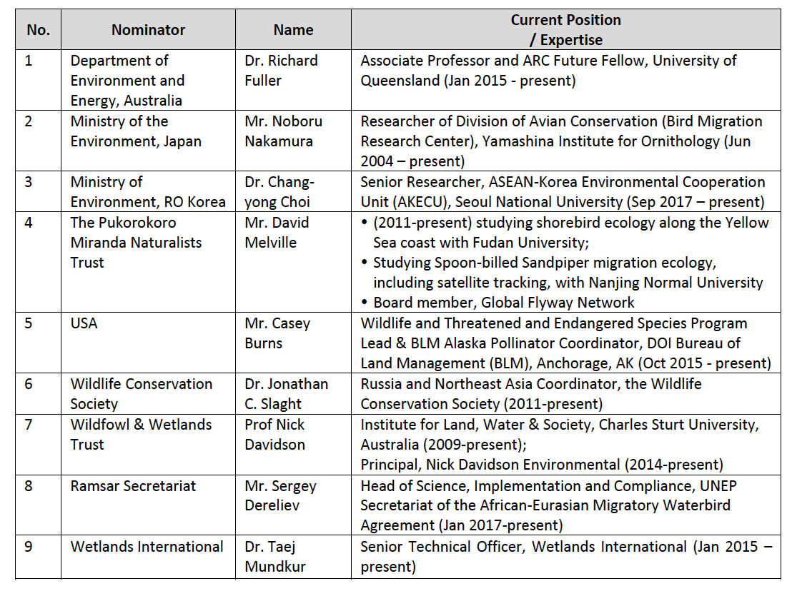

Report from the Chair of the Finance Sub-Committee

Prepared by Finance Sub-Committee and the EAAFP Secretariat
Summary
The Finance Sub-Committee presents its report to the eleventh Meeting of Partners (MoP11), and requests the MoP to:
- Note the development of a Resourcing Plan to support the delivery of the Strategic Plan (approved at MoP 10) and endorse the Plan
- Re-endorse the EAAFP Voluntary Fee Contribution system and encourage Partners to make voluntary payments.
- Note the terms of use for the Contingency Fund

Development of A Resourcing Plan

At MoP10 it was agreed that the Finance Sub-Committee would coordinate the development of a Resourcing Plan to assist in the delivery of the 10 year Strategic Plan.

It was agreed that the Finance Sub-Committee, with the support of the Secretariat and if needed others with relevant expertise, develop the Resourcing Plan that establishes the priorities for funding for the first 2 years of the Strategic Plan (2019-2021).

The Finance Sub-Committee was tasked to develop the Plan by end of 2019.

The Finance Sub-Committee proposed that the Resourcing Plan should be a 10-year plan to match to the term of the Strategic Plan, and be divided into 2 year rolling cycles with Partners and the Secretariat reporting to the MoPs on progress with implementation of the KRAs. As a starting point, the Sub-Committee considered the KRAs in the Strategic Plan and identified the key priorities that would be the focus for the first two rolling year period of the Plan.

Reflecting on the successful process in developing the Strategic Plan, it was decided to hold a workshop of key people in Singapore in September 2019. The result is a draft Resourcing Plan based of identified priority KRAs from the Strategy. All the KRAs were assessed against the three driving elements to score and assess the KRAs, namely:
- Enabling – KRAs that will facilitate and support other KRAs
- Impactive – KRAs that can deliver tangible outcomes
- Urgency – KRAs that require urgent action because of the level of threat.

The global COVID pandemic has had significant impacts on both the Partners’ and Secretariat’s capacities to undertake many of the activities highlighted in the first Resourcing Plan. It has been agreed that progress with the Strategic Plan implementation should be reviewed mid term (i.e. 5 years) which given the potential impact of Covid is very timely. A workshop will be convened in 2023 to review progress and priorities of the Strategic and Resourcing Plans. The draft Resourcing Plan, for the period 2023- 2025, is presented to MoP11 for endorsement.

2. Establishing the EAAFP Contingency Fund
The Finance Sub - Committee discussed the purpose and use for the Contingency Fund. It was agreed that this will only cover the Secretariat operations and personnel costs, and should not include Partnership activity costs. It was also agreed that the Fund should equal three months of the base Secretariat costs which amounted to around 98,000 USD. The Contingency Fund would be used as an emergency fund to ensure that Secretariat activity can be retained in exceptional circumstances.

- Progress with implementation of the Sustainable Funding Strategy
Adopted at the 9th EAAFP Meeting of Partners (MOP9) in 2018, the EAAFP Sustainable Funding Strategy proposed a number of recommendations in response to the need to increase and diversify funding for EAAFP operations and activities to achieve its strategic goals. The Finance Sub-Committee considered three major components.

Voluntary Contribution Scheme
The Finance sub Committee discussed the Voluntary Contribution Scheme. It was recognised that the Covid Pandemic was inevitably having a marked impact on INGO budgets but it was extremely important that all partners should be contributing as much as possible to the work of the Partnership. It was noted that individual partner financial and budgeting periods differed, and it was agreed that the Secretariat will modify the voluntary contribution letter according to the objectives and timings of each Partner with the requests being sent when the individual Partners are working on their budget for the following year.

Establishment of an EAAFP Foundation

One of the recommendations of the Sustainable Funding Strategy was to strengthen Partners’ efforts to identify funding, provide direct contributions and help raise funds for priority actions and EAAFP support. As the budget of the Secretariat is heavily relying on the contributions from the Incheon Metropolitan City, Ministry of the Environment Korea, US and Japan, and the limited voluntary contributions from the Partners, in efforts to mobilize resources outside the Partnership, the EAAFP Finance Sub-Committee during their resourcing plan workshop in September 2019 noted the potential value of establishing a Foundation in the Republic of Korea as a channel of domestic fundraising and assisting to promote the work of the Partnership in the host country.

Since the legal status of the EAAFP Secretariat does not allow the provision of tax-deductible receipts to corporate donors, the establishment of a Foundation was raised with, and endorsed by, Incheon Metropolitan City.

The Secretariat consulted both Incheon Metropolitan City and Ministry of Environment Korea about the legal issues for the establishment of a Foundation linked to the EAAFP Secretariat, and both governments showed strong support. As part of the consultation process, the Secretariat reviewed relevant laws and practices of NPO management in Korea, which is prepared in the document: The Analysis on the Establishment and Management of the EAAFP Foundation. The document was reviewed by the Finance Sub-Committee and the Management Committee and the Foundation was established.
The Chief Executive of the EAAFP Secretariat, Mr. Doug Watkins, is the Chair of the EAAFP Foundation, to ensure full accountability for the financial management of the EAAFP Foundation to the Partnership, through the Finance Sub-Committee and Management Committee.

Board members

Mr Doug Watkins, CEO EAAFP Chair
Vivian Fu, Senior Communications Officer/ EAAFP Secretariat
Jisun Lee, EAAFP Foundation Coordinator/ EAAFP Foundation

Auditor
Hyojung Yoo, Administration and Finance Officer/ EAAFP Secretariat

Co-funders as of 2023

Korea South-East Power Co.
Hyundai Motor Company
S-Oil Corporation
Kyungdong City gas co., Ltd.
Korea petro chemical Ind. Co., Ltd.
Domestic Individual donations from fundraising efforts

The EAAFP Foundation has focused on public awareness activities collaboratively with the external organizations to brand the foundation, to increase the number of donors and impact of the foundation in support of the Secretariat’s activities on conservation of migratory waterbirds and their habitats in EAAF. The number of recurrent donors and the amount of the donations has been increasing with EAAFP Corporate champion programme, fundraising events, campaigns, ecological art activities and others cooperated with other local organizations. The total raised is currently 70,000 USD.

Corporate engagement

The Finance Sub Committee meeting in Singapore in 2019 noted the need for developing principles of engaging the corporate sector. The Secretariat collected 13 corporate engagement policies from 12 international Non-Profit Organizations to aid the identification of the key principles and risk factors. The resulting guidelines were approved by the Sub Committee and the Management Committee.

Guiding Principles for engagement with Corporates

- Do no harm to migratory waterbirds and their important habitats in the East Asia-Australasian Flyway
- Contribute to the implement the EAAFP Strategic Plan 2019-2028
- Mutual benefits are expected between the EAAFP and the corporate
- The engagement should not diminish EAAFP’s integrity and reputation
- Cooperation with the corporate must be transparent in financial management and follow the financial regulations and rules of the respective country(ies).
- Do not undermine the existing relationship with other corporates or other Partners
- The engagement should not result in negative public perceptions of the EAAFP
- A communication protocol is in place to guide the way the engagement is presented to the outside world
- A potential engagement candidate should not be involved in ..
  - [weapons and war-related industries - weapons with the exception of hunting equipment?]
  - [Child labor]
  - [Violation of human rights]
  - [causing significant threat to human health]
  - [significant habitat destruction without policies to follow the mitigation hierarchy in that…..]
As an example, the Committee discussed an approach from the largest coal port in the world based in Australia to become an EAAFP corporate champion. It was agreed that the Secretariat will not seek sponsorship from coal export companies due to the need for worldwide reductions in carbon emissions and consequently potential damage to the reputation of the EAAFP.

