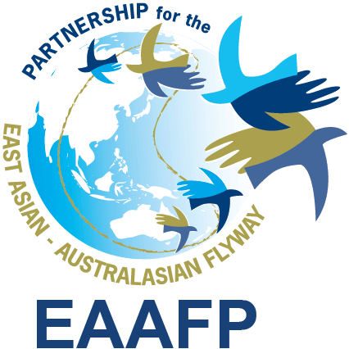
EAAFP Management Committee meeting
15:00hr, 3 October 2019 (Seoul Time)

Meeting Agenda

Confirmed participants (8): Pete Probasco, How Choon Beng, Martin Spray, Nick Davidson, Aree Suwanmanee, Doug Watkins (EAAFP New Chief Executive), EAAFP Secretariat (Hyeseon Do, Vivian Fu)

Not Available: MOEK (Joonhee Lee), Ward Hagemeijer (WI), Tilman Schneider (CMS)

- Progress of MOP11

- In June 2019, After the Secretariat approached Australia Gov’t to consider hosting the next MOP in early 2021 given the existence of very engaged Partners in Australia such as AWSG, Birdlife Australia and Queensland University which might bring strong support in technical aspects to EAAFP Partners. On 22 August 2019, Australia gov’t, after careful review about the hosting documents provided the Secretariat, officially informed the Secretariat of the agreement on hosting MOP11 in Brisbane, Australia. On 12 September 2019, the Department’s official letter was delivered to the Secretariat Annex I
- Discussed points
- Date: 14 – 19 March 2021 (*Ramsar COP 14 in Oct)
- Location: Brisbane, Queensland
- Venue: TBC
- Host: Australian Federal Gov’t, Birdlife Australia (Sponsoring Scope: Venue, Meeting Rooms, Catering (breaks and lunch), Opening Reception)
- Co-organizers (or co-sponsors): Queensland Gov’t, University of Queensland – TBC
- Proposed Tentative Schedule, Provisional agenda, Information Sheet, Timlines: Attachements
- Focal Point: Dr. Mark Carey, Department of Environment and Energy/Ms. Sam Vine, Head of Conservation, Birdlife Australia
- Special request: Keep confidential until the announcement by the Minister on World Migratory Brid Day on 12 Oct 2019 *Press Release and MOP11 page to be prepared with the Secretariat
- Follow up actions needed: EAAFP Chair to send the acceptance letter and to announce Partners.
- Decision:

- Progress of New Chief Executive recruitment
- The contract with MOEK and the candidate has been finalized on 26 September 2019, and at the same time his commencement date starts on 7 October 2019, he will go to China to meet Science Unit and to DPRK for Swan Goose Festival with the special request of the DPRK focal point for his attendance. His first reporting day at Incheon Secretariat will be between 20 – 24 October 2019 depending on the approval process for working visa issuance to Korea. The Secretariat has provided all the necessary documents for the visa process and the pending documents from the candidate such as legalized certificates will be supplemented
- The announcement email with Partners and article has been completed on 27 September 2019. https://www.eaaflyway.net/eaafp-secretariat-welcomes-new-chief-executive-mr-doug-watkins/
- Decision:

- Finance Sub-Committees report-back

- Finance Sub-Committee face-to-face meeting in Sep 2019 https://www.eaaflyway.net/eaafp-finance-sub-committee-workshop/
- EAAFP Resourcing Plan to Implement the EAAFP Strategic Plan 2019-2028

- Technical Sub-Committee report-back

- Techinical Sub-Committee workplan 2019-2020
- Techinical Sub-Committee face-to-face meeting plan in Dep 2019
- Meeting minutes in Sep – annex 3

- AOB

Decisions:

** Reporting on the re-format of the meeting agenda / minutes
Annex I

