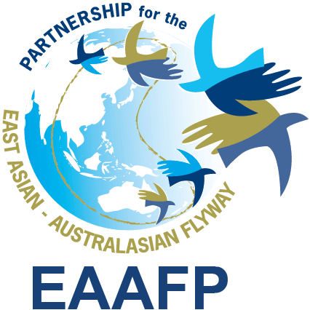

EAAFP Management Committee meeting
15:30hr – 16:30hr, 16 December 2019 (Korean Time)

Meeting Agenda

- Committee Members (5): Pete Probasco (Chair), How Choon Beng (Vice Chair), Martin Spray (FsC Chair), Nick Davidson (TsC Chair), Ward Hagemeijer (WI), Sukanya Wisan (Thailand)
- Committee Members Apologies (2): MOEK (Joonhee Lee), Tilman Schneider (CMS)
- EAAFP Secretariat: Doug Watkins, Hyeseon Do

- Report of the CE
- 2019 EAAFP Year-end Reception, 28 Nov 2019: EAAFP Key achievement presentation (Attachment 1)
- Update on MOP11
- China GEF National Flyways Project Proposal: involving 4 FNS, 3 Yellow Sea intertidal sites
- AOB

- Potential IUCN membership application

- Benefits: Enable the EAAFP Partnership to engage formally in the development/coordination process of new motions / side events for IUCN WCC (eg. IUCN Yellow Sea Working Group) in liaison with Partners and different stakeholders. Although most of the EAAFP Government Partners are already an IUCN members, in order to lead the liaison effectively with different stakeholders for identified issues requested by Partners, EAAFP was recommended by several Partners (Birdlife International, International Crane Foundation and IUCN) in 2019 to consider being an IUCN member targeting before IUCN World Conservation Congress in June 2020.

- IUCN World Conservation Congress: Members can vote during the members’ assembly which is the highest decision-making body. It involves government, NGOs and international organizations, so that they can make a joint decision by submitting a motion (Resolution) on conservation and sustainability.
- Networking and Regional Alliance: Members are able to develop partnerships by being part of an alliance of governments and NGOs. Members also have the possibility to expand their networks through international contacts with other Members and IUCN’s experts and staff.
- Required documents to submit with the application: Audited financial statements, Membership application form, Letter of endorsement from two IUCN members (MOEK, Japan - TBC), annual membership dues (1,338 CHF equivalent to 1,346 USD, based on the scale of its annual operating budget). The Secretariat is seeking clarification from IUCN in relation to EAAFP entity that would be most appropriate to use for the registration (options are the Korean Business Registration of the “EAAF Partnership Secretariat” or the EAAF Foundation).

- Application Submission Deadline: the end of Dec 2019 to be a member by next WCC

- [Decisions request]: Whether this decision is decision for the Management Committee of if it is considered more appropriate for it to go to at MoP11?

- Finance Sub-Committee report-back
  - Update on the Foundation: The Foundation was established in September 2019 to increase sustainable financing for the conservation of migratory waterbirds and habitats. It would contribute to increasing and diversifying funding for EAAFP operations and activities to achieve its strategic goals and enhance the collaboration with the corporates that are willing to support the environment agenda. As of now, the foundation is waiting to get approval from Ministry of Finance - Korea to be a Statutory Donation Acceptance Organization that allows an issuance of tax-deductible receipts for corporate and individual donors.
  - EAAFP Resourcing Plan (Attachment 2)
  - [Decision Request]: Approval on the EAAFP Resourcing Plan document and the circulation to Partners

- Strategic Plan Task Force report-back
  - EAAFP Reporting Template (Attachment 3)
- [Decision Request]: Approval on the EAAFP Reporting Template and the circulation to Partners, TsC, WG/TFs and Secretariat (Incheon and Beijing)

- Technical Sub-Committee report-back
  - Report on the meeting of the TsC Chair, TsC Vice Chair, SU Coordinator, CE, PO at Poyang Lake on Dec 5 2019 [For information] (Meeting Note: Attachment 4)
  - The EAAFP MC of the 2 Aug 2019 approved the organization of a face-to-face meeting on the TsC. This was planned to be linked to the Poyang Event but many members had existing commitments. Now proposed for 10 – 12 May 2020 (USD 20,000 – Activity 4.1 Secretariat budget). [For information]
  - [Decision request]: Organization of TsC face-to-face meeting, 10 – 12 May 2020 (USD 20,000 – Activity 4.1 Secretariat budget, approved in 2 Aug 2019 by EAAFP MC)

- AOB
- Revision of the text on last MC meeting minutes regarding the next Ramsar COP date.
“The dates suggested for MoP11 by the Australian Department of the Environment and Energy are 14 – 19 March 2021. The specific venue is yet to be decided. HD noted that the 14th Meeting of the Conference of the Parties (COP), Ramsar will be held in October 2021 in Wuhan, Hubei, China”

