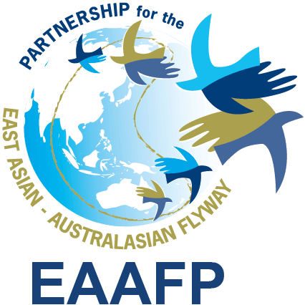
EAAFP Management Committee meeting (19.2)
15:30hr – 17:30hr , 20 June 2019 (Seoul Time)

Meeting Agenda

Confirmed participants (7): Pete Probasco (Chair, U.S.A), Shufen Yang on behalf of How Choon Beng (Vice Chair, Singapore), Martin Spray (WWT, FsC Chair), Nick Davidson (TsC Chair), Ward Hagemeijer (WI), Timan Carlo Schneider (CMS), Aree Suwanmanee (Thailand)

Can’t: Joonhee Lee (Republic of Korea)

EAAFP Secretariat: Programme Officer, External Relations Manager, Communication Officer

- Adoption of the last MC meeting minutes on 21 March 2019 [Annex 1]

- Report back of the EAAFP 10th-anniversary event on 10 May 2019 and New MOU establishment with Korean Gov’t [Annex 2 – New MoU]
https://www.eaaflyway.net/celebration-of-eaafp-secretariat-10th-anniversary/; https://www.eaaflyway.net/eaafp-secretariat-celebrates-the-2019-world-migratory-bird-day/

- Update on the Location of MOP11; Suitability of EAAFP MOP venues *suggested by Ward: [Annex 3]

- Update on the CE recruitment
The request for applications for the new CE closed on 10 June 2019, a total of seven applications were received. The hiring panel also was set with 9 members and the applications are under the review according to the developed criteria and weighed scores. The video-interviews will be carried out within 2 – 3 weeks.

- Finance / Technical Sub-Committee report-back
- Finance Sub-Committee meeting minutes on 12 April 2019 [Annex 4] and other issues
- Technical Sub-Committee meeting minutes on 30 April 2019 and updated workplan [Annex 5 – draft version / Annex 6] and other issues

- Update on Follow-up status for MOP10 Decisions
- MOP 10 meeting minutes first draft *Status: Completed
- EAAFP Small Grants for WG/TFs (DD.07) *Status: Completed
- Developing Guidelines for National and Site Partnership (DD.08) *Status: Completed

