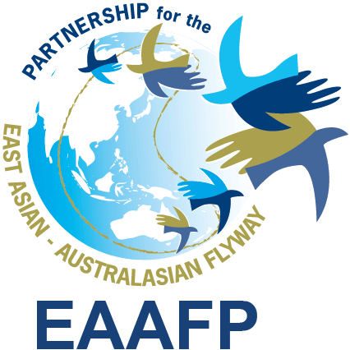
EAAFP Management Committee meeting (19.1)
15:00hr, 21 March 2019 (Seoul Time)

Meeting Agenda

Confirmed participants : Pete Probasco (Chair, U.S.A), How Choon Beng (Vice Chair, Singapore), Aree Suwanmanee (Thailand), Joonhee Lee (Republic of Korea), Timan Carlo Schneider, Laura Aguado, Marco Barbieri (CMS), Martin Spray (WWT, FC Chair), Nick Davidson (TC Chair), Ward Hagemeijer (WI), EAAFP (Deputy, Finance Officer, External Relations Manager, Programme Officer, Science Unit)

- Briefing on Lew’s passing; Address any matters that the Management Committee still needs to address as it relates to the passing of our dear friend Lew
- Secretariat’s supports: Organization of the Funeral service in Beijing on 11 March, Memorial service in Hongkong on 12 March, Memorial service in Incheon on 19 March, Memorial space at his office from 20 – 22 March; Setting up the Condolences email account (condolences.eaafp@gmail.com) and Online memorial wall (https://www.forevermissed.com/lewyoung/#about)
- Compensation of his passing

Content | USD | Proposed  Budget line | Note
Funeral and memorial Service  (included travel and miscellaneous cost for family) | 35,000 | Contingency fund | Spent already
National Pension | 3,000 |  | Provided by National Pension Service
Compensation for the family | 30,000 | Personnel expenses | Equivalent to CE’s Salary for 3 months
Retirement Pension | Not applicable | Personnel expenses | Need to work for more than one year
National Health and Long-term Care Insurance | Not applicable | Personnel expenses | Only cover medical expenses in Korea
Industrial Disaster Compensation Insurance | Not applicable | Personnel expenses | An employer be excepted
Total (USD) | 68,000
- Proposed discussion points by the Secretariat: Decision on the Compensation for his passing; Development of the staff guideline, compensation, and contract (*Need to include the support of Personal Life Insurance for staff members, especially CE position)

- Proposed discussion on formulating the strategy on how best to move forward after the passing of Lew
- Secretariat - until a new Chief Executive is hired the lead responsibilities will have to be handled by the Deputy Chief Executive and the Programme Officer. [Annex 1 – Workplan and Calendar]
- The Management Committee will need to step up its role in assisting with the workload of the Secretariat. This will mean the Management Committee will have to do our best to be available for meetings and probably for the next 4-6 months meet more regularly.
- Identify how best to move forward in finding a new Chief Executive - Following the same process when we hired Lew.
- If MC members all agree, the MC need to pull the paperwork together consisting of the following; job description, announcement, how to apply, length of the announcement, etc.
- When should we start this process?
- Formulate a hiring committee.
- Identify how best to inform the Partnership.
- Analysis of the MOP10 evaluation [Annex 2]; Location of MoP11 [Annex 3]

- Finance Sub-Committees report-back of the meeting on 15 Feb – Finance Sub-Committee Chair *Technical Sub-Committee meeting will be held in April

- Briefing on the establishment of the Contingency Fund – Finance Sub-Committee Chair [Annex 4]

- Update of the EAAFP 10th anniversary event and new MoU

The EAAFP 10th anniversary event (including the signing ceremony of new MOU) is scheduled on 10 – 11 May. Given the current circumstances, we have decided to reduce the scale of the event from the original plan which was 3 days event. Ramsar Convention Secretary General, EAAFP Chair and Minister of the MOEK are invited as a VIP. The new MoU is under the revision and MOEK is discussing with the Ministry of Planning and Finance in order to increase the budget. The Secretariat will share the draft of new MoU and a budget plan for the expected increase for the advice of the Finance Sub-Committee no later than mid-April. The final amount will be decided in the beginning of May before the event.

- The minutes of this meeting will need to be shared with the Partnership as soon as possible

