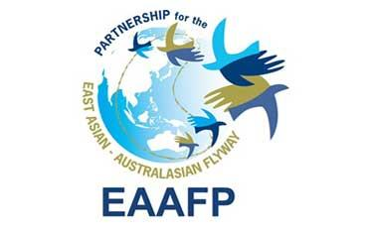

**NATIONAL PARTNERSHIP**

**GUIDELINE**

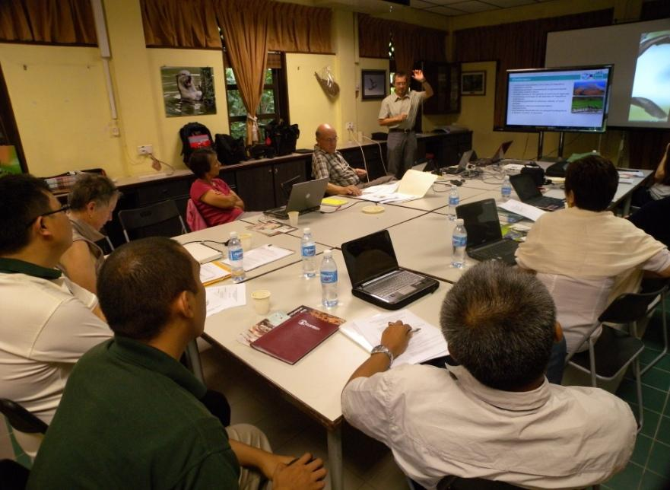

**National Partnerships**

**2023**

**Acknowledgements:** Many people from across the Flyway have given their time in webinars, individual meetings, interviews, written material and photographs. Without their input it would not have been possible to gather the information and data, and more importantly to gain their expertise and personal insights into the workings of the EAAFP. As we have worked with all these passionate people – some we never met but simply received emails or read their stories – we have become full of admiration for the work and commitment of so many citizens of so many countries to migratory waterbirds and their habitats. This body of work is a tribute to their stories, efforts and experiences and it has been a privilege to collect it all together for the benefit of all and especially the birds themselves that journey across all our lands of the Flyway never belonging to one and relying on all. 

*Jennifer George, Consultant 2022*

**Cover photo:**

East Asian-Australasian Flyway Partnership EAAFP Task Force Meeting, CEPA Strategy Workshop ©EAAFP

**Contents**

SECTION 1: INTRODUCTION 4

1.1 PURPOSE OF THE GUIDELINE 4

1.2 BACKGROUND TO THE EAST-ASIAN AUSTRALASIAN FLYWAY PARTNERSHIP 4

1.3 OBJECTIVES OF THE EAAF PARTNERSHIP 5

1.4 STRUCTURE OF THE RELATIONSHIPS WITHIN THE EAAFP 5

SECTION 2: UNDERSTANDING THE NATIONAL PARTNERSHIP MECHANISM 6

2.1 PRINCIPLES OF A NATIONAL PARTNERSHIP 6

2.2 DEFINITION OF A NATIONAL PARTNERSHIP 6

2.3 POTENTIAL “PARTNERS” IN A NATIONAL PARTNERSHIP 7

2.4 CASE STUDY OF A NATIONAL PARTNERSHIP - INDONESIA 7

2.5 IMPACTS AND BENEFITS OF A NATIONAL PARTNERSHIP 8

2.6 CASE STUDY OF A NATIONAL PARTNERSHIP - JAPAN 9

SECTION 3: ESTABLISHING A NATIONAL PARTNERSHIP 11

3.1 WHAT TO CONSIDER WHEN ESTABLISHING A NATIONAL PARTNERSHIP 11

3.2 WHAT TO DO NEXT 11

3.3 FUNCTIONS OF A NATIONAL PARTNERSHIP 11

3.3.1 ANNUAL MEETING 12

3.3.2 BETWEEN ANNUAL MEETINGS 12

3.4 ANNUAL NATIONAL PARTNERSHIP MEETING 12

3.5 NATIONAL WORK PLAN 15

3.5.1 CASE STUDY: NATIONAL PARTNERSHIP WORKSHOP 15

3.5.2 DEVELOPING A NATIONAL WORK PLAN 16

3.5.3 TEMPLATE FOR A NATIONAL WORKPLAN 16

3.5.3.1 CASE STUDY OF NATIONAL PARTNERSHIP MEETING TO ADDRESS CLIMATE CHANGE UNDER OBJECTIVE 5 17

3.5.3.2 CONTRIBUTION TO THE CHALLENGE OF CLIMATE CHANGE AT EACH LEVEL OF THE FLYWAY 18

3.6 DIAGRAM OF RELATIONSHIPS WITHIN A NATIONAL PARTNERSHIP 18

3.7 ROLES WITHIN A NATIONAL PARTNERSHIP 19

3.7.1 ROLE OF THE GOVERNMENT PARTNER / NATIONAL FOCAL POINT 19

3.7.2 ROLE OF NGO PARTNERS IN THE NATIONAL PARTNERSHIP 20

3.7.3 ROLE OF THE SITE MANAGER IN THE NATIONAL PARTNERSHIP 20

3.7.4 ROLE OF NATIONAL EXPERTS / SCIENTISTS IN THE NATIONAL PARTNERSHIP 21

3.7.5 ROLE OF THE EAAFP COMMITTEES, WORKING GROUPS & TASK FORCES IN THE NATIONAL PARTNERSHIP 21

3.7.6 ROLE OF THE EAAFP SECRETARIAT SUPPORTING THE NATIONAL PARTNERSHIP 21

**ACRONYMS AND DEFINITIONS**

|  |  |
| --- | --- |
| EAAFP | East Asian-Australasian Flyway Partnership |
| FNS | Flyway Network Site |
| CEPA | Communication, Education, Participation & Awareness |
| NGO | Non-Government Organisation |
| INGO  MOU | International Non-Government Organisation  Memorandum of Understanding |

# SECTION 1: INTRODUCTION

## 1.1 PURPOSE OF THE GUIDELINE

The purpose of this document is to provide guidelines for EAAFP Government Partners to develop and strengthen National Partnerships for the conservation of migratory waterbirds of the EAAF, their habitats and to support national planning for the implementation of the EAAFP Strategic Plan.

National Partnerships and the Site Partnerships are the mechanisms that support and mobilise the people and relationships across a country to enhance the conservation of migratory waterbirds and their habitats. They work together through relationships rather than obligations.

## 1.2 BACKGROUND TO THE EAST-ASIAN AUSTRALASIAN FLYWAY PARTNERSHIP

The East Asian-Australasian Flyway Partnership (EAAFP) provides a flyway wide framework across 22 countries from Alaska (USA) and Russia in the north, to Australia and New Zealand in the south, and transverses the breadth of Asia from Bangladesh to China and Japan. Its purpose is to promote dialogue, cooperation, and collaboration between a range of stakeholders to conserve migratory waterbirds and their habitats. It was launched internationally as a “Type II Partnership” as defined by the Johannesburg 2002 World Summit on Sustainable Development (WSSD). This type of partnership is distinct from the ‘traditional’ Type I agreements which are regarded as legally binding intergovernmental commitments designed to aid states in the implementation of sustainable development goals. The then President of the World Resources Institute, Jonathan Lash, described the alternative Type II approach in more colourful terms as “*The beginnings of a shift from the stiff formal waltz of traditional diplomacy to the jazzier dance of improvisational solution-oriented partnerships that may include non-government organizations, willing governments and other stakeholders”.[1]*

In 2005 the EAAFP was recognized as a Ramsar Regional Initiative and then in 2006 the EAAFP was formed as a Type II partnership *“characterized by collaborations between national or sub-national governments, private sector and civil society actors, to form voluntary transnational agreements in order to meet specific sustainable development goals.”[2]*

It is important to recognise that this type of approach does not require binding commitments from governments, and so there are no national government policy imperatives for specific funding to fulfil specific commitments. The success of the EAAFP relies very much more on the strength of National and Site Partnerships and the relationships generated at all levels within those partnerships. Feedback from surveys of Partners reflect a measure of uncertainty about what a National Partnership is or should be.

The guidelines provided in this document recognise the importance of a National Partnership in fulfilling a Partner’s commitments to the EAAFP strategic objectives and that each country’s arrangement will reflect their own existing structures and needs.

## 1.3 OBJECTIVES OF THE EAAF PARTNERSHIP

1. Develop the Flyway Network of Sites of international importance for migratory waterbirds.

2. Enhance communication, education and public awareness of the values of migratory waterbirds and their habitats.

3. Enhance flyway research and monitoring activities, build knowledge and promote exchange of information on waterbirds and their habitats.

4. Build the habitat and waterbird management capacity of natural resource managers, decision makers and local stakeholders.

5. Develop flyway wide approaches to enhance the conservation status of migratory waterbirds.

## 1.4 STRUCTURE OF THE RELATIONSHIPS WITHIN THE EAAFP

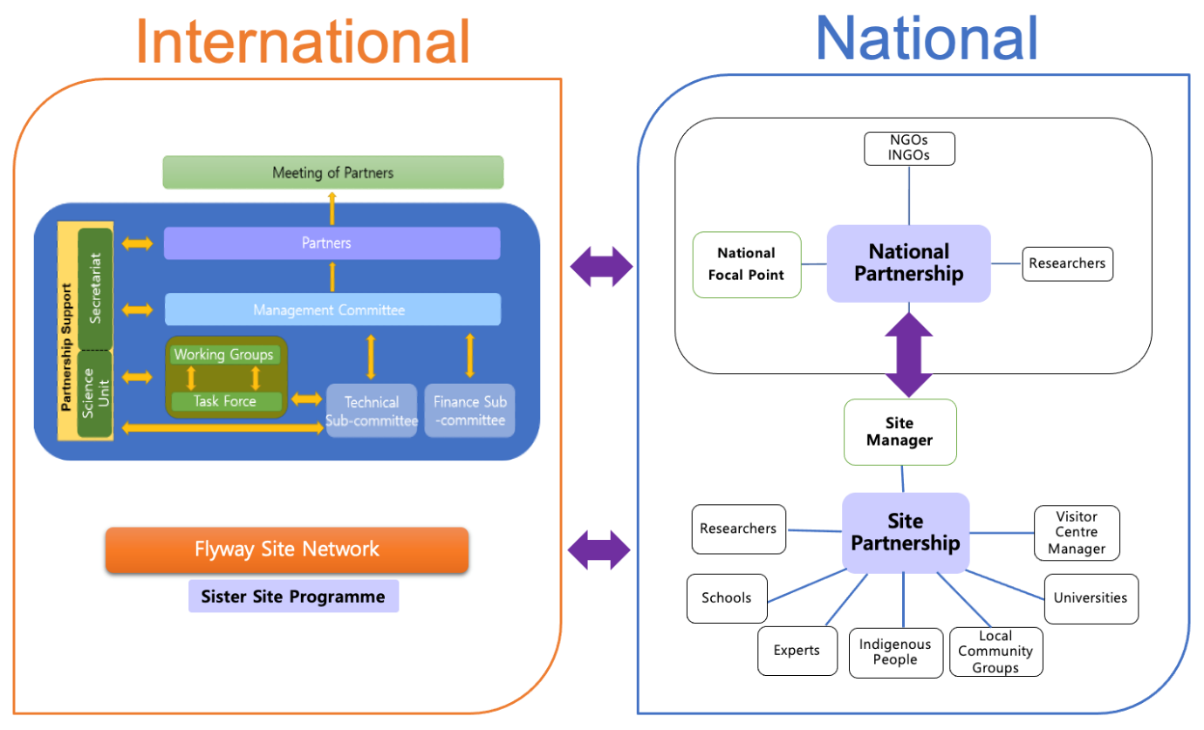

*People, their decisions and actions lie at the heart of effective wetland and migratory waterbird conservation. Local communities, Site Managers, local and national government decision-makers, experts, scientists, educators, NGOs, and civil society all have a role to play in conserving migratory birds and their wetland habitats.*

*The most significant contribution to the conservation of migratory waterbirds and their important sites would be for each country to have a partnership which worked on this and brought the different sectors together towards common objectives.*

# SECTION 2: UNDERSTANDING THE NATIONAL PARTNERSHIP MECHANISM

## 2.1 PRINCIPLES OF A NATIONAL PARTNERSHIP

The EAAFP, by its nature as a Type II Partnership, does not have prescriptive obligations as to implementation and so there is flexibility in how each National Government Partner carries out this role. National Partnerships can be very formal structures or quite informal, depending on the circumstances in each country*.*

The following are common principles:

* Grow from shared vision.
* Build from strengths.
* Be flexible to suit the needs, social conditions, existing structures and national culture.
* Work collaboratively.
* Include indigenous people and traditional knowledge.
* Build enduring relationships of mutual respect.
* Build towards sustainability.

## 2.2 DEFINITION OF A NATIONAL PARTNERSHIP

**The value of INGOs & NGOs**

NGOs and INGOs have a wealth of knowledge and experience to offer National Partnerships:

* Capacity building.
* Organisation and administration.
* Developing strategies and action plans.
* Supporting relationships with Ramsar Committees.
* Facilitating engagement with corporates, local businesses, national and international connections.
* Facilitating connection with other FNSs.
* Supporting citizen science initiatives.
* Helping with on the ground Site management.
* Monitoring and research.
* Public awareness and education.
* Advocating when there are threats to Sites.

A National Partnership is a national network of stakeholders who cooperate at national level to support the implementation of the EAAFP Strategic Plan within their country. Stakeholders include local governments, Site Managers, NGOs, academia, experts and other relevant stakeholders working on common activities and issues concerning the conservation of migratory waterbirds and their habitats.

The National Partnership provides a mechanism that:

* Facilitates the relationships between people and builds the capacity and outreach of network Sites.
* Provides a mechanism for the sharing of information throughout the country.
* Facilitates national planning for the implementation of the EAAFP Strategic Plan.
* Facilitates data and information gathering for the National Focal Point to report to MOP on implementation of the EAAFP Strategic Plan.
* Promotes implementation of EAAFP CEPA Action Plan.
* Promotes studies and information exchange among scientists and researchers.
* Identify challenges that need to be tackled within their country, in a region and/or in other parts of the Flyway.

Working together, National and Site Partnerships can provide a mechanism to set national and sub-national priorities to enable the implementation of priority on-ground activities and to build capacity of Flyway Site Managers, to communicate flyway information to a larger group, and to identify new potential Flyway Network Sites. It is designed with the needs of the partnership paramount.

A balance between a representative structure, a leadership structure and a technical structure needs to be considered in the early development of a National Partnership. The model used will depend on your needs.

## 2.3 POTENTIAL “PARTNERS” IN A NATIONAL PARTNERSHIP

* + National Focal Point.
  + Managers of current or potential internationally important FNS for migratory waterbirds.
  + National, Regional and Local government officers involved with the management of internationally important wetlands.
  + Local government representatives.
  + Local and Indigenous people with cultural responsibilities for internationally important wetlands.
  + Researchers, scientists and other technical experts.
  + NGOs involved in migratory waterbird conservation nationally and internationally.
  + NGOS involved in other conservation work, where relevant to the conservation of migratory waterbirds and their habitats.

These partners are a network of people who represent all the different levels within their country who can provide the National Focal Point with all the information about what is happening. This greatly simplifies the reporting responsibility and shows how much their country is achieving for the conservation of migratory waterbirds and their habitats.

## 2.4 CASE STUDY OF A NATIONAL PARTNERSHIP - INDONESIA

**Indonesia’s National Partnership Mechanism**

This mechanism was established by the Government partner with the support of an INGO.

**National Steering Committee**

**National Partners**

**Ministry of Environment and Forestry**

**Indonesian Institute of Sciences (***Lembaga Ilmu Pengetahuan Indonesia***)\***

**Burung Indonesia**

**Wetlands International – Indonesia Program**

**Burung Nusantra**

**WWF – Indonesia**

**Raptors Indonesia**

**Burung Laut Indonesia**

**Birding Indonesia**

**\*** Recently amalgamated into National Innovation and Research Agency

**EAAFP Secretariat**

**National Focal Point**

**Raptor**

**Seabirds**

**CEPA**

**Shorebirds**

**EAAFP Site Network**

**Monitoring**

**Zoonosis**

## 2.5 IMPACTS AND BENEFITS OF A NATIONAL PARTNERSHIP

A National Partnership is a mechanism for sharing information – both within the country and internationally. It brings data and information to the public domain. National Partnerships also allow countries to identify issues that need to be tackled within their own country, in a region and/or internationally by a number of countries of the Flyway.

Due to its multi-stakeholder nature, a National Partnership establishes and builds a national alliance for implementation of the EAAFP Strategic Plan.

The benefits of a strong National Partnership are:

1. Assists the National Focal Point with data and information to prepare their national reports, develop a national work plan that addresses the EAAFP Strategic Plan and showcase the wide range of activities happening across their country.
2. Brings together the unique strengths and resources of diverse partners to have more impact and achieve more sustainable outcomes for migratory waterbirds and their habitats, than each partner could achieve by acting alone and boosts the scale of the collective effort.
3. Opportunity for the partners to talk about their successes and innovations, what they want to do, the needs they have, discuss how they can collaborate, and how they can strengthen monitoring at a national level.
4. Provides a mechanism to link local and national NGOs in contributing to EAAFP work at a national level.
5. National and sub-national priorities are set that facilitate key on ground activities.
6. Provides an effective mechanism for Site Managers, experts, academic and NGO communities to actively participate in migratory waterbird and habitat conservation at a national level.
7. Partnering arrangements value and respect Indigenous heritage and cultural knowledge and provide roles in designing and implementing projects in their country.
8. Working together as a larger national group raises the profile of the conservation work for migratory waterbirds and their habitats at a national and international level.
9. Increased communication and exchange of information, training and expertise between the Flyway Network Sites of the country and build the capacity of Site Managers.

## 2.6 CASE STUDY OF A NATIONAL PARTNERSHIP - JAPAN



This mechanism in Japan was developed in the time prior to the formation of the EAAFP.

It offers a successful example of a formal national structure organised around important Sites for different waterbird groups.

**Activities of each waterbird species group**

* Publish and disseminate newsletters to Flyway Network Site in Japan sharing information on the activities of each species network and each Flyway Network Site – arrival of migratory waterbirds, World Wetlands Day, World Migratory Bird Day, and other CEPA activities at Flyway Network Sites.
* Share information through mailing lists and Facebook.
* Hold network meetings.
* Coordinators attend relevant meetings.
* Participate in public awareness raising activities, surveys and research at each Site and collect information and support creation of awareness raising materials.
* Engage with potential wetlands to join the EAAF.

**National Liaison Meeting held annually**

* Share information on EAAFP – Meeting of Partners, its agendas, and important decisions.
* Share progress of ongoing national activities, discuss issues and strategies.
* Plan future activities.
* Includes government partner, coordinators of species groups, experts, and NGOs.

**National Training Workshop for Flyway Network Site Managers held annually**

The target for this was a Local Government, who serve as Managers of each Flyway Network Site, and relevant NGOs involved to promote understanding of EAAFP, share efforts and experience of each FNS and promote cooperation among the FNS. Recent themes have included identifying migration trends by using the Flyway Site Network and strengthening the monitoring systems as the Flyway Network Sites.

**Achievements**

* Awareness among government official significantly increased.
* Inclusion of NGOs enhanced communication between local government and the private sector.
* Discussed agenda prior to EAAFP MOP provided National Focal Point detailed material to present at MOP. And meeting after the MOP, decisions were discussed in a workshop style and incorporated into the plan for Japan’s domestic activities, based on the EAAFP Strategic Plan.
* Shared information on EAAFP MOP’s and other international movements.
* Strengthened the understanding and cooperation among stakeholders.
* Chance to get to know each other and be encouraged and inspired by each other.
* Small group workshop format allowed more in depth discussions.
* Liaison meetings discussing and reviewing activities enables meaningful exchanges of opinions and understanding of issues.

# SECTION 3: ESTABLISHING A NATIONAL PARTNERSHIP

## 3.1 WHAT TO CONSIDER WHEN ESTABLISHING A NATIONAL PARTNERSHIP

* Firstly, consider what mechanisms you already have in your country that link key stakeholders together at a national level for wetlands and/or migratory waterbirds – Government Officers, NGOs, experts, Site Managers, academia. How could you build on that?
* Is there a leader who either has the respect to lead this Partnership or who can grow into that role?
* Meet at conferences to discuss what is happening.
* Research the National Partnerships of other EAAFP countries and ideas that might be relevant to your country.
* Your mechanism should suit the circumstances of your country.
* What other international frameworks can you collaborate with, for example does the Ramsar Committee meet annually and find out if the EAAFP annual meeting could be part of that meeting agenda.
* Can you secure the support / approval from senior Managers?
* Can you secure a budget, even if small, to support the National Partnership?
* List of all relevant stakeholders who might be involved: Site Managers, Visitor Centre Managers, NGOs, INGOs, national experts, researchers, research institutions, other government agencies.
* Identify the interest and capacity of each of these stakeholders.
* What means of communication and information sharing will be needed.
* If there is an EAAFP INGO Partner that is active in your country, consider requesting their assistance with supporting the National Partnership. (Note that BirdLife International has National Partners in many countries of the EAAF (e.g., in Indonesia the National BirdLife International Partner (Burung Indonesia) is supporting the development of the National Partnership in Indonesia.

## 3.2 WHAT TO DO NEXT

* Invite stakeholders to meet.
* Consider delegating to an NGO the organisation and recording of actions.
* Appoint a national / regional coordinator that will maintain contact with in country EAAF Partners on a regular basis (perhaps this role could be allocated to an NGO).
* Identify other reporting processes under other instruments or treaties, which require similar data and information, so that you can collaborate. These might include Ramsar National Committee, NBSAP (CBD), bilateral Migratory Bird Agreements. Ramsar is key because some of the EAAFP Flyway Network Sites are, or more could be nominated as Ramsar Sites.

## 3.3 FUNCTIONS OF A NATIONAL PARTNERSHIP

A National Partnership is a mechanism to support the work of the EAAFP within each country. To do this it is recommended to:

* Meet annually (face-to-face or online) to report on progress and discuss innovations, successes, and concerns, and to build relationships.
* Develop a collaborative National Workplan – including input from all in-country Partners about what is happening at Flyway Network Sites. and potential sites.
* Provide a mechanism for implementation of the ongoing monitoring programme of waterbirds and wetlands at Flyway Network Sites and potential sites. This would benefit from linking to the annual Asian Waterbird Census being coordinated regionally by Wetlands International.
* Keep in touch with in-country Partners to provide support and advice.
* Develop capacity building workshops.
* Contribute to CEPA activities at national level.
* Encourage the mainstreaming of the National Partnership to the National Biodiversity Strategy and Action Plan.
* Collaborate on reporting to government and biennial reporting to EAAFP MOP.

### 3.3.1 ANNUAL MEETING

The annual meeting with in-country partners is both a planning exercise and an opportunity to exchange and share information between the national partners.

* Discuss migratory waterbird and wetland conservation, exchange information, get updates on innovations, techniques, management strategies, seek input from local level about issues, make connections with others, discuss EAAFP engagement, and provide an opportunity to ask questions, seek advice and cover anything else that will advance the conservation of migratory waterbirds in your country.
* Develop a national work plan that addresses the EAAFP Strategic Plan.
* Report progress on implementation of that plan.
* Plan joint national activities relating to migratory waterbirds and their habitats e.g., national training needs, waterbird, and wetland monitoring activities, CEPA activities.
* Develop relationships with others working for the conservation of migratory waterbirds and their habitats.

### 3.3.2 BETWEEN ANNUAL MEETINGS

Between annual meetings the stakeholders in the National Partnership:

* Cooperate with others within the National Partnerships to carry out the national workplan.
* National Focal Point builds a network for the regular flow of information and communication about what is happening at Flyway Network Sites and potential network sites. A key person appointed to drive the communication within the National Partnership, and this may be with an NGO delegated to carry out this role.
* Hold ad-hoc online meetings, if possible, to connect with others, discuss issues, successes, and progress, build relationships, etc.
* With the agreement of the members of the National Partnership, provides member contact details to enable the EAAFP Secretariat to circulate its news.
* Meet at conferences –National BirdLife Partner Conferences, or other national meetings e.g., Ramsar National Committee, visiting Sites face to face, hold the annual National Partnership meeting at a Flyway Network Site with a Visitor Centre.

## 3.4 ANNUAL NATIONAL PARTNERSHIP MEETING

*Important outcomes of a national meeting include building relationships, and getting to know each other, getting to know the work each is doing and building cooperation nationally between Site Managers and NGOs.*

One of the most important functions of a National Partnership is the annual meeting of key stakeholders convened by the National Focal Point (or delegated by National Focal Point to NGO). This is the opportunity to discuss all the activities Sites have been doing, and what they plan for the next year. All this can be collated for the National Focal Point to include in their reporting to their government.

If they also send their Workplan to the EAAFP Secretariat, it can look to identify synergies between National Workplans and where National Partnerships from different countries are doing something similar. They can then offer to link them together and share experiences as they both take on common activities.

An agenda might include:

* Report from National Focal Point.
* Report on progress within the country.
  + Reports from academia, experts and researchers.
  + Reports from NGOs.
  + Reports from each Site including achievements and challenges.
* Share progress on ongoing projects.
* National monitoring system to gather data collected nationally and regionally.
* Reviewing data gathered.
* Identify national training needs.
* Discuss issues of importance to migratory waterbirds and habitats at Sites.
* Opportunities to share successes, innovations and questions with other Site Managers.
* Discuss priority activities to be done and CEPA material development.
* Develop/agree a National Workplan with common activities for EAAFP work in the country.
* Develop recommendations for the bi-annual Meeting of Partners.

3.4.1 CASE STUDY ANNUAL NATIONAL PARTNERSHIP MEETING

**The New Zealand National Partnership Annual Meeting offers an example of an informal structure**

The New Zealand National Partnership links its meeting to the annual National Bird Conference. All partners are usually present, and it provides the opportunity to hold the meeting and check on progress with the various projects. Most of the year, partners are spread across the country, so they appreciated being able to have a face-to-face meeting. The government representative prepares and circulates a report on the meeting. Updates and planning cover:

**International engagement and planning**

* Update on ongoing engagement and monitoring with an international Site.
* Recognised that maintaining face-to-face engagement to protect wetlands in the EAAF is very important but COVID travel restrictions may make it difficult to travel.
* Discussion on how to promote the work with international government of the Flyway Network Site.

**Important news from the EAAFP Flyway**

* Acknowledged the importance of the World Heritage nominations around the Yellow Sea by Republic of Korea as recent tracking results highlight its importance for migratory waterbirds.

**Research and monitoring updates and planning**

* Update on research and monitoring of Bar-tailed Godwits from New Zealand to East Asia and the need to continue for a number of years to understand the reasons when and how they migrate and to coordinate observations.
* Update on Pacific Golden Plover research and the difficulties experienced due to difficult conditions and tricky’ birds. This will continue.
* Update on the New Zealand National Wader Count project. Confirmed the intention to continue and to look for options to expand coverage of the country.

## 3.5 NATIONAL WORK PLAN

A national work plan sets out the actions agreed on by the National Partnership for the coming year and how they will be achieved. It takes the EAAFP Strategic Plan and says, “let’s develop our National Workplan and identify activities we plan to do between MOPs specifically focused on migratory waterbirds and their habitats.”

National Partnerships are encouraged to share their Plans with the EAAFP Secretariat, and with explicit approval from the National Government Partner, upload this to the EAAFP Web Site. This would enable other National Partnerships to see plans from other countries, how they may assist each other, and where there is the potential to make connections and build relationships, whether that be combining training, sharing monitoring information or building a formal Sister Site Programme. None of this can be achieved without knowing what other National Partnerships are doing. The EAAFP Secretariat can provide advice and connections to make this happen.

The starting point to develop a National Workplan is the EAAFP Strategic Plan. Under each objective in the Strategic Plan the National Partnership can list activities that they plan to do for each of the objectives.

### 3.5.1 CASE STUDY: NATIONAL PARTNERSHIP WORKSHOP

**The Indonesian National Action Plan Workshop 2018 illustrates a commitment to activities,**

**EAAFP objectives, the challenges faced and their aspirations.**

30 participants including representatives of Government, Local Government, NGOs, National Partnership on Conservation Migratory Birds and their Habitat (KNKBBH), Indonesia Scientific Authority.

**National Partnership Activities**

* Inventory / monitoring waterbird populations periodically.
* Awareness campaign for waterbird protection - To the local peoples and to local farmers.
* Ranger patrol and law enforcement.
* Local community empowerment – planting.
* School visits.
* Eco-tourism – birdwatching.

**Challenges faced**

* Increase access for fundraising for conservation of migratory waterbirds and their habitats.
* Increase the coordination between government institutions related to conservation issues.
* Raise the importance of migratory birds for the local government, for private sector and for the community.

**Future Plans**

* Engage all stakeholders (other ministries, local government, private sector, university).
* Monitoring for migratory birds as annual event.
* Implement National Action Plan.
* Nominate 7 - 8 new Flyway Network Sites.
* Identification and mapping of potential FSN in Indonesia.
* CEPA activities: public awareness to local community, private sector and local government.

### 3.5.2 DEVELOPING A NATIONAL WORK PLAN

Using the format below, not only follows the objectives of the EAAFP Strategic Plan, but is also the format used for the National Government Partner to report activities to the MOP. Therefore, it establishes consistency and simplicity for national reporting and streamlines the process.

However, a National Workplan is about action, and it is about partners’ aspirations. It provides a framework to support and inspire people and mobilise communities to become more involved in migratory waterbird and habitat conservation.

The Indonesian case study above (3.5.1) is an example of the Government empowering their National Partnership mechanism. The Government committee that sits behind this includes INGOs and NGOs, civil society as well as government representatives.

### 3.5.3 TEMPLATE FOR A NATIONAL WORKPLAN

|  |  |
| --- | --- |
| **OBJECTIVES FROM THE EAAFP STRATEGIC PLAN** | **ACTIVITIES THAT YOU MIGHT INCLUDE - WITH TIME FRAMES - TO IMPLEMENT EACH OBJECTIVE OVER THE COMING YEAR** |
| **Objective 1**  Development of the Network of Sites of international importance for the conservation of migratory waterbirds along the East Asian- Australasian Flyway. | Examples of activities may include:   * + Plans for activities at Flyway Network Sites.   + Develop proposals for new Flyway Network Sites.   + Hold the annual National Partnership meeting.   + Develop an agreed National Workplan with national partners. |
| **Objective 2**  Enhance communication, education and public awareness of the values of migratory waterbirds and their habitats. | Examples of activities may include:   * + List of NGOs working on migratory waterbirds in the country.   + List of interested people who are not involved in an NGO but who could provide expertise – social media, scientists, NGOs working with flora and fauna.   + Develop a migratory waterbird communication strategy for NGOs and communities to use – using CEPA material.   + Celebrate achievements – award ceremonies, locally and nationally.   + Ways to promote regional meetings with bi-monthly online meetings, webinars to keep connected on common issues and successes.   + Support and promote national and/or international events e.g. the national coordination of the Asian Waterbird Census, and activities supporting the World MB Day, popular bird vote, etc.   + Develop and distribute CEPA material. |
| **Objective 3**  Enhance flyway research and monitoring activities, build knowledge and promote exchange of information on waterbirds and their habitats. | Examples of activities may include:   * + Collaborate on research.   + Monitoring activities for the year.   + Identify research topics of importance to migratory waterbirds on your part of the Flyway that your country would like to pursue. |
| **Objective 4**  Build the habitat and waterbird management capacity of natural resource managers, decision makers and local stakeholders. | Examples of activities may include:   * + Identify capacity needs and interests within the country and activities that will meet those needs.   + Run national training workshops annually for Site Managers. |
| **Objective 5**  Develop, especially for priority species and habitats, flyway wide approaches to enhance the conservation status of migratory waterbirds.  (See case study below) | * + Identify and develop relationships with other Flyway Network Sites both in-country and with other countries on the Flyway.   + Identify potential Sister Site Partners in other countries.   + Evaluate an existing Sister Site Programme.   + Contribute to the international climate change dialogue regarding the impact on migratory waterbirds. |

#### 3.5.3.1 CASE STUDY OF NATIONAL PARTNERSHIP MEETING TO ADDRESS CLIMATE CHANGE UNDER OBJECTIVE 5

The Japanese National Partnership convened an online workshop hosted by the Ministry of the Environment. The workshop provided both an outline of the challenges and tasks ahead and also a valuable case study on how a National Partnership can set about addressing these challenges:

1. Understand the trends of waterbirds migration using the Flyway Site Network.
2. Strengthen the monitoring system in Flyway Network Sites.
3. Consider whether they could understand the impact of climate change on the Flyway Network Sites.

Participants involved: Experts, National Flyway Coordinators, and thirteen Wetland Managers involved in migratory waterbirds monitoring at Flyway Network Sites.

THE STRUCTURE OF THE WORKSHOP

1. Prior survey on monitoring.
2. Lecture on the impact of climate change on ecosystems, species population trends revealed by monitoring and change in migration time and wintering ground. The 3 topics were:
   1. The EAAFP Strategic Plan and monitoring.
   2. Case study of monitoring results.
   3. Case study assessing the impacts of climate change on ecosystems and monitoring analysis.
3. Workshop – divided into groups to discuss 3 questions:
   1. How to make the most of monitoring?
   2. How to promote collaboration within the region?
   3. How to promote collaboration among Flyway Network Sites?

The workshop provided valuable guidelines and ideas of how to approach the challenges of climate change:

* Assess existing and historical data gathering (monitoring) and the status at each FNS.
* Identify and coordinate simultaneous surveys on the same day.
* Methods and scale of monitoring vary from Site to Site.
* Understand the impact of climate change on ecosystems and populations and changes in migration time, breeding grounds and feeding grounds.
* Explore the integration of emerging technologies such as drones, Artificial Intelligence (AI) and people surveys through Q&A.
* Explore and invite cross–discipline collaboration with other fields of science such as, for example, researchers in meteorological and statistical fields by utilizing EAAFP/FNS monitoring data.
* Share case studies from each Site.
* Raise awareness through social media and YouTube channels.
* CEPA working groups, EAAFP and National Partnership work to make people aware of the importance of migratory waterbirds.

#### 3.5.3.2 CONTRIBUTION TO THE CHALLENGE OF CLIMATE CHANGE AT EACH LEVEL OF THE FLYWAY

|  |  |
| --- | --- |
| EAAFP/  Secretariat | * Facilitate communication and relationships between National Partnerships, National Focal Points, and Flyway Network Sites. * Provide connections and introductions to experts, researchers and research institutions. * Promote CEPA activities across the Flyway. |
| National Partnerships | * Facilitate monitoring across Flyway Network Sites. * Promote consistency between methods and scale at Flyway Network Sites. * Promote CEPA activities nationally and within government. * Encourage national research to invest and collaborate with Flyway Network Sites. * Promote data gathered through Flyway Network Sites monitoring across other avenues of government to encourage collaboration and reciprocity. |
| Site Partnerships | * Build monitoring and research capacity. * Promote CEPA activities across local communities. |
| Relationships between Sites | * Where there are existing Sister Site Programmes or relationships with other Flyway Network Sites ensure that there is a climate change initiative. * Encourage consistency in methodology and scale of monitoring between Sites. |

## 3.6 DIAGRAM OF RELATIONSHIPS WITHIN A NATIONAL PARTNERSHIP

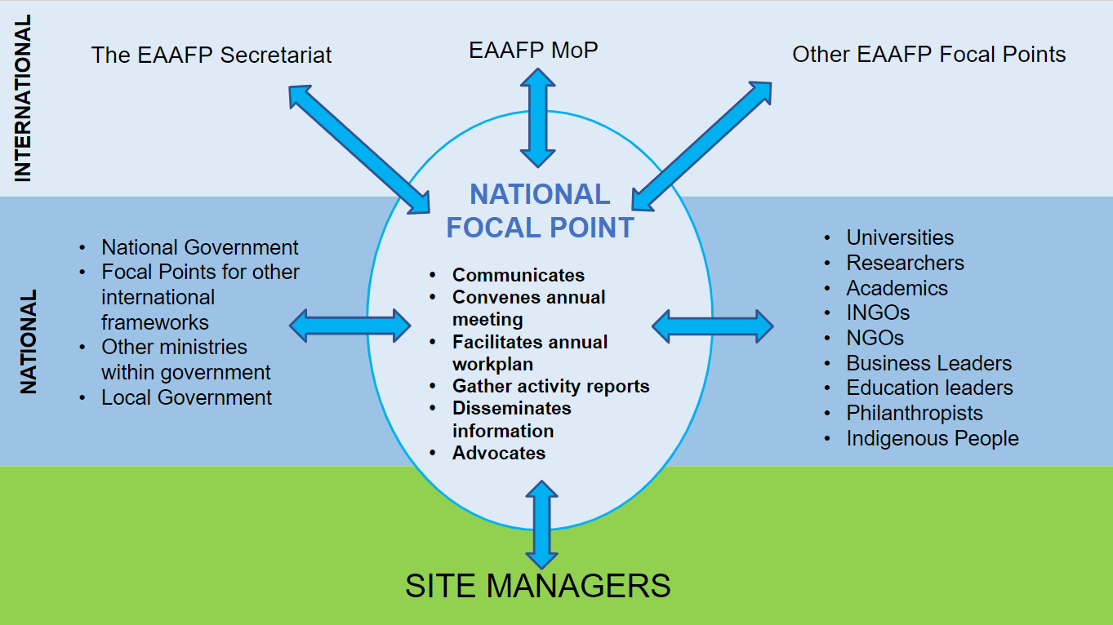

## 3.7 ROLES WITHIN A NATIONAL PARTNERSHIP

### 3.7.1 ROLE OF THE GOVERNMENT PARTNER / NATIONAL FOCAL POINT

The National Focal Point has a key role for the EAAFP. They are the EAAFP Government representative in the country; the government link between the Meeting of Partners, the EAAFP Secretariat, the in-country and Flyway Partners. As a member of staff of the National Administrative Authority appointed to coordinate national implementation they act as the “daily” contact point for people within the country and the EAAFP Secretariat.

Building and maintaining positive relationships, convening, and communicating are central to their success. They liaise regularly with the EAAFP Secretariat, coordinate the compilation of National Reports, status of EAAFP Sites and other wetlands, facilitate National Partnership meetings and liaise with their National Focal Points of other international agreements.

However, their role as National Focal Point for the EAAFP is likely to be only one responsibility among a number of, or even many, responsibilities and so are anticipated to only dedicate a small amount of their time to the EAAFP role. Depending on the structure of the country and its administration National Focal Points may work at varying levels of seniority from country to country and this may influence how they implement their role. Nonetheless, the effectiveness of the National Partnership sits very much on the shoulders of National Focal Point and their ability to carry out their role.

National Focal Points may delegate some of the in-country activities to experienced and well regarded INGOs already working for the conservation of migratory waterbirds and their habitats in their country.

ACTIVITIES MAY INCLUDE

* Coordinating and responding to the EAAFP Secretariat enquiries.
* Disseminate information to the national network. This may include a list of Site Managers and NGOs.
* Call annual meetings of national partners, publish agenda and record actions. This may be delegated to an NGO.
* Collaborate with partners in the National Partnership to receive information for reporting to the biennial MOP and where relevant on government conservation activities.
* Identify other reporting processes under other instruments or treaties, which require similar data, information and reports in order to collaborate. These might include the Convention on Migratory Species, Ramsar National Committee. Ramsar is important because some of the EAAFP Flyway Network Sites are also Ramsar Sites.
* Engagement with Indigenous people.
* Conduct Site Manager workshops.
* Work with Site Managers, INGOs to encourage the Education Department / Ministry to include the concept of migratory waterbirds and conservation of their habitats in the school curriculum.
* National Focal Points, Site Managers, Visitor Centre Managers send materials (Brochure, e-Newsletter, etc.) to local academic institutions and encourage lecturers and students to conduct monitoring and research on migratory waterbirds and habitats and share this information with the EAAFP Secretariat, Government contacts, Site Manager and Visitor Centre Manager.
* Work with the Asian Waterbird Census National Coordinator[3] to strengthen regular monitoring of waterbirds and wetlands at EAAFP Flyway Network Sites and potential sites (the National Coordinator may be the national agency (currently in Japan, Philippines, South Korea and Thailand), a BirdLife International national partner (currently in Australia, Thailand and Singapore) or Wetlands International offices (Indonesia and Philippines) or Wildlife Conservation Society (in Cambodia).
* With INGOs, WLI, Site Managers and Visitor Centre Managers help identify the extended audience of the publications and supply the necessary contacts to the EAAFP Secretariat.
* Provide access to seed funds as an incentive to develop new Sister Site agreements.

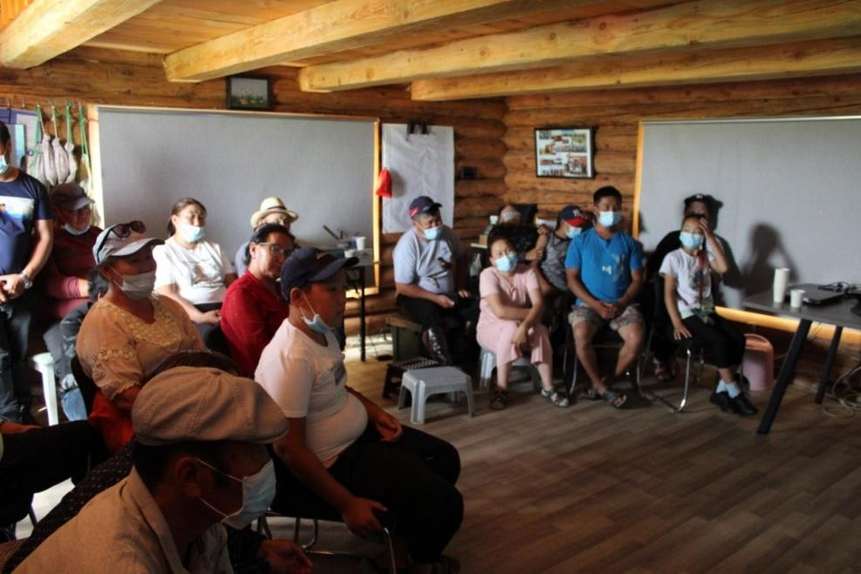

©Chukh Bird Research Station, Mongolia

### 3.7.2 ROLE OF NGO PARTNERS IN THE NATIONAL PARTNERSHIP

* If delegated, an NGO will take on the organisation and communication of the National Partnership.
* Supports the operation of the National Partnership.
* Attend annual planning meetings, and other ad-hoc online meetings.
* Contribute to the development of the National Workplan.
* Attend / conduct annual training for Site Managers.
* Feedback to National Partnership work for migratory waterbirds and their habitats, and with indigenous people.
* Work with the Asian Waterbird Census National Coordinator to strengthen regular monitoring of waterbirds and wetlands at EAAFP Flyway Network Sites and potential sites (the National Coordinator may be the national agency (currently in Japan, Philippines, South Korea and Thailand), a BirdLife International national partner (currently in Australia, Thailand and Singapore) or Wetlands International offices (Indonesia and Philippines) or Wildlife Conservation Society (in Cambodia).
* Communicate with National Focal Point and the EAAFP Secretariat.

### 3.7.3 ROLE OF THE SITE MANAGER IN THE NATIONAL PARTNERSHIP

* Contribute to the annual meeting and develop a National Workplan.
* Share the National Workplan with the local community.
* Feedback on Flyway Network Site progress towards the National Workplan to the National Partnership.
* Report to the National Partnership on their local workplans – these may include support needed for new Flyway Network Sites, new relationships with other Sites and Sister Site Programmes, or may include sharing successful local activities, monitoring and research results, engagement with local government, arts and culture, indigenous people that other Site Managers can learn from and use.
* Include the voice of indigenous people at the local level.
* Attend national training for Site Managers.
* Work with National Focal Point, INGOs to encourage the Education Department / Ministry to include the concept of migratory waterbirds and conservation of their habitats in the school curriculum.

### 3.7.4 ROLE OF NATIONAL EXPERTS / SCIENTISTS IN THE NATIONAL PARTNERSHIP

* Provide scientific and research advice on projects.
* Contribute to the National Workplan.
* Share their knowledge and expertise within the National Partnership.

### 3.7.5 ROLE OF THE EAAFP COMMITTEES, WORKING GROUPS & TASK FORCES IN THE NATIONAL PARTNERSHIP

The Flyway has a range of support committees, working groups and task forces. They provide advice to the Meeting of Partners and the EAAFP Secretariat:

* The [Finance Sub-Committee](https://www.eaaflyway.net/finance-sub-committee/) provides advice on the sustainable financing and fundraising.
* The [Technical Sub-Committee](https://www.eaaflyway.net/technical-sub-committee/) provides scientific and technical advice.
* There are 7 working groups working to implement action plans:
  1. Anatidae Working Group.
  2. Avian Influenza Working Group.
  3. Black-faced Spoonbill Working Group.
  4. CEPA Working Group e.g., work with National Focal Point to identify media (including social media) groups and opportunities and provide relevant materials and support as necessary.
  5. Crane Working Group.
  6. Seabird Working Group.
  7. Shorebird Working Group.
* Task forces are established to address issues raised during the Meetings of Partners and coordinate activities across the Flyway. These include:
  1. Species focus e.g., Spoon-billed Sandpiper, Baer’s Pochard.
  2. Regional focus e.g., Yellow Sea.
  3. Issue focus e.g., Illegal hunting, taking and trade.
  4. Monitoring and research focus.

### 3.7.6 ROLE OF THE EAAFP SECRETARIAT SUPPORTING THE NATIONAL PARTNERSHIP

* The EAAFP Secretariat has no active role in the National Partnership however, it is available for assistance and advice in developing a National Partnership if requested by the National Focal Point. The Secretariat is available to make connections with committees, working groups and task forces.
* Encourages the National Partnership to develop a National Workplan and welcomes that plan being shared with the EAAFP Secretariat.
* The EAAFP Secretariat looks to identify synergies between National Workplans. Where a National Partnership is proposing to do something where they know another National Partnership is doing or has done something similar before, the EAAFP Secretariat can then link these countries to share their experience as they both take on a common activity within their country e.g., monitoring, tracking, research of species, invasive species and CEPA projects.
* Manages the biennial reporting to MOP and receives and compiles the reports from each government partner (and other partners). The National Partnership has a key role in providing the information included in that report.
* Provides information, materials, and training to National Focal Points to support implementation of the National Workplan, CEPA etc.

1. Wilson, Marion - "The New Frontier in Sustainable Development: World Summit on Sustainable Development Type II Partnerships" [2005] VUWLawRw 16; (2005) 36 Victoria University of Wellington Law Review 389
2. EAAFP Website
3. Contact details for AWC national and regional coordinators https://www.wetlands.org/our-network/iwc-coordinators/