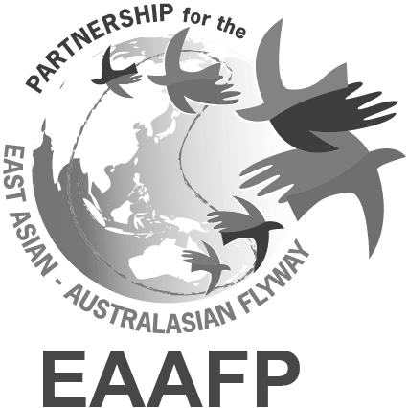

EAAFP Management Committee Meeting Final Agenda
April 2021

Date: 15:00 – 17:00, 1 April 2021 (Seoul Time)

Link: https://global.gotomeeting.com/join/182174709

Anticipated Participants
- Committee Members: Robb Kaler (Chair), Pete Probasco (Former Chair), Choon Beng How on behalf of Shufen Yang (Vice Chair), Martin Spray (FsC Chair), Nick Davidson (TsC Chair), Ward Hagemeijer (WI), Swaros.and Parinya on behalf of Sukanya Wisan (Thailand), Seulki Lee on behalf of Jang Sung Hyun (Republic of Korea), Tilman Schneider (CMS)
- EAAFP Secretariat: Doug Watkins (CE), Hyeseon Do (PO), Yoon Lee (ER), Vivian Fu (CO)

Agenda

1. Introduction of the new USA representative for the Chair of the Partnership

2. Report on the activities of the Secretariat since the last Management Committee Meeting

A short verbal report on the key activities of the Secretariat between December 2020 and mid March.

3. Report of the Finance Sub-Committee (paper attached)

The Finance Sub-Committee meet on the 24 February 2010. The following FsC members participated: Martin Spray (Chair), Alison Russell-French, Tomoko Ichikawa, Ward Hagemeijer, and Mernard Putugan. The agenda covered:
- Funding of the EAAFP Science Unit
- Secretariat Work Plan 2021-2022
- Improvement of EAAFP Voluntary Contribution Scheme
- Updating the Resourcing Plan
- Update on the EAAFP Foundation.

Discussion is anticipated on each of the five items addressed by the FsC, including the request to endorse the Secretariat Work Plan 2021-2022.

4. Report of the Technical Sub-Committee (TsC)

The TsC has not met since the last Management Committee Meeting.

In March, the TsC has been busy assessing applications for the EAAFP Taskforce and Working Group small Grant Fund. The Secretariat thanks the TsC Chair for providing timely recommendations on projects to be funded.

5. Update on new/updated MoU’s involving the EAAFP Secretariat and EAAFP Foundation (paper attached)

Recently, the EAAFP Secretariat has been involved in discussions on renewing the MoU with Hwaseong City (to continue work on the FSN) and developing a new MoU with KOEN and also linking with Incheon City Government in a new three-party MoU.

The EAAFP Secretariat has also been discussing with the Ramsar Regional Center East Asia (based in Suncheon, RoK) to strengthen collaboration on capacity building for managers of important sites for migratory waterbirds in East Asia.

The EAAFP Foundation has signed an MoU with the Yeonsu Foundation for Arts and Culture to collaborate on CEPA activities on wetlands and migratory waterbirds in Incheon.

Copies of the MoU are attached.

6. Update of on the proposed ADB Regional Flyway Initiative (draft flyer attached)

Draft flyer from Asian Development Bank is attached.

7. Updated Guidelines for Ramsar Regional Initiatives (paper attached)

The Ramsar Secretariat has recently had a consultant prepare an update of the “Guidelines for Regional Initiatives” (attached). The primary issue for the EAAFP is the level of annual reporting recommend. Most Regional Initiatives are “regional training centers”. The EAAFP is very different in that we are a Partnership and annual reporting on the contribution that we are making to the implementation of the Ramsar Strategic Plan would require all Partners to prepare an annual report!

8. Update on Flyway Network Sites

- Nominations
- Sarobetsu Wetland, Japan
- Planned – nomination of Ulsan Wetlands, RoK
- Planned - nomination of Rason Wetlands, DPRK

- Management Issue
Several FNS are currently under “potential” threat (Australia, Philippines, Mongolia, RoKorea).
The Secretariat welcomes additional guidance from the Management Committee in relation to how to respond in relation to these issues. Our current practice is to limit our response to requesting information from the National Government Partner.

9. Any Other Business

