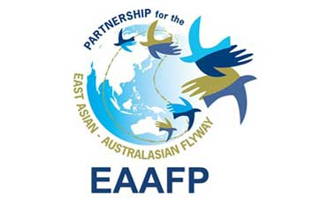
GUIDELINES
SISTER SITE PROGRAMMES
&
OTHER RELATIONSHIPS BETWEEN FLYWAY NETWORK SITES

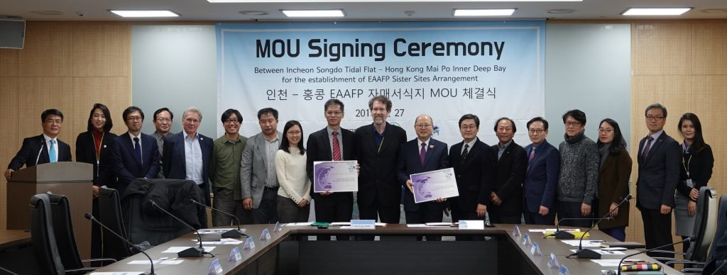

Sister Site Programmes
2022

Acknowledgements: Many people from across the Flyway have given their time in webinars, individual meetings, interviews written material and photographs. Without their input it would not have been possible to gather the information and data, and more importantly to gain their expertise and personal insights into the workings of the EAAFP. As we have worked with all these passionate people – some we never met but simply received emails or read their stories – we have become full of admiration for the work and commitment of so many citizens of so many countries to migratory waterbirds and their habitats. This body of work is a tribute to their stories, efforts and experiences and it has been a privilege to collect it all together for the benefit of all and especially the birds themselves that journey across all our lands of the Flyway never belonging to one and relying on all.
Jennifer George, Consultant 2022

Cover photo:
Group photo of the Sister Site Agreement between Incheon Songdo Tidal Flat – Hong Kong Mai Po Inner Deep Bay MoU Signing Ceremony (2019_11_27) ©EAAFP

Contents
SECTION 1: INTRODUCTION 4
1.1 PURPOSE OF THE GUIDELINES 4
1.2 BACKGROUND TO THE EAST-ASIAN AUSTRALASIAN FLYWAY PARTNERSHIP 4
1.3 THE EAAF PARTNERSHIP OBJECTIVES 5
1.4 RELATIONSHIPS WITHIN THE EAAFP 6
SECTION 2: UNDERSTANDING THE SISTER SITE PROGRAMME 7
2.1 DIAGRAM OF THE SISTER SITE RELATIONSHIPS 7
2.2 EXISTING SISTER SITE PROGRAMMES IN THE EAAFP 8
2.3 DEFINITION OF A SISTER SITE PROGRAMME 9
2.4 PRINCIPLES OF A SISTER SITE PROGRAMME 9
2.5 IMPACTS AND BENEFITS OF A SISTER SITE PROGRAMME 10
2.6 GOOD PRACTICE - A CASE STUDY OF THE SISTER SITE PROGRAMME 11
SECTION 3: ESTABLISHING A SISTER SITE PROGRAMME 12
3.1 WHAT TO CONSIDER BEFORE ESTABLISHING A SISTER SITE PROGRAMME 12
3.1.1 LINKING TWO CITIES – A CASE STUDY 13
4. SECTION FOUR: CASE STUDIES 14
4.1 STUDY OF AN EXISTING SISTER SITE PROGRAMME: YATSU HIGATA TIDAL FLATS AND BOONDALL WETLANDS 14
4.2 CASE STUDY OF 3-5 YEAR PLAN FOR A SISTER SITE PROGRAMME 14
4.3 CASE STUDY: SUCCESSFUL OUTCOME OF A SISTER SITE PLAN 16
SECTION 5: GUIDELINES TO DEVELOP RELATIONSHIPS WITH OTHER FLYWAY NETWORK SITES 17
5.1 INTRODUCTION 17
5.2 INFORMAL RELATIONSHIPS 17
5.3 SPECIAL PURPOSE EXCHANGES 18
5.4 SPECIES SPECIFIC NETWORKS LINKING TWO OR MORE SITES 18
5.5 RELATIONSHIPS BASED ON MONITORING 18
5.6 BUILDING ON EXISTING INFORMAL REGIONAL NETWORKS 19
5.7 VIRTUAL RELATIONSHIPS 20
5.8 RELATIONSHIPS WITH WETLANDS THAT ARE NOT EAAFP SITES 20
5.9 RELATIONSHIPS BETWEEN FLYWAY NETWORK SITES AND SPECIFIC PARTNERS 21
5.10 INDIGENOUS EXCHANGE 21
5.11 FORMAL AND INFORMAL RELATIONSHIPS THAT SUIT LOCAL CIRCUMSTANCES 22
APPENDICES 23
APPENDIX 1: A GOOD PRACTICE CASE STUDY OF SISTER SITE PROGRAMME / WETLAND COOPERATION AGREEMENT 23
APPENDIX 2: TEMPLATE - MEMORANDUM OF UNDERSTANDING 27

ACRONYMS AND DEFINITIONS
CEPA | Communication, Education, Participation & Awareness
EAAFP | East Asian-Australasian Flyway Partnership
FNS | Flyway Network Site
INGO | International Non-Government Organisation
NGO  MOU | Non-Government Organisation  Memorandum of Understanding

SECTION 1: INTRODUCTION
People, their decisions and actions lie at the heart of effective wetland and migratory waterbird conservation. Local communities, Site Managers, local and national government decision-makers, educators, NGOs, and the civil society all have a role to play in conserving migratory birds and their wetland habitats.

1.1 PURPOSE OF THE GUIDELINES

This document aims to guide the development and strengthen the relationships between Flyway Network Sites for the conservation of migratory waterbirds and their habitats and the implementation of the EAAFP Strategic Plan. It recognises the importance of relationships between Flyway Network Sites and that each country’s arrangement will reflect their own existing structures and needs.

Relationships and Partnerships are the mechanisms that support and mobilise people across a country and internationally to enhance the conservation of migratory waterbirds and their habitats. Some are informal arrangements or based on agreements to cooperate on particular projects. Others are formally agreed with a Memorandum of Understanding (MoU) and may be called a Sister Site Programme or a Wetland Cooperation Agreement or another name decided on by the Partners. This document will use the term Sister Site Programme.
Throughout this document, case studies demonstrate the guidelines. They are not intended to be “how to” prescriptions, but to provide inspiration to enhance collaboration at the Site level to benefit migratory waterbirds and their habitats.

Part One discusses what a Sister Site Programme is, how it operates, and the benefits it brings. It provides possible first steps in identifying how it will work for your Site and how to identify potential Flyway Network Sites to explore entering into a Sister Site Programme.

Part Two sets out the matters to consider when entering into a Sister Site Programme. A Sister Site Programme is formalised in a Memorandum of Understanding (MoU) between the Sites. The MoU provides status and international recognition and sets out the aspirations of the two Partners and their collaborative plans. Several Sister Site MoU templates are provided in Appendix 1.

Part Three recognises that a formal Sister Site Programme does not always fit the needs, aspirations or capacity of a particular Site. Across the Flyway there have been many other formal and informal Partnerships between Sites driven by personal relationships and identifying particular needs around species, training or habitat. These are discussed in Part Three, as good practice applies to all Partnerships entered into to achieve goals, build personal relationships and sustain enthusiasm and motivation.

1.2 BACKGROUND TO THE EAST-ASIAN AUSTRALASIAN FLYWAY PARTNERSHIP

The East Asian-Australasian Flyway Partnership (EAAFP) provides a Flyway framework across 22 countries from USA (Alaska) and Russia in the north, to Australia and New Zealand in the south, and transverses the breadth of Asia from Bangladesh to eastern China and Japan. Its purpose is to promote dialogue, cooperation and collaboration between a range of stakeholders to conserve migratory waterbirds and their habitats. The approach was endorsed internationally as a “Type II Partnership” as defined by the Johannesburg 2002 World Summit on Sustainable Development (WSSD). This type of Partnership is distinct from the ‘traditional’ Type I agreements which are regarded as legally binding intergovernmental commitments designed to aid states in the implementation of sustainable development goals. The then President of the World Resources Institute, Jonathan Lash, described the alternative Type II approach in more colourful terms as “The beginnings of a shift from the stiff formal waltz of traditional diplomacy to the jazzier dance of improvisational solution-oriented Partnerships that may include non-government organisations, willing governments and other stakeholders”.

In 2005 the EAAFP was recognized as a Ramsar Regional Initiative and then in 2006 the EAAFP was formed as a Type II Partnership “characterized by collaborations between national or sub-national governments, private sector and civil society actors, to form voluntary transnational agreements in order to meet specific sustainable development goals.”

It is important to recognise is that this type of approach does not require binding commitments from governments, and so there are not national government policy imperatives for specific funding to fulfil specific commitments.

1.3 THE EAAF PARTNERSHIP OBJECTIVES

1. Develop the Flyway Network of Sites of international importance for migratory waterbirds.
2. Enhance communication, education, and public awareness of the values of migratory waterbirds and their habitats.
3. Enhance flyway research and monitoring activities, build knowledge, and promote exchange of information on waterbirds and their habitats.
4. Build the habitat and waterbird management capacity of natural resource managers, decision makers and local stakeholders.
5. Develop flyway wide approaches to enhance the conservation status of migratory waterbirds.
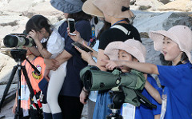

CEPA Working Group ©EAAFP

1.4 RELATIONSHIPS WITHIN THE EAAFP

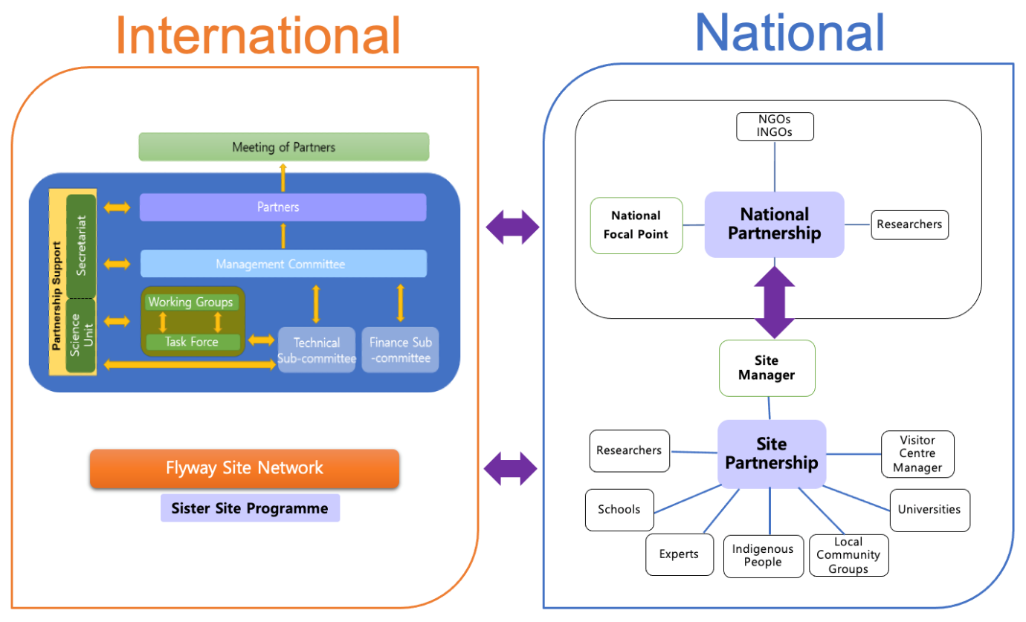
Site partnerships are a local network of stakeholders involved in the conservation of migratory waterbirds – “the engine room of migratory waterbird conservation”

SECTION 2: UNDERSTANDING THE SISTER SITE PROGRAMME

The success of the EAAFP relies very much more on the strength of relationships generated at all levels within the Partnership. Feedback from surveys, in this project, reflected the level of warmth held by those involved in relationships between Sites. Each Site in its own way, responding to its human and natural environment, contributes to the collective achievement of the Strategic Objectives of the EAAFP.

For migratory waterbirds, the Flyway is a journey across habitats, from breeding grounds to feeding grounds and back. Each National Partnership across the Flyway is a man-made mechanism reflecting its own country. The actual cross-border relationships occur at a citizen level by connecting participation at Flyway Network Sites, so people participate in supporting the journey of the migratory waterbirds. Relationships between Flyway Setwork Sites enhance and fulfil the EAAFP Objectives.

2.1 DIAGRAM OF THE SISTER SITE RELATIONSHIPS
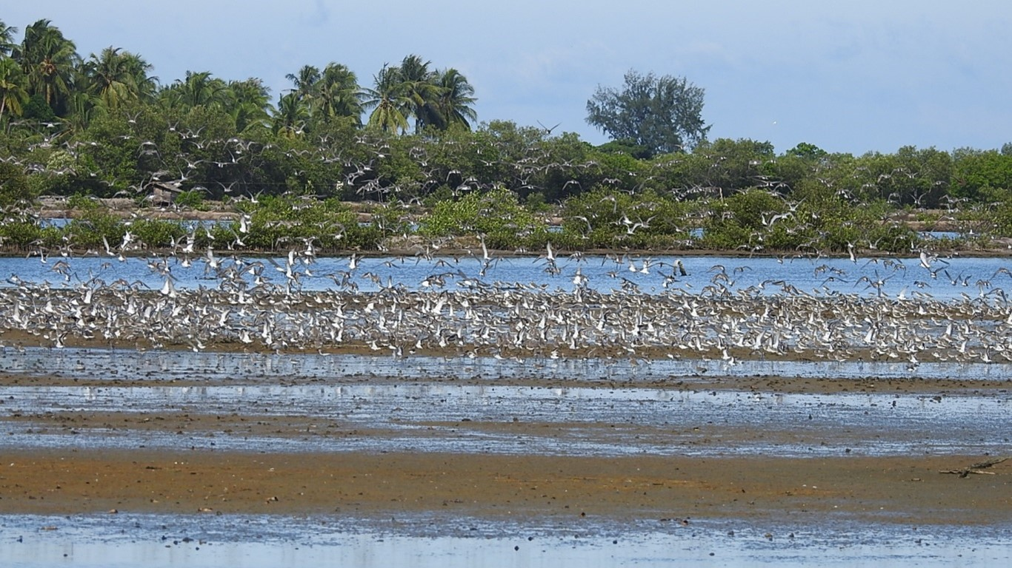

COUNTRY TWO
NATIONAL PARTNERSHIP
COUNTRY ONE
NATIONAL PARTNERSHIP
SISTER SITE PROGRAMME
RELATIONSHIPS ACROSS BORDERS

FNS
PARTNER
SITE
FNS
PARTNER
SITE
Other FNSs in-country
Other FNSs in-country

MOU • Activity Plan • Sharing of research and information • Monitoring of shared species • Exchanges • Volunteers • Civic dignitaries and staff • Students and schools • Academics • Training for staff • Citizens • CEPA • Joint research • Personal Relationships• Indigenous Exchanges

Other Site-to-Site relationships are formed formally or informally to achieve collaborative goals and activities.
A Sister Site Programme formalises and recognises a direct relationship between the FNSs of two National Partners through an MOU and Activity Plan.

2.2 EXISTING SISTER SITE PROGRAMMES IN THE EAAFP

 | Country | Site Name | Country | Site name
 | Management authority |  | Management authority
1 | China | Yalujiang National Nature Reserve | New Zealand | Firth of Thames
 | Dandong City |  | Pukorokoro Miranda Naturalist Trust
2 | Republic of Korea | Junam Reservoir | Japan | Kejo-numa
 | Changwon City |  | Osaki City, Miyagi Prefecture
3 | China | Zhalong National Nature Reserve | Republic of Korea | Janghang Wetland Protected area
 | Qiqihar City |  | Goyang City
4 | Australia | Moreton Bay, Boondall wetlands | Japan | Yatsu-higata
 | Brisbane City |  | Narashino City Chiba prefecture
5 | Australia | Hunter River Estuary Wetlands | Japan | Kushiro Wetland
 | Newcastle City |  | Kushiro City, Hokkaido
6 | Republic of Korea | Suncheon Bay | Japan | Arasaki
 | Suncheon City |  | Izumi City, Kagoshima Prefecture
7 | Japan | Fujimae Tidal Flat | Australia | Swan Bay Tidal Flats
 | Nagoya City |  | Greater Geelong City, Victoria
8 | Republic of Korea | Yubudo Tidal Flat | Singapore | Sungei Buloh Wetland Reserve
 | Seocheon County |  | National Parks Board of Singapore
9 | China | Chongming Dongtan National Nature Reserve | Singapore | Sungei Buloh Wetland Reserve
 | Shanghai City |  | National Parks Board of Singapore
10 | Korea | Incheon Songdo Tidal Flat | China | Mai Po Inner Deep Bay
 | Incheon Metropolitan City |  | Hong Kong Special Administrative Region

2.3 DEFINITION OF A SISTER SITE PROGRAMME

The heart of the Flyway Partnership is the network of Flyway Sites and the relationships between them.
The fundamental concept of the Flyway Initiative is that we have shared biodiversity. When we realise that if people at Flyway Network Sites foster relationships with other parts of the Flyway, they become part of the Flyway story, which builds the whole energy of what the Partnership is trying to achieve.
No one country can conserve migratory waterbirds alone which is why international cooperation is crucial. Building relationships with other Flyway Network Sites that share the journey of migratory waterbirds on the Flyway is the foundation of the EAAF Partnership.

A Sister Site Programme is one mechanism to enable this cooperation. It links up two or more Flyway Network Sites who share the same species in a formal agreement to collaborate on activities that advance the conservation of migratory waterbirds on the EAAF. Five main areas of collaboration:
- Joint monitoring.
- Joint research.
- Capacity building of Site Managers.
- CEPA.
- Promoting the international link to local communities.
A EAAFP leaflet on Sister Sites can be read at: https://www.eaaflyway.net/2021-eaafp-flyway-site-network-leaflet/
Sister Site Programmes are the most formal of relationships between Sites. There are a range of less formal arrangements across the Flyway that are effective for the conservation of migratory waterbirds on the Flyway.

2.4 PRINCIPLES OF A SISTER SITE PROGRAMME

- Clarity about the purpose of connecting with another Site informs what kind of arrangement will best serve the needs of each Site and the people involved.
- Build on shared values, goals and challenges.
- Personal relationships and exchanges where both parties actively participate are fundamental to keeping the relationships between Sites alive.
- Effort and commitment through regular working-level, operational contact between Sites and through regular contact and communication.
- Physical exchanges build enduring relationships – monitoring and research, cultural and art and capacity building exchanges.
- It takes time. Sister Site relationships thrive on continuity of contact and building trust between Sites.
- Both parties actively participate in the agreed activities.
- Regular review between 1 and 3 years of the status of the Sister Site Programme creates new direction for the Partnership.

2.5 IMPACTS AND BENEFITS OF A SISTER SITE PROGRAMME

Why have a Sister Site Programme? What difference does a Sister Site Programme make to the work of conserving migratory waterbirds, their habitats and those whose livelihoods depend on them?
There are many benefits to both Sites for migratory waterbirds and their habitats as well as the wider community. Linking Sites allow each to learn from the other, collaborate on management, monitoring and research, and develop community connections through CEPA. An international cooperation agreement:
- Raises the profile of the Flyway Network Sites, the migratory waterbirds and the connectivity of the Flyway:
  - in the community, resulting in greater interest from local citizens, local schools and commercial interests,
  - with local government, who may increase consideration for species and habitats in their decision making and assist with local funding for CEPA material and exchanges,
  - with national government, as a contribution to international reporting obligations,
  - with international recognition and opens opportunities for joint research, monitoring, eco-tourism and cultural exchanges.
- Allows people at FNSs to learn from each other, collaborate on monitoring and research, and develop community connections through CEPA.
- Builds deeper relationships across the Flyway.
- Increases Site management capability at both Sites through sharing knowledge, technical expertise and monitoring techniques.
- Exchanges of staff raise understanding of good practices to bring home and raises motivation.
- Learn new techniques for outreach and education.
- Exchange of technical expertise and support for monitoring.
- Learn about another culture on the Flyway through associated cultural exchanges.
- Increases the interest in citizen science and volunteering.
- Enthuses the younger generation through educational exchanges.
- Shares count data at two or more Sites of shared species across their migration.
- Share knowledge nationally with other Sites through the National Partnership mechanism.
- Greater inclination from local government as a Sister Site Programme is based on a non-binding MOU.

“In the last eight years Chinese and international experts have worked together, conducting shorebird surveys and other monitoring work at the Yalu Jiang Estuary during the migratory season. Such cooperation has not only enabled the collection of extensive amounts of bird migration data but also the exchange of experiences. Subsequently, the management standard of the reserve has increased, the management methods and strategies have improved, scientific research techniques have been strengthened, advocacy and education have been significantly effective and regional and international exchanges were expanded… These results highlight the importance of international cooperation.”
Chen Kelin, (the then) Director of Wetland International – China

2.6 GOOD PRACTICE - A CASE STUDY OF THE SISTER SITE PROGRAMME

The full case study jointly agreed by each Sister Site Partner / Wetland Cooperation Partner is at Appendix 1.
WETLAND COOPERATION AGREEMENT BETWEEN YATSU TIDAL FLATS, JAPAN & BOONDALL WETLANDS, AUSTRALIA

This Sister Site Programme is known as a Wetland Cooperation Agreement. It is a relationship built on a long-term commitment from both Sites to a Partnership that benefits the migratory waterbirds, their habitats and the wellbeing of the people involved.

The relationship was established between the two local authorities, and many aspects are shared between the Sites: both are Ramsar Sites, both are in a bay near major cities, both have a nature or observation centre.

The agreement objective remains the conservation of wetlands and shorebirds and includes research and information exchange, support for training exchanges of staff, support for school exchanges, awareness raising and support for citizen exchanges. Every 5 years the action plans are reviewed.

The main activities are sharing information and making materials, people-to-people exchanges, joint research and school exchanges.

KEYS TO SUCCESS

- Official arrangement and collateral.
  - Agreement between the two local governments.
  - EAAFP, Ramsar Convention, etc.
- Similar nature environment and common migratory waterbirds.
- Presence of physical centers at the Sites.
  - As the hubs of activities.
  - Professional staff on hand.
- Diverse stakeholders involved in wetland exchange.
  - Government, environmental NGOs, citizen volunteers, school staff, etc.
- Ongoing publicity, report meetings and exchanges, exhibitions at events, publicity through newsletters, media and the internet.
- People continuously involved in the wetland exchange and their connection.
  - People on both sides have been actively involved in the wetland exchange for a long time.
  - Personal connections and feelings have been valued, and friendships have been built.

CHALLENGES AND OPPORTUNITIES

This has been a positive relationship and the Partners looking at possible options for future plans. They are still interested in opportunities to grow in these areas:
- Expanding and strengthening of activities.
  - How to link the Sister Site activities to conservation of wetlands and migratory birds?
- Involving a diverse range of stakeholders.
  - Universities, research institutes, other departments of the local government, private entities, etc.
- Educational exchanges.
- Ageing of the participating citizens and involving younger generation in the organisation.
- Designated administrator.
- Language barriers.
SECTION 3: ESTABLISHING A SISTER SITE PROGRAMME

3.1 WHAT TO CONSIDER BEFORE ESTABLISHING A SISTER SITE PROGRAMME

First, consider the main reasons for developing a formal relationship, what the Site expects from the relationship, what each can offer the other Site.

Then consider your available resources to support the relationship - this may include Site Managers, NGOs and support INGOs may offer. Also consider support from various levels of government and industry.

The next challenge is finding a Site to partner with. This will be a Site that has similarities such as shared species or similar habitats or similar management challenges and who are keen to build relationships and have the potential for collaboration on projects.

Some options to start with:
- Access case studies from other Sites on the Flyway through the EAAFP website, the National Partnership and shared on social media. These provide insight what you might have in common and that could serve as a basis for a Sister Site relationship.
- At the biennial Meeting of Partners, the Secretariat, National Government Partners or Site Managers share their plans and aspirations, so others see the potential for a relationship and connect.
- National Focal Point approaches the Secretariat or other National Focal Points to recommend Sites and make introductions.
- When the Secretariat receives the annual National Workplans of each Partner, they may identify activities Partners have in common and then connect those who are seeking to build relationships internationally.
- Sharing projects within the ASEAN Flyway Network highlights commonalities and opportunities and through shared training programmes in local language.

Research helps evaluate the likely success of the Sister Site Programme and what support will be needed in terms of understanding the cultural and language differences. Consider the following:
- Identify the strengths of your Flyway Network Site, the common species, and issues and where the opportunities are for knowledge sharing and joint research. Consider how those align with your work plans - monitoring, research, CEPA outreach, capacity building.
- Identify Flyway Network Sites who might be a good match, particularly those with common species, and common type of habitats, or challenges.
- Identify the benefits for your Site and migratory waterbirds.
- Work with an INGO to assist with connections, organisation and planning.
- If there is an existing relationship with the other Site, consider whether it would benefit from strengthening into a Sister Site Programme.
- Identify Flyway Network Sites who have other environmental reporting obligations connected to their Sites as potential Partners e.g., Ramsar, Convention on Migratory Species, Bi-lateral agreements.
- Engage early on with key people in local authorities, in local businesses and philanthropists to inspire support as they can play an important role in the establishment of sister sites. They may be able to offer resources – funding, administrative expertise, connections, etc. Involve them in Partnership conferences, training, meetings and field visits.
- Seek EAAFP secretariat support to assist with identifying prospective Sister Site Partners, opportunities for joint projects, joint research and monitoring, joint activities for awareness-raising and long-term cooperation.
- Identify a key organisation to drive the engagement and development of the Sister Site Programme. This maybe an NGO or an INGO you have a relationship with.

3.1.1 LINKING TWO CITIES – A CASE STUDY
Case Study
Black-faced Spoonbill links two cities, Incheon, South Korea and Mai Po, Hong Kong
in a wide variety of activities
https://www.youtube.com/watch?v=ceydWSHFxYs
This video illustrates how a Sister Site Agreement enhances the collaboration between two Flyway Network Sites, Songdo Tidal Flat in Incheon, Republic of Korea, and Mai Po Inner Deep Bay in Hong Kong for the conservation of migratory waterbirds, specifically Black Faced Spoonbills. The Sister Site Programme has the support also of the EAAFP Black Faced Spoonbill Working Group.

The Black-faced Spoonbill breeds in Incheon, and Hong Kong is one of its wintering grounds, so the countries are connected by this iconic and endangered bird even though they are 2000 kilometres apart.

The Sister Site agreement facilitates experience sharing and information exchange through physical exchanges and scientific collaboration on tracking Black Faced Spoonbills as they travel between the Sites.

The collaboration also raises awareness in the public who can contribute to monitoring. They may be trained through a citizen science program to take part in the annual scientific survey Black Faced Spoonbill Winter Census, a 20-year long survey that has made a significant contribution to understanding the needs of these birds.

Local NGOs play an important role in both Sites conducting activities to raise awareness an educate citizens and communities about the Black Faced Spoonbills and other migratory waterbirds sharing the Sites and the importance of conserving them and their habitats. The Black Faced Spoonbill is the ‘poster bird’ of these projects.

Sponsors: Incheon Metropolitan City Support: Agriculture, Fisheries and Conservation Department (AFCD), Hong Kong SAR Government, WWF-Hong Kong, Hong Kong Bird Watching Society, Black-faced Spoonbill Working Group, Waterbird Network Korea, Black-faced Spoonbill and Friends Production: FHS Wildlife

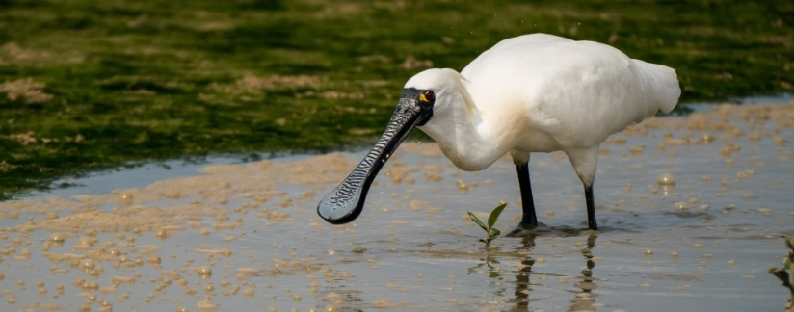
Black-Faced Spoonbill
©EAAFP

4. SECTION FOUR: CASE STUDIES

4.1 STUDY OF AN EXISTING SISTER SITE PROGRAMME: YATSU HIGATA TIDAL FLATS AND BOONDALL WETLANDS

INTRODUCTION
This Sister Site Programme is called a Wetland Cooperation Agreement. The Memorandum of Understanding on which the Agreement is based was entered into between the City of Narashino and the Brisbane City Council in 1998 and is still going strongly. Due to the COVID pandemic the latest exchange was held virtually, driven by the continuing warmth of relationships developed over 20 years of conserving the migratory waterbirds they share on the EAAF.

The Yatsu Higata Tidal Flats of Narashino, Japan and Moreton Bay, Brisbane, Australia (incorporating Boondall Wetlands) are important Sites for migratory waterbirds and both are also listed under the Ramsar Convention on wetlands of international importance. The Narashino Agreement:
- Embraces the idea of “thinking globally and acting locally.”
- Is a shared initiative for the conservation of migratory waterbirds and their habitats.
- Responds to increasing concern and awareness of both cities and their citizens regarding the conservation of wetlands.
To find out more: https://www.brisbane.qld.gov.au/clean-and-green/natural-environment-and-water/bushland-reserves/boondall-wetlands/narashino-agreement
The Yatsu Higata Site in Japan, and Boondall Flats Site in Australia, share many positive ideas.
In Australia the Brisbane City Council sponsored an online school Lesson: Wings of the World (https://www.brisbane.qld.gov.au/things-to-see-and-do/brisbane-better-together-our-digital-neighbourhood/brisbane-better-together-video-hub/school-lesson-wings-of-the-world-video-transcript). This video and transcript published by the Brisbane City Council, is just one example of how a Sister Site Programme can deepen young people’s understanding of the EAAFP Flyway. The Sister Site arrangement helps students in both Brisbane and Narashino to understand the importance of a Sister Site Programme for migratory waterbirds and their habitats across the Flyway.

4.2 CASE STUDY OF 3-5 YEAR PLAN FOR A SISTER SITE PROGRAMME

Yalu Jiang National Nature Reserve (FNS in China) & Pukorokoro Miranda (FNS in New Zealand)
This case study demonstrates a 3-5 year programme from 2006. It is a good example of how to go about setting goals. These two Sites achieved their goals and published a research document in both Mandarin and English. It also demonstrates how a Sister Site Programme can have a finite goal and purpose and then set about achieving it.
Objectives | Proposed activities
1 . To enhance awareness of shorebird and its habitat conservation. | - Establish the sister school Partnership between schools in Yalu Jiang and Firth of Thames regions through the implementation of a series of environmental education activities.  - Use a range of different media and production of publications to enhance community awareness on wetlands and shorebird monitoring.  - Development of a volunteers’ group/network for Yalu Jiang to assist in conservation and management of wetland and shorebird with Yalu Jiang NNR.
2. To exchange information on the conservation status of migratory shorebirds, especially Bar-tailed Godwits (a key shared species). | - Designing and production of a bilingual Chinese-English website for Yalu Jiang National Nature Reserve (Yalu Jiang NNR) in the cooperation with Miranda Naturalists’ Trust;  - Establishment of an electronic network, including the use of existing publications, newsletters, email and websites between both parties;  - Produce annual report with shorebird information by both sides as timely feedback to the participants and other interested audience, and recommend the outputs to other shorebird Sites of the EAAF. Hold working meetings (twice for five years) in Yalu Jiang NNR or Miranda;
3. Training and building capacity. | - Conduct a series of staff exchange programs between YJNNR and Miranda.  - Jointly organise training courses on wader identification, surveys and banding for both Sites.
4. To develop and implement mutually agreed shorebird conservation projects. | - Jointly conduct comprehensive mapping and assessment of shorebird habitat to identify the distribution and threats to important shorebird areas in both Sites.  - Implement a long term monitoring program for Bar-tailed Godwits to gather data on the species, its habitat and main threats at both Sites.  - Set up a wetlands/shorebird center for Yalu Jiang NNR drawing on the experience and results of Miranda Shorebird Center operated by Miranda Naturalists’ Trust.  - Develop and implement eco-tour programs for Yalu Jiang NNR in conjunction with Miranda Naturalists’ Trust.  - Prepare and finalise a draft Shorebird Management Strategy for the Firth of Thames and Yalu Jiang NNR.

This photo demonstrates connections raising the profile of a Sister Site. It highlights the multiple levels of how people work in Partnership within the goal of the EAAFP. It shows politicians, public servants and civil society all engaged in migratory waterbird conservation.

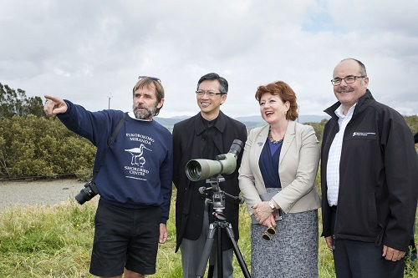

Miranda Wetlands, New Zealand ©EAAFP
From left to right: Mr Adrian Riegen, Vice Chair of Pukorokoro Miranda Naturalists Trust, Wang Lutong, Chinese Ambassador to New Zealand, Honourable Maggie Barry, New Zealand Minister of Conservation, Mr Lou Sanson, Director General of Conservation New Zealand.

4.3 CASE STUDY: SUCCESSFUL OUTCOME OF A SISTER SITE PLAN

Miranda and Yalu Jiang Sister Site Programme collaborate to publish important monitoring survey

Sister Site Programme
Miranda Shorebird Centre, New Zealand (NZ) and Yalu Jiang, Estuary Wetland Nature Reserve China
These two Sites formed a relationship in the late 1990’s and established a formal Sister Site Programme with the signing of a MOU in 2004. The Yalu Jiang Estuary is an important feeding ground for many shorebirds including the Bar-tailed Godwit that spends the southern hemisphere summer in New Zealand including Miranda. The two Sites have cooperated with exchanges and research projects involving monitoring. In 2011 they published the “Yalu Jiang Shorebird Survey Report” in both English and Mandarin to “draw the attention of decision makers to the importance of the Yalu Jiang Estuary Wetland National Nature Reserve so that they can make decisions based on good science” *
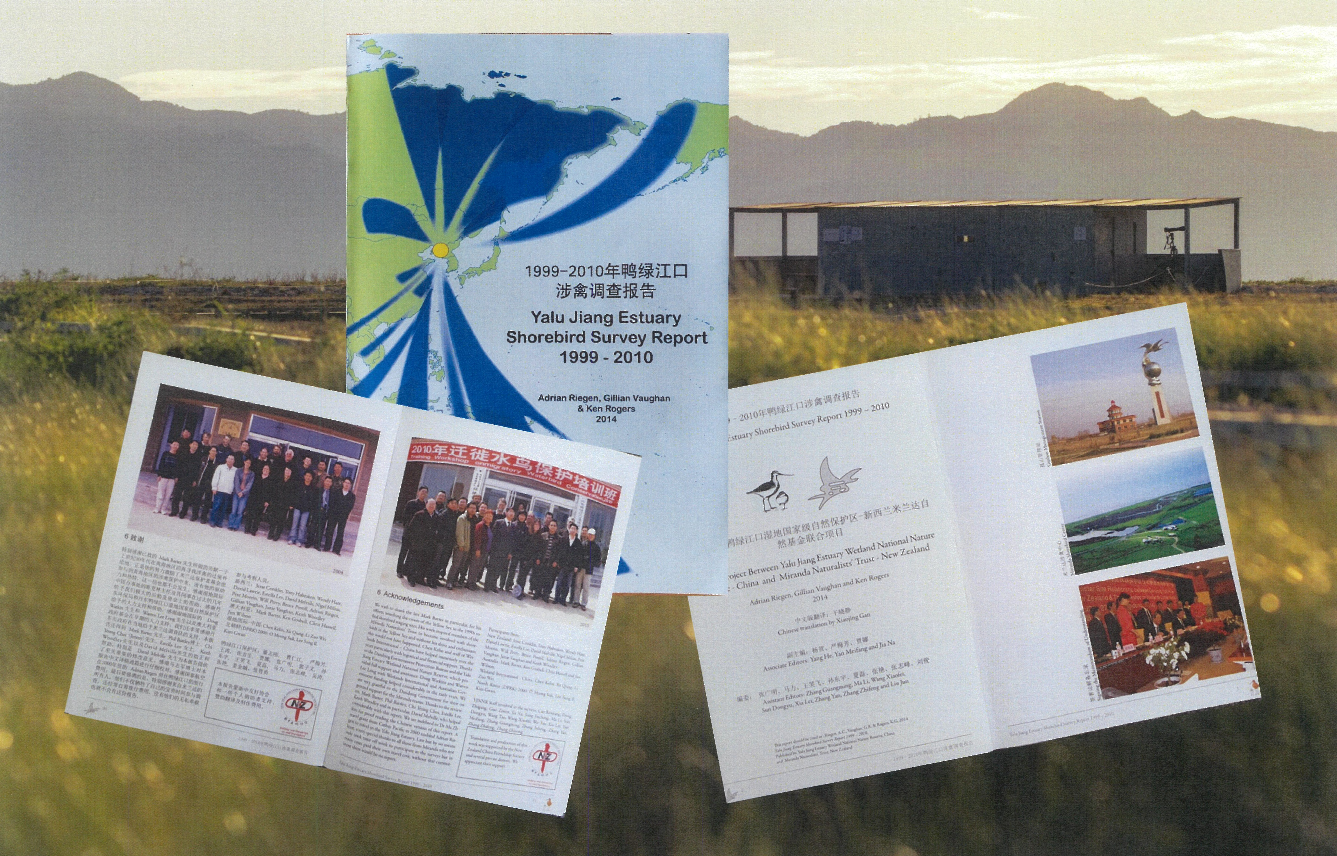

*Mark Barter; Foreword to Yalu Jiang Shorebird Survey Report, 2011

“I hope the publishing of this report will promote other wetland conservation activities in China and East Asia.” Chen Kelin, Director Wetland International – China

*Mark Barter; Foreword to Yalu Jiang Shorebird Survey Report, 2011

SECTION 5: GUIDELINES TO DEVELOP RELATIONSHIPS WITH OTHER FLYWAY NETWORK SITES

5.1 INTRODUCTION

There are other international relationships that exist across the Flyway. These may be one-off exchanges, ongoing informal exchanges with other Sites with the same species or grow into Sister Site Programmes. Regional Partnerships are also an important part of the relationships across the Flyway. They may follow the migration of a particular species such as the migration of Cranes or the Spoon-billed Sandpiper. The ASEAN Flyway Network is a formal regional network supporting the conservation of migratory waterbirds in Southeast Asia. Another example is Wetland Link International - Asia which provides opportunities to share with wetland center colleagues in other countries.
CASE STUDY
One country’s approach to building relationships with other Sites
“Singapore does not limit Partnership to only EAAF, predominantly we think that if it would help us improve our wetland management and conserve the birds it is good. There are different aspects of a good Partnership, and we try to work out the useful areas for collaboration.

For example, the very first Partnership was signed with Mai Po wetland in Hong Kong and one of the predominant aspects was education and outreach. We were very interested to work in those areas and at that time we had a strong corporate Partner, HSBC bank. The bank was a strong support and good platform for us to leverage. So, we wanted to learn from Hong Kong wetland how to achieve the outreach and what programs they have. That’s how we started school exchanges, and we learned how they run their programs reaching out to high school students. It helped us improve a range of outreach programs, and it was a fun benefit from that Partnership.

Based on past experiences of outreach programs to reach out to schools, we started our own program in Singapore reaching out to high school students. The school students were interested to find out what happened in other countries along the flyway. Hence even though we couldn’t physically go to Russia allowing the students to understand, that despite being far and having different habitats, it is still the same bird flying through the flyway and how it connects the people together was important. So, we had a very interesting project where the students could connect over the internet. We were keen to start this again, but it takes a fair amount of logistics and to find the right Partner at the right time. What we learned from this Partnership was good timing, and not to rush it because we want a good program.”

We have learned a lot from the way Hong Kong and Republic of Korea share outreach materials.”

5.2 INFORMAL RELATIONSHIPS

Informal relationships between two Sites with shared values, migratory waterbirds, and goals, also develop strong relationships and maintain regular communication, sharing lessons learned, challenges, and ideas for action. These linked Sites will have an agreement that sets out how they will work together and monitoring, research or capability projects they agree to collaborate on. Occasional in-person exchanges help to strengthen relationships and expand alliances and learning.
Case Study
Exchange helped identify potential collaboration
Singapore hosted Suncheon Wetland study trip. They discussed their Sites and the challenges and how they work to deal with the issues, and it helped to identify potential collaboration points for future exchanges. A very good exchange built strong relationships between Sites with without having a formal Partnership. This helps the understanding that we are not standalone Sites but belong to a larger Flyway.

5.3 SPECIAL PURPOSE EXCHANGES

A group from one Site may visit another Site to learn about techniques e.g., bird banding to improve skills and to generate inspiration for the work at their own Site. While there may be an immediate follow-up to share details of projects, long-term communication is not necessarily maintained, but the benefit was achieved through capacity building.
Case Study
Inviting an expert trainer to learn new skills
Singapore identified that it needed to improve technical capabilities for bird banding. They invited one of the famous bird banders from Shanghai who could whistle a particular bird so they could trap and band them. Through the visit they found they had many things in common. Following on from this successful visit, Singapore sent a team to Shanghai who learned a lot and built the working capacity for wetland management.

5.4 SPECIES SPECIFIC NETWORKS LINKING TWO OR MORE SITES

It is what happens at the Site that makes the difference for the conservation of migratory waterbirds. However, it is the birds themselves that capture the interest of people. For example, the Snow Leopard Network links anyone interested in Snow Leopards across a range in Central Asia to participate in discussions, monitoring, and cross border meetings.

This has potential for migratory waterbird species on the EAAF so all who are working with a species, on the ground and with the passion connect and get to know each other. With a National Partnership in place, this group could feed information to the government for reporting and sharing and a realisation “we didn’t realise this species was so threatened” whereas if it is just Site to the Site, it might not be so apparent.

A group may operate for those working on the ground for ducks and swans, a group for those working on the ground for mudflat Sites etc. While there are EAAFP Working Groups and Task Forces for species, there is also a need to connect people working on the ground connected to with these mechanisms.

5.5 RELATIONSHIPS BASED ON MONITORING

Monitoring of species and habitat is a fundamental activity carried out by Flyway Network Sites. It is a natural characteristic of the Flyway that migratory waterbirds move across vast distances, from one country to another and from one hemisphere to another. Monitoring migratory waterbirds at one Site has limited value without monitoring results from other Sites. Monitoring is an EAAFP strategic objective, and a core activity in National and Site Partnership work plans and Sister Site Memorandum of Understanding. Often following the migratory waterbirds while monitoring can be the first step of Flyway Network Sites connecting with each other and building relationships. Whether they lead to more formal relationships and Partnerships or simply share monitoring information informally depends on the individuals involved and the aspirations and needs of the Sites.

5.6 BUILDING ON EXISTING INFORMAL REGIONAL NETWORKS

Case Study
How a monitoring relationship grew between Miranda Shorebird Centre, New Zealand and Democratic People’s Republic of Korea (DPRK)
This relationship grew from the Miranda Shorebird Centre, New Zealand (NZ) Sister Site Programme with the Yalu Jiang Estuary Wetland Nature Reserve China. They observed in their visits to Yalu Jiang the importance of DPR Korea wetlands to migratory waterbirds although almost nothing was known about shorebirds in DPR Korea. When it was announced that the New Zealand Minister of Foreign Affairs would make a formal visit to DPR Korea in November 2007. Miranda Shorebird Centre wrote to the Minister requesting he raise the issue of joint shorebird surveys during his visit. He did this and the response from the DPRK authorities was very encouraging. A process to engage with the DPR Korea national government and the Mundok Migratory Birds Wetland Reserve (Mundok) was begun leading to a three day visit and it was observed that three shorebird species, Bar-tailed Godwit, Eurasian Curlew and Far-eastern Curlew occurred in internationally significant numbers.

This link to an article tells the story of how the relationship between Miranda and Mundok came about and the results of monitoring:
http://www.birdskorea.or.kr/Habitats/Yellow-Sea/DPRK/BK-HA-Miranda-Mundok-2009.shtml
The following New Zealand media documentary follows the exchange of Miranda volunteer experts to monitor migratory waterbirds in Mundok: https://shorebirds.org.nz/about-us/pukorokoro-miranda-news-articles/the-flyway

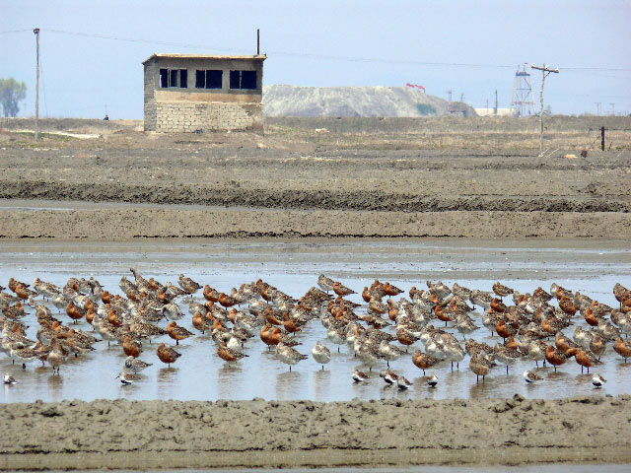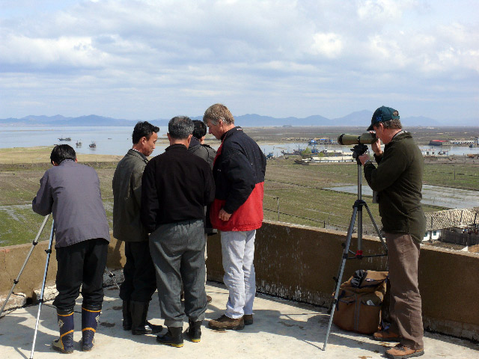
Godwits & Dunlin in Salt Pond Monitoring from Reserve Building Roof
Photos © Miranda Naturalists’ Trust

*Mark Barter; Foreword to Yalu Jiang Shorebird Survey Report, 2011

The crane migration is a good story that demonstrates informal regional networks as the cranes migrate north and south between Sites in different countries close to each other so there are real connections. A “Crane International Highway” or a “Sandpiper Interstate” where the focus is on the species rather than the Site as it is a real connection for people. One Site can message the next one, “Our cranes are on the way and should be with you on stopover tomorrow! Then on their way to Russia to breed before we see them back.”

The ASEAN Flyway Network, Indo-Burma Ramsar Regional Initiatives are other regional networks of importance.

5.7 VIRTUAL RELATIONSHIPS

It is not always realistic or affordable to have an in-person or ongoing exchange between Sites. Opportunities to dialogue with Flyway Network Sites exist through webinars, emails, and regular calls and will offer some opportunities to build collaborative projects and build capacity. Identify your needs and interests and then identify other Sites who might be a good match. This is something the Secretariat may assist with.
Case Study
School exchange via web conferencing
Students from River Valley High (RVHS), Singapore, met with students from 4 schools in Russia via web conferencing to discuss projects they worked on at Sungei Buloh (Singapore) or Muraviovka Wetlands Park (Russia). Topics were mangrove propagation (Singapore) and bird banding and a spring hunting ban campaign (Russia).
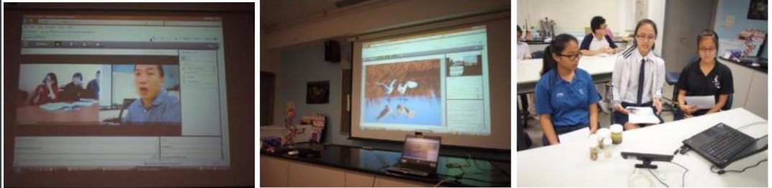

5.8 RELATIONSHIPS WITH WETLANDS THAT ARE NOT EAAFP SITES

Partnerships with wetland Sites that are not a EAAFP Flyway Network Sites aim to help improve wetland management and conserve the migratory waterbirds. EAAFP INGO Partners, Wildfowl and Wetlands Trust (WWT) and Wetland Link International (WLI), are important examples of networks of wetland Sites which share common goals with EAAF and tell the story of migratory waterbirds through CEPA even though those Sites might not be a EAAFP Flyway Network Site.
Case study
Capacity building and promotion with a Passport2Nature
Sungei Buloh Nature Reserve, Singapore has an MOU with Pulau Kukup, Johor National Park (Malaysia) with the goal of building staff capacity and cross promotion of Sister Sites with a Passport2Nature. The passports have 2 sides with questions about each of the Sites and proved a popular and fun way to build capacity and inform the public.

5.9 RELATIONSHIPS BETWEEN FLYWAY NETWORK SITES AND SPECIFIC PARTNERS

Not all international relationships are with wetland Sites. There are relationships with academic institutions which contribute to the ongoing research on migratory waterbirds and their habitats. They offer scientific and academic expertise to research undertaken at Sites across the Flyway. The relationship may be with monitoring experts skilled at using appropriate protocols and contributing to larger datasets.

One example is the Republic of Korea and Singapore who have signed a Memorandum of Understanding to foster academic exchange and research cooperation, to build capacity in ecological management and conservation, to collaborate on outreach initiatives such as developing education and conservation programmes.

5.10 INDIGENOUS EXCHANGE

There is a growing imperative to facilitate exchanges between indigenous peoples. Indigenous people have ownership and/or stewardship of many important Sites for migratory waterbirds across the Flyway. They often have rich knowledge of an area, of how areas have changed over time, relationships between species, and how sustainability can be practiced based on many thousands of years of stewardship.
The EAAFP is the only international agreement with a direct relationship to the people working at Site level. This provides a unique opportunity for the EAAFP to develop strong connections with Indigenous people and traditional communities.
There are many Indigenous groups and traditional communities in countries across the EAAF deeply connected to FNSs and migratory waterbirds and fostering opportunities for connection and exchanges will add significant value to the work of the EAAFP and establish new Site Partnerships.
Indigenous Peoples already have exchange programs in place globally with a wide focus. Those provide existing networks and examples of collaboration that can add value to the conservation of migratory waterbirds, their habitats with traditional knowledge and understanding.
Case Study
Young professionals engage with Indigenous people
The Pacific Peoples’ Partnership has supported the aspirations of South Pacific Islanders and Indigenous peoples for peace, environmental sustainability, social justice, and community development for 45 years.
Indigenous Peoples Abroad Program (IPAP provides opportunities for young professionals from First Nations, Inuit and Métis communities to engage directly in sustainable development initiatives, sharing skills, knowledge and cultural perspectives with Indigenous peoples in the South Pacific.

Projects were based on mutually defined priorities including initiatives promoting good governance, anti-corruption, sustainable resource management, marine and terrestrial environmental policy development.

5.11 FORMAL AND INFORMAL RELATIONSHIPS THAT SUIT LOCAL CIRCUMSTANCES

Singapore provides insight into the importance of mixing formal Sister Site Programme s with less formal relationships between FNSs and adapting to the circumstances in their country. Sungei Buloh Wetland Reserve in Singapore is at the centre of EAAF. It requires strong justification to secure the space for birds and their approach is to regard the entire population of Singapore as the stakeholders. Hence, a shared understanding for the stakeholders to view the Site as a national heritage, and a habitat for migratory waterbirds is essential.
In support of this, as in the case study, Singapore encourages many programs to connect the people at the FNS and to enhance four major MOUs with China, Hong Kong, Malaysia and the Republic of Korea. The diverse MOU activities extend from school exchanges, cross promoting other international Sites as a tourist spot, capacity building exchanges. As well, MOUs extend from FNSs to various institutions such as the National Institute of Ecology, where Singapore held the 1st EAAF Shorebird Science meeting.

APPENDICES

APPENDIX 1: A GOOD PRACTICE CASE STUDY OF SISTER SITE PROGRAMME / WETLAND COOPERATION AGREEMENT

WETLAND COOPERATION AGREEMENT BETWEEN YATSU TIDAL FLATS, JAPAN & BOONDALL WETLANDS, AUSTRALIA
This Sister Site Programme is known as a Wetland Cooperation Agreement. It is a relationship built on a long-term commitment from both Sites to a Partnership that benefits the migratory waterbirds, their habitats and the wellbeing of the people involved.
- About Two Wetlands.
- Background of the Wetland Cooperation Agreement.
- Main Activities.
- Achievements and the Keys to Continuation.
- Challenges and Opportunities.
- Future Plans.
- Toward Further Development.

ABOUT TWO WETLANDS – YATSU TIDAL FLATS & BOONDALL WETLANDS

Yatsu Tidal Flats
- Narashino City, Chiba Prefecture.
- Located at the inner most of Tokyo Bay.
- Rectangular tidal flat surrounded by residences and roads.
Water depth about 1m at high tide.
- Designated as a Ramsar Site in 1993.
- Yatsuhigata Nature Observation Center opened in 1994.

Boondall Wetlands
- Brisbane City, Queensland.
- Located at the edge of Moreton Bay.
About 15km north of Brisbane city center.
- Diverse environments (e.g., tidal flats, mangroves, wetlands & forests).
- Designated as a Ramsar Site in 1993 (as a part of Moreton Bay).
- Boondall Wetland Environment Centre opened in 1996.

BACKGROUND OF THE WETLAND COOPERATION AGREEMENT

The agreement was entered into in 1998 under the Asia-Pacific Migratory Waterbird Conservation Strategy, which as the precursor to the formation of the EAAFP. The governments of each country agreed to enter into a Memorandum of Understanding. Common features of the two Sites:
- Ramsar Sites.
- EAAFP Sites.
- Saved from reclamation by citizen action.
- Citizens involved in wetland conservation activities.
Objective: Conservation of Wetlands and Shorebirds.

Essential Items included in the Agreement:
- Research and information exchange.
- Support for training exchange of staff.
- Support for children's exchange.
- Awareness raising.
- Support for citizens’ exchange visits.

Action Plans
5-year action plans were agreed 1999, 2003, 2009 and in 2017 a Long-term Implementation Plan was developed.

MAIN ACTIVITIES

- Sharing Information & Making Materials
- Exchanging information about shorebirds and wetlands, information on tracking migratory birds shared between the Sites.
- Environmental education programs.
- Pamphlets, Filed guide, etc.

- People-to-people Exchanges
- Visiting each other’s wetlands for field trip and exchange.
- 37 visits over 20 years involving 150 people.
- Activities related to wetlands and migratory waterbirds:
  - Bird watching, field trip, clean-up activities, experience of environmental education programs, visits to schools, discussion on wetland activities and plans.
- Cultural exchange, participation in local events, tourist activities, social events, etc.
- Holding symposiums during visits.
- Communicating online with schools.
- Symposiums where visitors give lectures.

- Joint Research
- ‘Revealing the migration route of Grey-tailed Tattler by using geolocators’ research at both Sites led by NGOs in each country.
- 41 birds were colour-flagged.
- Resulting collaborative research report received international recognition and interest in the results.

- School exchanges
- Wetland Cooperation Agreement led to annual high school language exchange including visits to both Sites.

ACHIEVEMENTS

The Wetland Cooperation Agreement laid a strong foundation to make it easy to collaborate on activities and projects because of the good relationships maintained over a long period of time.

- Building cooperative relationships.
- Collaboration on various activities.
- Accumulating experiences and knowledge.
- Increase in the number and capacity of people involved in wetlands.
- Setting up a new organisation (Y&B Wetland Exchange Society for alumni).
- Activating initiatives in each other’s wetland.

KEYS TO SUCCESS

- Official arrangement and collateral
  - Agreement between the two governments.
  - EAAFP, Ramsar Convention, etc.
- Similar nature environment and common migratory waterbirds.
- Presence of physical centers at the Sites.
  - As the hubs of activities.
  - Professional staff on hand.
- Diverse stakeholders involved in wetland exchange.
  - Government, environmental NGOs, citizen volunteers, school staff, etc.
- Ongoing publicity, report meetings and exchanges, exhibitions at events, publicity through newsletters, media and the internet.
- People continuously involved in the wetland exchange and their connection.
  - There are people on both sides who have been actively involved in the wetland exchange for a long time.
  - Personal connections and feelings have been valued, and friendships have been built.

CHALLENGES AND OPPORTUNITIES

This has been a positive relationship and the Partners are still interested in opportunities to grow in these areas:
- Expanding and strengthening of activities.
  - How to link the Sister Site activities to conservation of wetlands and migratory birds?
- Involving a diverse range of stakeholders.
  - Universities, research institutes, other departments of the local government, private entities, etc.
- Educational exchanges.
- Ageing of the participating citizens and involving younger generation in the organisation.
- Designated administrator.
- Language barriers.

FUTURE PLANS – possible options to choose as activities

- Strengthen and expand wetland exchange activities:
- Develop projects contributing to wetland conservation and bird protection (joint research and exchange of up-to-date information).
- Exchange of environmental education programs conducted at both centres.
- Bird-watching tours to each other's wetlands.
- Joint planning of programmes at both centres.
- Creating joint exhibits – could be virtual or local.
- Sharing photos and illustrations and making them common properties.
- Information dissemination and communication.
- Information translated in each other’s language (English information on Yatsu Tidal Flats and Japanese information on Boondall Wetlands).
- Information sharing and transmission domestically and internationally, including to the Ramsar and the EAAFP Secretariats. In particular, information dissemination at the international level about the progress of the wetland exchange between the two Sites and activities that have been conducted so far.
- Building the system.
- Exchange training of each other’s staff (about one month length).
- Continuing education exchange – with some support funding.
- Enhancing the wetland exchange by promoting activities that involve people and organisations from various positions, such as university researchers, companies and administrators of Moreton Bay, in particular, planning to promote research activities in the form of wetland exchange, in collaboration with NGOs and universities in the future.
- Expanding the range of people who participate in the wetland exchange. Promoting the wetland exchange to general citizens on a regular basis.
- Establishment of a small team of people involved in the wetland exchange where participants from various positions such as local government, NGOs, volunteers, and school personnel can get together to discuss future initiatives.

APPENDIX 2: TEMPLATE - MEMORANDUM OF UNDERSTANDING

Following is a sample MOU and a range of MOU precedents are available by contacting the EAAFP Secretariat. They may be able to discuss the most suitable MOU for your Site and facilitate options if requested.

(Logos of Partners)
MEMORANDUM OF UNDERSTANDING BETWEEN

ABC
and
XYZ

BACKGROUND

- ABC and XYZ Desiring to establish the ABC Site and XYZ Site as Sister Sites under the East Asian-Australasian Flyway (hereinafter referred to collectively as the “Sites”);
- and recognising the mutual interest in and benefits of strengthening co-operation between the ABC managing agency and the XYZ managing agency; (hereinafter referred to singularly as a “Party” and collectively as the “Parties”) agree to collaborate in:
- the joint research on the migratory shorebirds to be found within the Sites (hereinafter referred to as the “Shared Species”), and
- the building of knowledge and expertise on the wetland habitat and its flora and fauna, to have a better understanding on the management of the habitats of the Shared Species.

The collaboration as Sister Sites under the East Asian-Australasian Flyway will be based on the following understanding:
Parties will endeavour to collaborate in the research on the Shared Species that breed and/or stopover at the Sites, with the effective protection of migratory shorebirds as the Parties’ common goal.
- Parties commit to exchanging their available expertise and training in relation to the management of the wetland habitat and the Shared Species with a goal towards the protection and conservation of the Shared Species that use the Sites.

- Parties will endeavour to develop the Sites as important Sites for migratory shorebirds, for the collaboration in research on migratory shorebirds and the management of wetlands, and for the education and recreation of the people and the community.

- Parties will cross-promote the Sites based on their mutual agreement that the Sites are important Sites for shorebirds and centres of excellence about wetland management, and such cross-promotion will include hosting and promoting various international events.

- Parties will collaborate on a good will basis under this Memorandum of Understanding (hereinafter referred to as the “MOU”), which shall not be legally binding, but which serves as a definite expression and record of the purpose and intention of the Parties to which they each honourably pledge themselves that it will be carried through with mutual loyalty and friendly co-operation.

OPERATIVE PART
BACKGROUND
THE PARTIES
HEADING
The MOU will come into effect on the date it is signed by the Parties’ representatives (“the commencement date”) and will remain in effect for three (3) years from the commencement date.

At the end of the first three years, the MOU will automatically be renewed for a further period of three (3) years unless the ABC managing agency or XYZ managing agency give the other Party six (6) months prior notice in writing before the end of the first three years that the MOU will not be automatically renewed.

The MOU can be terminated by either Party giving the other Party six (6) months written notification of the termination.

If either Party wishes to amend the MOU, they shall inform the other Party in writing of their proposed amendments, and the other Party shall reply in writing whether they are agreeable to the proposed amendments. Amendments shall not take effect until agreement is reached between both Parties.

Signature: | Signature:
(Name) | (Name)
(Position) of ABC | (Position) of XYZ
Date: | Date:

EXECUTION OF THE MOU

SIGNATORIES

Wilson, Marion - "The New Frontier in Sustainable Development: World Summit on Sustainable Development Type II Partnerships" [2005] VUWLawRw 16; (2005) 36 Victoria University of Wellington Law Review 389
EAAFP Website

