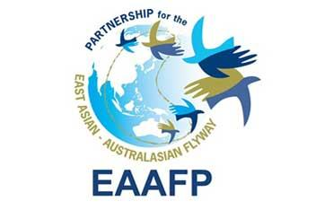
PARTNERSHIP GUIDELINES
“Bringing people together to better conserve migratory waterbirds”
National Partnerships
Site Partnerships
Sister Site Programme

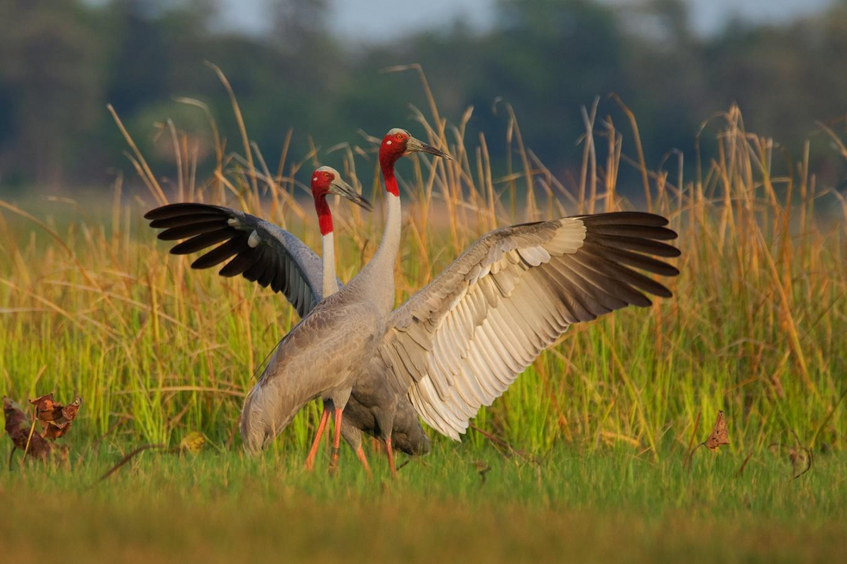
2023
Acknowledgements: Many people from across the Flyway have given their time in webinars, individual meetings, interviews, written material and photographs. Without their input, it would not have been possible to gather the information and data and more importantly, to gain their expertise and personal insights into the workings of the EAAFP. As we have worked with all these passionate people – some we never met but simply received emails or read their stories – we became full of admiration for the work and commitment of so many citizens of so many countries to migratory waterbirds and their habitats. This body of work is a tribute to their stories, efforts and experiences and it has been a privilege to collect it all together for the benefit of all and especially the birds themselves that journey across all our lands of the Flyway never belonging to one and relying on all.
Jennifer George, Consultant 2022

Cover Photo - Sarus Crane (The “Year of the Cranes” EAAFP story series #7 – Sarus Crane Nest Adoption in Thailand) ©EAAFP

“Although our birds are the connection, it is people who connect with each other throughout the Flyway and at local level that makes it all work”
Contents
SECTION 1: INTRODUCTION 4
1.1 PURPOSE OF THE GUIDELINE DOCUMENTS 4
1.2 BACKGROUND TO THE EAST ASIAN-AUSTRALASIAN FLYWAY PARTNERSHIP 4
1.3 OBJECTIVES OF THE EAAF PARTNERSHIP 5
1.4 STRUCTURE OF RELATIONSHIPS WITHIN THE EAAFP 5
SECTION 2: NATIONAL PARTNERSHIP MECHANISM 6
2.1 WHAT IS A NATIONAL PARTNERSHIP? 6
2.2 EAAFP NATIONAL PARTNERSHIP MEMBERS AND ROLES 6
2.3 WHO ARE THE POTENTIAL “PARTNERS” IN A NATIONAL PARTNERSHIP? 7
2.4 WHY HAVE A NATIONAL PARTNERSHIP? 7
2.5 PRINCIPLES OF A NATIONAL PARTNERSHIP 7
2.6 WHAT DOES A NATIONAL PARTNERSHIP DO? 8
2.6.1 ANNUAL MEETING 8
2.6.2 NATIONAL WORKPLAN TEMPLATE 8
2.6.3 BETWEEN ANNUAL MEETINGS 9
2.7 ROLES WITHIN THE NATIONAL PARTNERSHIP 9
2.7.1 NATIONAL FOCAL POINT 9
2.7.2 DIAGRAM OF THE ROLES AND RELATIONSHIPS OF THE NATIONAL FOCAL POINT 10
2.7.3 SECRETARIAT SUPPORT TO THE NATIONAL PARTNERSHIP 10
2.7.4 THE VALUE OF INGOs AND INGOs 10
2.8 WHAT TO CONSIDER WHEN ESTABLISHING A NATIONAL PARTNERSHIP 11
SECTION 3: SITE PARTNERSHIP MECHANISM 12
3.1 DIAGRAM OF A SITE PARTNERSHIP MECHANISM 12
3.2 WHAT IS A SITE PARTNERSHIP 13
3.3 WHO ARE THE POTENTIAL SITE “PARTNERS” 13
3.4 WHY HAVE A SITE PARTNERSHIP? 14
3.5 WHAT DOES A SITE PARTNERSHIP DO? 15
3.5.1 SITE PARTNERSHIP ACTIVITY / WORK PLAN 15
3.6 HOW TO ESTABLISH A SITE PARTNERSHIP? 15
3.7 ROLES WITHIN A SITE PARTNERSHIP 16
3.7.1 SITE MANAGER 16
3.7.2 DIAGRAM OF SITE MANAGER ROLES AND RELATIONSHIPS 16
3.7.3 THE EAAFP SECRETARIAT 17
3.7.4 NGOS AND INGOS 17
3.8 SITE PARTNERSHIPS WORK WITH NATIONAL PARTNERSHIPS 17
SECTION 4: SISTER SITE PROGRAMMES & RELATIONSHIPS WITH OTHER SITES 18
4.1 DIAGRAM OF SISTER SITE RELATIONSHIPS AND OTHER INTERNATIONAL RELATIONSHIPS 18
4.2 WHAT IS A SISTER SITE PROGRAMME? 19
4.3 PRINCIPLES OF A SISTER SITE PROGRAMME 19
4.4 WHY HAVE A SISTER SITE PROGRAMME? 20
4.5 CASE STUDY - SISTER SITE ACTIVITY / WORK PLAN 21
4.6 OTHER RELATIONSHIPS WITH FLYWAY NETWORK SITES 21
4.6.1 TYPES OF RELATIONSHIPS 21
SECTION 5: AGREEMENT TO COLLABORATE 22
5.1 MEMORANDUM OF UNDERSTANDING 22
APPENDICES 23
APPENDIX 1: TEMPLATE FOR NATIONAL PARTNERSHIP WORKPLAN 23
APPENDIX 2: TEMPLATE FOR SITE PARTNERSHIP WORKPLAN 24

ACRONYMS AND DEFINITIONS
CEPA | Communication, Education, Participation & Awareness
EAAFP | East Asian-Australasian Flyway Partnership
FNS | Flyway Network Site
INGO | International Non-Government Organisation
NGO  MOU | Non-Government Organisation  Memorandum of Understanding

SECTION 1: INTRODUCTION

1.1 PURPOSE OF THE GUIDELINE DOCUMENTS

At EAAFP MOP10, Partners adopted a Decision that instructed the EAAFP Secretariat to “develop guideline material on National and Site Partnerships in consultation with Partners”. The three Guideline Documents subsequently produced and described here are the outcomes of that decision.

The purpose of the guideline documents is to facilitate improved communication and cooperation for the work of the EAAFP. In addition, it is intended to provide context and background to promote a consistent approach across the Flyway Partnership on what National and Site Partnerships are and how they might operate.

These guideline documents will help National Partner representatives, National Focal Points, and others consider the design and operation of a National Partnership. They aim to describe how these mechanisms might function across the Flyway to benefit migratory waterbirds and their habitats. Each Guideline Document is an in-depth self-contained publication that provides definitions, ideas, templates, and case studies for each of these three mechanisms.

This Partnership Guideline Overview document summarises the three detailed Guideline documents the EAAFP has produced to guide the development of National Partnerships, Site Partnerships and Sister Site Programmes and other relationships across the Flyway.

These guideline documents do not seek to replace existing guidelines and are not a substitute for any information or communication within the EAAFP.

1.2 BACKGROUND TO THE EAST ASIAN-AUSTRALASIAN FLYWAY PARTNERSHIP

The East Asian-Australasian Flyway Partnership (EAAFP) provides a flyway wide framework across 22 countries from Alaska (USA) and Russia in the north, to Australia and New Zealand in the south, and transverses the breadth of Asia from Bangladesh to China and Japan. Its purpose is to promote dialogue, cooperation and collaboration between a range of stakeholders to conserve migratory waterbirds and their habitats. It was launched internationally as a “Type II Partnership” as defined by the Johannesburg 2002 World Summit on Sustainable Development (WSSD). This type of Partnership is distinct from the ‘traditional’ Type I agreements which are regarded as legally binding intergovernmental commitments designed to aid states in the implementation of sustainable development goals. The then President of the World Resources Institute, Jonathan Lash, described the alternative Type II approach in more colourful terms as “The beginnings of a shift from the stiff formal waltz of traditional diplomacy to the jazzier dance of improvisational solution-oriented partnerships that may include non-government organizations, willing governments and other stakeholders”.

As a Type II Partnership it is “characterized by collaborations between national or sub-national governments, private sector and civil society actors, to form voluntary transnational agreements in order to meet specific sustainable development goals.” This type of approach does not require binding commitments from governments, hence there are no national government policy imperatives for specific funding to fulfil specific obligations. The success of the EAAFP relies very much more on the strength of National and Site Partnerships and the relationships generated at all levels within those Partnerships.

In 2006 the East Asian-Australasian Flyway Partnership was formed to provide a new collaborative framework for the conservation of migratory waterbirds and the internationally important that support them.

1.3 OBJECTIVES OF THE EAAF PARTNERSHIP

1. Develop the Flyway Site Network of international importance for migratory waterbirds.
2. Enhance communication, education and public awareness of the values of migratory waterbirds and their habitats
3. Enhance flyway research and monitoring activities, build knowledge and promote exchange of information on waterbirds and their habitats
4. Build the habitat and waterbird management capacity of natural resource managers, decision-makers and local stakeholders
5. Develop flyway wide approaches to enhance the conservation status of migratory waterbirds.

1.4 STRUCTURE OF RELATIONSHIPS WITHIN THE EAAFP

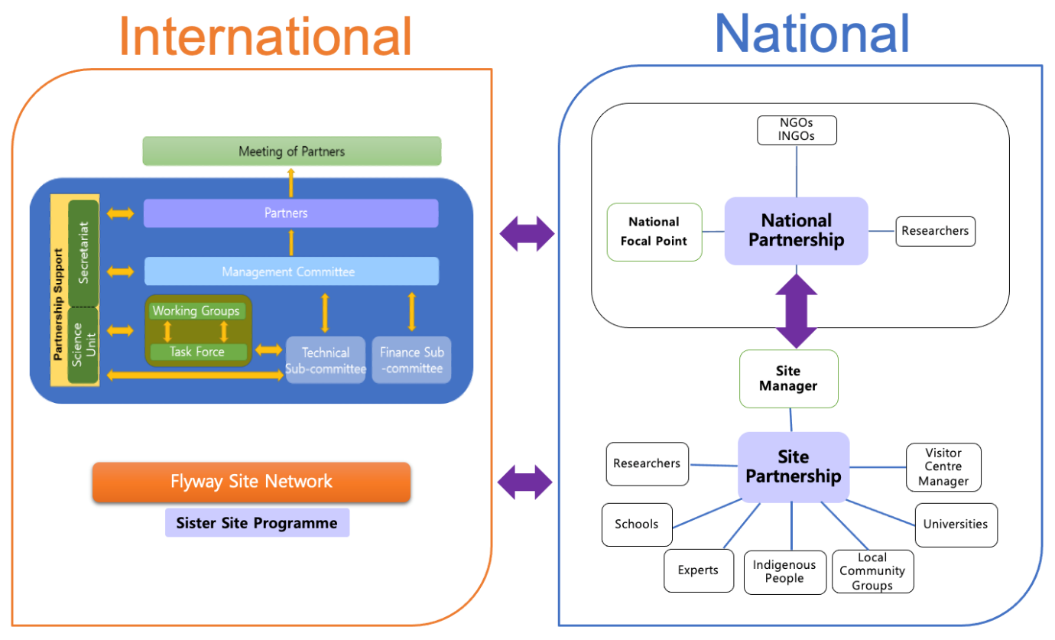

SECTION 2: NATIONAL PARTNERSHIP MECHANISM

2.1 WHAT IS A NATIONAL PARTNERSHIP?

A National Partnership is a national network of stakeholders who cooperate at national level to support the implementation of the EAAFP Strategic Plan within their country. The National Partnership works through relationships rather than obligations.

The National Partnership provides a mechanism that:
- Strengthens the relationships between people and builds the capacity and outreach of network Sites.
- Provides a mechanism for the sharing of information throughout each country.
- Facilitates national planning for the implementation of the EAAFP Strategic Plan.
- Facilitates data and information gathering for the National Focal Point to report to MOP on implementation of the EAAFP Strategic Plan.
- Promotes implementation of EAAFP CEPA Action Plan.
- Promotes studies and information exchange among scientists and researchers.
- Identifies challenges that need to be tackled within their country, in a region and/or in other parts of the Flyway.

2.2 EAAFP NATIONAL PARTNERSHIP MEMBERS AND ROLES

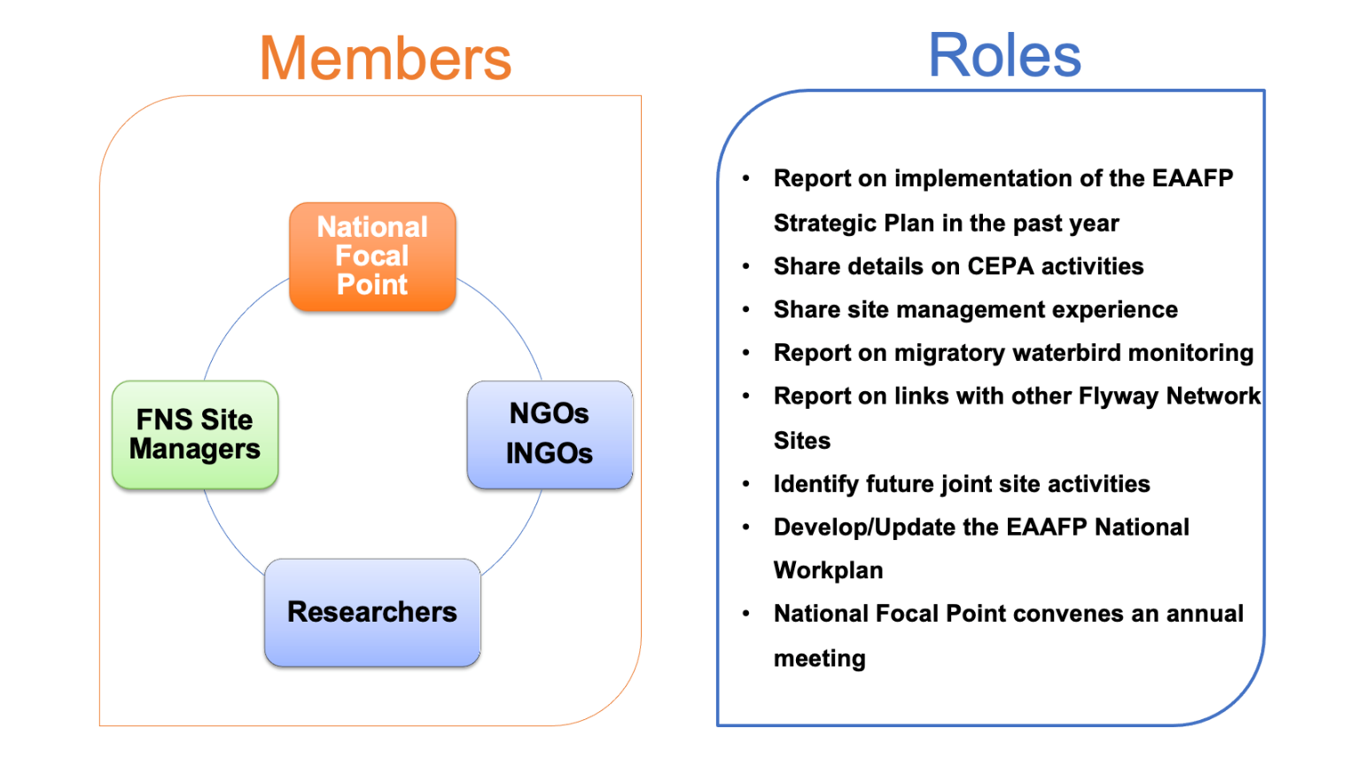

2.3 WHO ARE THE POTENTIAL “PARTNERS” IN A NATIONAL PARTNERSHIP?

Potential Partners in a national Partnership may include:
  - EAAFP National Focal Point.
  - Managers of current or potential FNS for migratory waterbirds.
  - National, Regional and Local government officers, involved with the management of internationally important wetlands.
  - Local government representatives.
  - Local and Indigenous people with cultural responsibilities for internationally important wetlands.
  - Researchers, scientists and other technical experts.
  - NGOs involved in migratory waterbird conservation nationally and internationally.
  - NGOs involved in other conservation work where relevant to the conservation of migratory waterbirds and their habitats.

These Partners are a network of people who represent all the different levels within their country who can provide the National Focal Point with information about migratory waterbird conservation action. This support will inform the reporting by the National Government Partner on the implementation of the EAAFP Strategic Plan. It will more comprehensively document how much each country is achieving for the conservation of migratory waterbirds and their habitats.

2.4 WHY HAVE A NATIONAL PARTNERSHIP?

Impacts and Benefits
- Provides a mechanism for Site Managers, experts, academic and NGO communities to actively participate in migratory waterbird conservation at a national level.
- Enhances and empowers Indigenous heritage and cultural knowledge and provides roles in designing and implementing projects in their country.
- Bringing together the unique strengths and resources of diverse Partners to impact and achieve sustainable outcomes for migratory waterbirds, which each Partner could not achieve by acting alone.
- Increased communication and exchange of information, training and expertise between the Flyway Network Sites of the country and build the capacity of Site Managers.
- Assists the National Focal Point with data and information for their Partner reports and showcases the wide range of activities happening across their country.
- Opportunity for the Partners to talk about their successes and innovations, what they want to do, the needs they have, discuss how they can collaborate, and how they can strengthen waterbird and Site monitoring.
- National and sub-national priorities are set that facilitate key on ground activities.
- Working together as a larger national group raises the profile of the conservation work for migratory waterbirds at a national and international level.
- Links with CBD National Biodiversity Strategy and Action Plan and post-2020 Biodiversity Framework.

2.5 PRINCIPLES OF A NATIONAL PARTNERSHIP
The EAAFP, by its nature as a Type II Partnership, does not have prescriptive obligations as to implementation and so there is flexibility in how each National Partnership carries out its role. However, the following are common guiding principles:
- Grow from shared vision.
- Build from strengths.
- Be flexible to suit the needs, social conditions, existing structures and national culture.
- Work collaboratively.
- Include indigenous people and traditional knowledge.
- Build enduring relationships of mutual respect.
- Build towards sustainability.

2.6 WHAT DOES A NATIONAL PARTNERSHIP DO?

A National Partnership is a mechanism to support the work of the EAAFP within each country. To do this it:
- Meets annually (face-to-face or online) to report on progress, discuss innovations, successes, concerns and to build relationships.
- Develops a collaborative National Workplan – including the input from all National Partners about activities at Flyway Network Sites.
- Keep in touch with National Partners to provide support and advice.
- Develops capacity building workshops.
- Contributes to CEPA activities at the national level.
- Encourages the mainstreaming of the National Partnership discussions in the updating and reporting on international commitments of the National Government (e.g., Ramsar Convention, CBD National Biodiversity Strategy and Action Plan, Bilateral Migratory Bird Agreements.

2.6.1 ANNUAL MEETING

One of the most important functions of a National Partnership is the annual meeting of key stakeholders convened by the National Focal Point (or delegated by National Focal Point to NGO). This meeting provides the opportunity to discuss the activities at Sites and what they plan for the next year. This information can be collated for the National Focal Point to include in their reporting. Important outcomes of a national meeting include building relationships and cooperation between Site Managers and NGOs, getting to know each other, getting to know the work each is doing.
The National Partnership Guideline document discusses agendas and lists possible items to include in the agenda for an Annual Meeting. It provides both guidelines for meeting preparation by the National Focal and the contributions that can be made to the Annual Meeting by all the national partners.
All this can be collated for the National Focal Point to include in their reporting to the EAAFP MOP which is scheduled for every two years.

2.6.2 NATIONAL WORKPLAN TEMPLATE

The starting point to develop a National Workplan, including a CEPA Action Plan, is the EAAFP Strategic Plan. A National Work Plan sets out the actions agreed on by the National Partnership for the coming two years and how they could be achieved. It takes the EAAFP Strategic Plan and says, “let’s develop our National Workplan and identify activities we plan to do between MOPs specifically focused on migratory waterbirds.”

National Partnerships are encouraged to share their Plans with the Secretariat, and with explicit approval from the National Government Partner, to have this uploaded to the EAAFP website. The Secretariat may identify synergies between National Workplans and can offer to link National Focal Points together to share experiences as they both take on common activities.
Having National Workplans on the EAAFP website would enable other National Partnerships to see plans from other countries, how they may assist each other, and where there is the potential to connect and build relationships – training, sharing monitoring information or building formal Sister Site Programmes.

An EAAFP template for a National Workplan, with planned activities set out according to the objectives in the EAAFP Strategic Plan, is provided in the National Partnership Guideline document with examples of what can be included under each objective and is also at Appendix 1.

2.6.3 BETWEEN ANNUAL MEETINGS

Between annual meetings, the stakeholders in the National Partnership:
- With the agreement of the members of the National Partnership, provide member contact details to enable the EAAFP Secretariat to circulate its news via email.
- Cooperate with others within the National Partnerships to implement the National Workplan.
- Hold ad-hoc online meetings, if possible, to connect with others, discuss issues, successes and progress, build relationships, etc.
- The National Focal Point builds a network for the regular flow of information and communication about what is happening at Flyway Network Sites. A person appointed to drive the communication within the National Partnership may be with an NGO delegated to carry out this role.
- Some useful methods of communication are bi-monthly online meetings, phone calls, emails, newsletters, social media appropriate for the country such as Facebook, WeChat, Tik Tok, Instagram, website as a source of disseminating information and data on monitoring, etc.
- Other helpful forums where members of a National Partnership may connect are conferences –BirdLife National Partner Conferences, or other national meetings, e.g., Ramsar National Committee, visiting Sites face to face, hold the annual National Partnership meeting at a Flyway Network Site with a Visitor Centre.

2.7 ROLES WITHIN THE NATIONAL PARTNERSHIP

2.7.1 NATIONAL FOCAL POINT

The National Focal Point has a key role for the EAAFP. They are the EAAFP Government Partner representatives in each country. Consequently, they are the government links between the Meeting of Partners, the Secretariat and the in-country Flyway Partners. As an employee of the National Administrative Authority they act as the key contact point for people within the country and the EAAFP Secretariat.

Key responsibilities:
- Disseminate information to the EAAFP Secretariat.
- Convene annual meetings of National Partners.
- Reporting on national activities to Government Partners.
- Providing information on capacity building workshops.
- Implement, coordinate, report on National CEPA activities for migratory waterbirds and internationally important wetlands e.g., World Migratory Bird Day and World Wetland Day.
- Coordinating and responding to Secretariat enquiries.

2.7.2 DIAGRAM OF THE ROLES AND RELATIONSHIPS OF THE NATIONAL FOCAL POINT
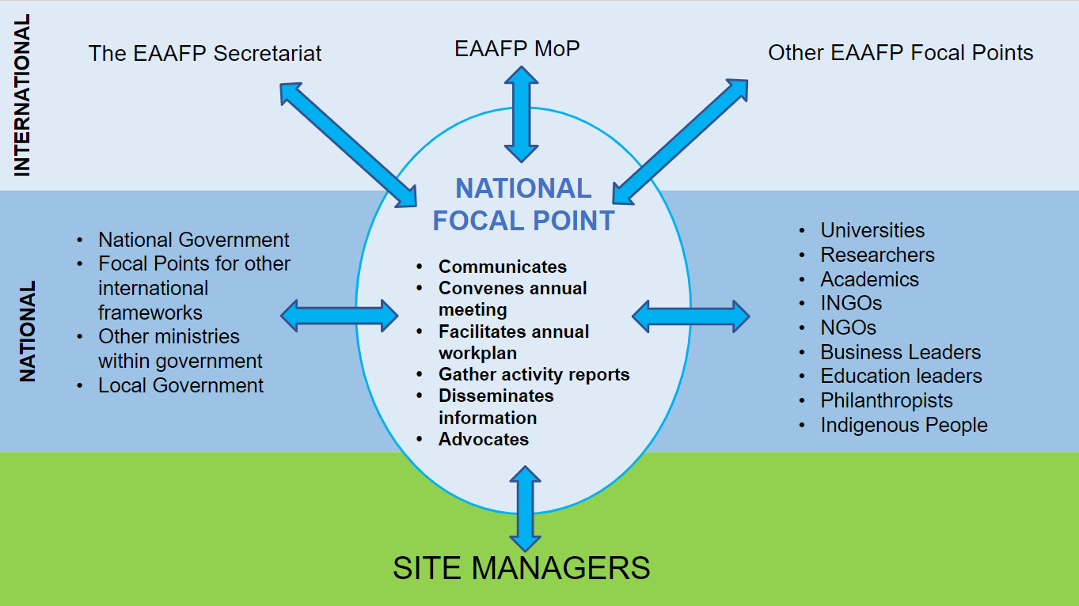

2.7.3 SECRETARIAT SUPPORT TO THE NATIONAL PARTNERSHIP

- EAAFP Secretariat provides information to members of the National Partnership and when requested offers advice and connections with other Flyway Network Sites.
- When requested, facilitates specialist input from EAAFP Working Groups and Task Forces.

2.7.4 THE VALUE OF INGOs AND INGOs

NGOs have a wealth of knowledge and experience to offer both National Partnerships and Site Partnerships, including:
- Capacity building.
- Organization and administration.
- Developing strategies and action plans.
- Supporting relationships with Ramsar Committees.
- Facilitating engagement with corporates, local businesses, national and international connections.
- Facilitating connection with other FNS.
- Supporting citizen science initiatives.
- Helping with on-ground Site management.
- Site and waterbird monitoring and research.
- Public awareness and education.
- Advocating when there are threats to FNS.

2.8 WHAT TO CONSIDER WHEN ESTABLISHING A NATIONAL PARTNERSHIP

Important questions to consider:
- What mechanisms already exist in your country that links key stakeholders together?
- Can you secure support / approval from senior Managers?
- Can you secure a budget?
- Who are the stakeholders already active in your country? And what is their interest?
- Is there an INGO or NGO that may support the National Focal Point to develop and maintain a national network for the EAAFP work?
- Is there a person who has the respect to lead this Partnership or can grow into that role?
- What means of communication and information sharing will be needed.

Next, invite the stakeholders to meet and work through the process of establishing a National Partnership.
The National Partnership Guideline document anticipates all these factors and provides valuable guidelines and assistance for National Focal Points and National Partners.
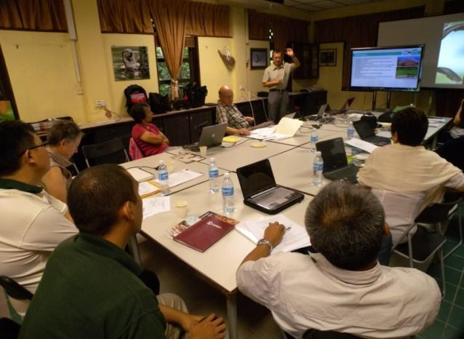

East Asian-Australasian Flyway Partnership EAAFP Task Force Meeting, CEPA Strategy Workshop ©EAAFP

SECTION 3: SITE PARTNERSHIP MECHANISM

“Although our birds are the connection,
it is people that connect at a Flyway and local level to make the EAAFP work.”

3.1 DIAGRAM OF A SITE PARTNERSHIP MECHANISM
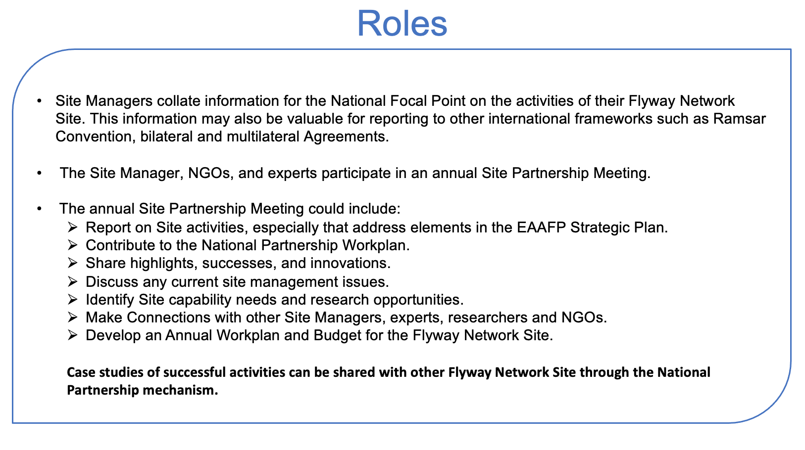
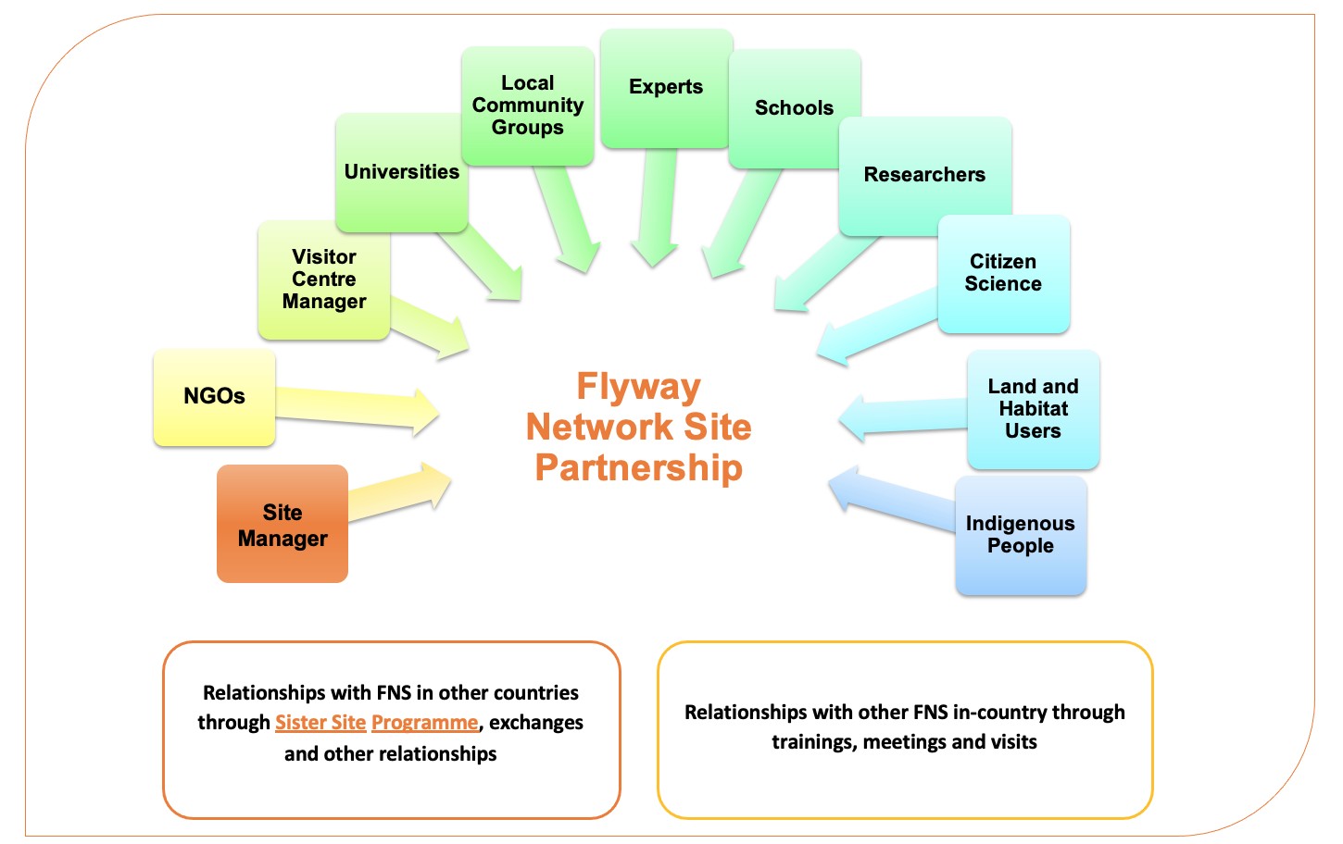

3.2 WHAT IS A SITE PARTNERSHIP

The Site Partnership is a mechanism to support and mobilize the people and relationships within a local area to enable on the ground activities to conserve migratory waterbirds and their habitats. It works through relationships rather than obligations, to:
- Build the capacity of Flyway Network Site staff and volunteers.
- Promote the relationships between people and build the capacity and outreach of Sites.
- Promote the implementation of the CEPA Action Plan.
- Facilitate data and information gathering to report to the National Focal Point.
- Provides a system for how information and data is distributed locally.
- Facilitate Site planning for the implementation of the EAAFP Strategic Plan.
- Communicate Flyway information to a larger group.
- Facilitate local Flyway Network Site activities.
- Support Site and waterbird monitoring.
- Identify potential new Flyway Network Sites.
- Provide a process to engage habitat and resource users in the conservation of migratory waterbirds.
There is a wide range of Site capacity across the Flyway and each Site Partnership will reflect local circumstances.

3.3 WHO ARE THE POTENTIAL SITE “PARTNERS”

Site Managers are encouraged to network with other local Government agencies, community groups, researchers, and other local people who have responsibilities in relation to the Sites or derive benefit from the Flyway Network Site. By working together, people will address the specific needs of the migratory waterbirds at each of their most critical locations.

Each Site Partnership will be different depending on the local circumstances: Examples of who might be involved:
- Local Governments, Site Managers and Visitor Centre Managers bring communication channels, information, data, research capability and analytical expertise. In addition, they provide facilitation and strategic planning.
- Universities, researchers, experts and academia bring international and national networks, data and knowledge and are trusted voices.
- Wetland and species scientists/researchers and experts.
- Local community groups (e.g. birdwatching groups, volunteer groups involved in habitat restoration and maintenance, churches, museums, village committees).
- Philanthropy brings networks; trust, credibility, and longevity; risk appetite; innovation and agility; diversity, and capacity to leverage investment and impact.
- Business brings data insights; purchasing power; supply chain relationships; communication expertise; research and development capability; marketing expertise; and risk management.
- NGOs bring relationships and broad networks; people power; credibility and local knowledge; and on-ground delivery of knowledge and experience.
- Adjacent landowners and habitat users bring local knowledge and can become valuable allies and supporters.
- Indigenous and traditional communities bring a deep connection with traditional and ecological knowledge to Sites and on-ground delivery and access to land.
- Passionate individuals in the community.
- Local businesses bring local knowledge, business skills and sponsorship.
- Include other Flyway Network Sites which do not have a visitor center, infrastructure or staff but who share local experts, volunteers and even the same Site Manager.

3.4 WHY HAVE A SITE PARTNERSHIP?

The impacts and benefits:
- Foster and facilitate increased engagement and appreciation in the community of migratory waterbirds and their habitats with a visible entity for the local community.
- Harness the enthusiasm of volunteers to engage in citizen science.
- Create enduring connections with local networks.
- Create a shared vision for the local community in the conservation of migratory waterbirds and their habitats.
- Provide a mechanism that identifies Flyway Network Site threats, concerns, successes and innovations with its community and prioritizes the actions needed to support the work at the Flyway Network Site.
- A more informed public through information dissemination, teaching and outreach materials and activities.
- Greater engagement of land use groups (agriculture, fish farming, developers) and resource users (fishers, eco-tourism, harvesters) to work together as a Site Partnership to find win-win outcomes for migratory waterbirds, their habitats and the land users.
- Increase the local appreciation and growing community of engaged civil society and conservation experts.
- Provide a base for monitoring and research on migratory waterbirds at each Site (data collection, analysis and reporting).
- Promote understanding through monitoring and publishing data of local migratory waterbird numbers.
- Provides a mechanism to report on activities to the community, to the National Focal Point to share with government, and to the EAAFP Secretariat.
- Develop training specific to the needs of the Flyway Network Site and local citizens.
- Delivers a place to inspire and educate the next generation.
- Make best use of experts who have long standing, practical experience in research, monitoring, who just want to get on and make a difference.
- Provides a basis to develop relationships with other Flyway Network Site and Sister Site Programmes.
- Provides an environment where those with common passion for migratory waterbirds and their habitat have enjoyment, fun and enhance community wellbeing.

3.5 WHAT DOES A SITE PARTNERSHIP DO?

- At a minimum, it meets annually to:
  - Report on Site activities, especially those that address elements in the EAAFP Strategic Plan.
  - Share highlights, successes and innovations.
  - Discuss any current Site management issues.
  - Identify Site capability needs and research opportunities.
  - Develop an activity/work plan for the following year.
  - Case studies of successful activities shared with other Flyway Network Sites through the National Partnership mechanism.
  - Contribute to the development of the National Partnership Workplan.
- Connects, and collaborates with local experts, researchers and NGOs, with land and resource users.
- Supports research, monitoring and CEPA activities.
- Arranges regular volunteer activities at the Site.
- Promotes the enjoyment and social benefits of being part of the Site Partnership.

3.5.1 SITE PARTNERSHIP ACTIVITY / WORK PLAN

A work plan is about action. It provides a framework to support and inspire people and mobilize communities to become more involved with migratory waterbirds and habitat conservation. It is on the ground that people are inspired.
“Having a meaningful purpose has played a fundamental role to drive them all to keep up the passion…” - The China Coastal Census Team

A Site activity plan sets out the actions agreed by the Site Partnership for the coming year and how they will be achieved. The Site Partnership looks at the EAAFP Strategic Plan and the National Partnership Workplan and says, “let’s develop our local Site workplan and identify activities we want to do specifically focused around migratory waterbirds at our Site.”

A template is included in Appendix 2.

3.6 HOW TO ESTABLISH A SITE PARTNERSHIP?

- Site Manager and a local NGO discuss potential to support the development and maintenance of a Site Partnership.
- Engage early in the process with the local government for support and commitment to the Site.
- Identify potential Partners.
- Call a meeting of the potential Partners.
- Agree on establishing a Site Partnership.
- Decide on what activities are achievable considering resources and people available.
- Develop an activity, or activities together.

When establishing a Site Partnership prioritize:
- Administration.
- A budget.
- Engagement all concerned with migratory waterbirds and their habitats.
- Bring people together
- Delegate.
- Communicate with local Partners.

The Site Partnership Guideline Document addresses all these issues in depth with templates, case studies and descriptions.

3.7 ROLES WITHIN A SITE PARTNERSHIP

3.7.1 SITE MANAGER

Key responsibilities:
- Updating the EAAFP Site Information Sheet for the Flyway Network Site.
- Managing the Site to maintain its waterbird and ecosystem functions.
- Promoting local recognition of the importance of the Site for migratory waterbirds.
- Strengthening community support for the management of the Site.
- Exchanging information and expertise on Site management with other Flyway Network Site Managers.
- Participating in national or international activities for the conservation of migratory waterbirds.
- Promoting the nomination of other internationally important Sites to enhance the Flyway Site Network.

Site Managers are the link between work at the Site and the National Partnership.

3.7.2 DIAGRAM OF SITE MANAGER ROLES AND RELATIONSHIPS

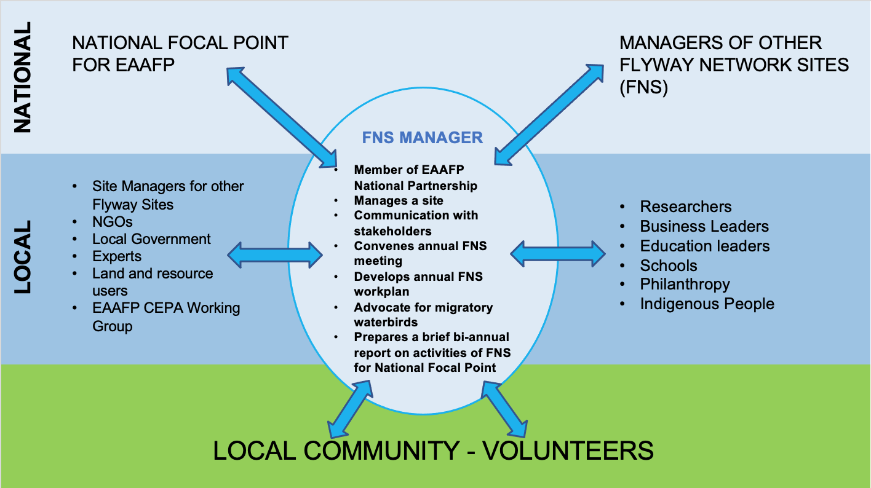

3.7.3 THE EAAFP SECRETARIAT

EAAFP Secretariat is available to support Site Partnerships with advice, for example on technical issues affecting the Site like disturbance caused by drones, access to CEPA material (potentially translation into local language), contacts with other Flyway Network Sites, assistance with planning workshops. They may have ideas and inspiration for Site Partnership activities and Site Managers may request advice.

3.7.4 NGOS AND INGOS

NGOs and INGOs have a wealth of knowledge and experience to offer both Site Partnerships and National Partnerships. They can make a significant contribution to the work at Site level.

3.8 SITE PARTNERSHIPS WORK WITH NATIONAL PARTNERSHIPS

The working relationship between the National Partnership and the Site Partnership is based on regular communication (at least two times a year) and meetings - face to face where possible. These two mechanisms allow experts, NGOs and experienced volunteers across the Flyway to contribute both at local level with practical expertise and at national level to contribute their knowledge and experience.

Site Managers and NGOs are the voice of the Flyway Network Site at the National Partnership level:
- National Focal Point disseminates CEPA material to Site Managers.
- National Focal Point organizes national training workshops for Site Managers.
- Site Managers provide the National Focal Point with on-ground information to include in reports to government and the EAAFP Secretariat and MOP. The information may also be helpful for the National Focal Point to report under other international frameworks such as CBD, Ramsar and bilateral or other multilateral agreements.
- The Site Manager, NGOs and experts participate in an annual National / Sub-National Partnership meeting and report back to the Site Partnership.

SECTION 4: SISTER SITE PROGRAMMES & RELATIONSHIPS WITH OTHER SITES

The nature of the EAAFP as a Type II Partnership means that trans-national relationships are Government to Government and citizen to citizen relationships. Although the Secretariat may assist with facilitating the development of Sister Site Programmes, once in place they remain citizen focused and operated.
The templates, component parts and best practice for Sister Site Programmes in the Sister Site Programme Guideline document provides in-depth resources for Sister Site Programmes that can be used for all types of relationships between Sites.

4.1 DIAGRAM OF SISTER SITE RELATIONSHIPS AND OTHER INTERNATIONAL RELATIONSHIPS
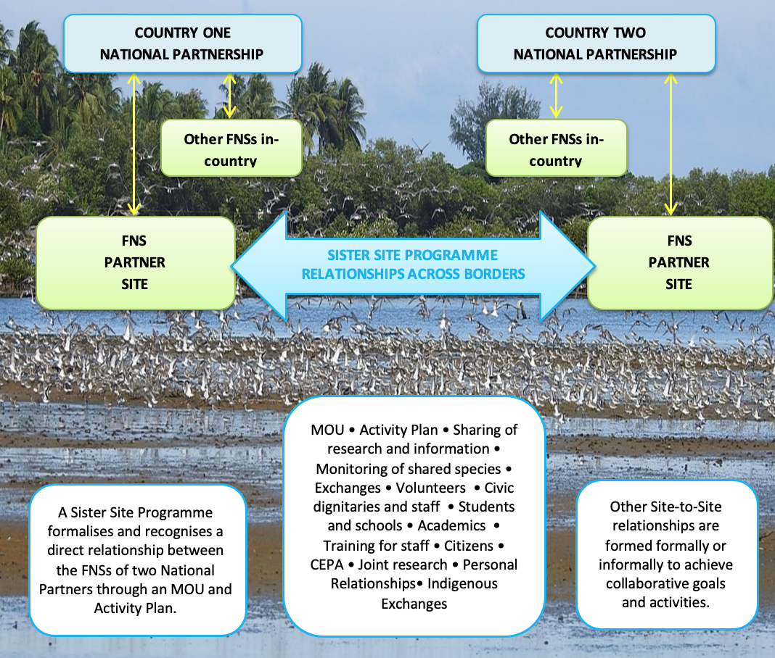

Within the EAAF Partnership framework there is a multiplicity of potential approaches. Choices on how to proceed are driven by the needs of the Site Manager’s Partners and practicalities on the ground. The EAAFP Secretariat is available to help explore options and to make suggestions but eventually, the Partners will have to own the process and the relationship.

4.2 WHAT IS A SISTER SITE PROGRAMME?

Understanding what a Sister Site Programme is, how it operates, and its benefits is the first step in identifying how it might work for your Flyway Network Site.
The fundamental meaning of the whole Flyway Initiative is shared biodiversity. When people at Flyway Network Sites foster relationships with other parts of the Flyway, they become part of the Flyway story and it builds energy of what the Partnership is seeking to achieve. A Sister Site Programme is one mechanism to do this through collaborating on activities around species that these Sites share.
No one country can conserve migratory waterbirds, so international cooperation is crucial. Building relationships with other Flyway Network Sites that share the journey of the waterbirds as they migrate between their breeding and wintering Sites on the Flyway is the foundation of the EAAF Type 2 Partnership.

The EAAFP leaflet is available at: https://www.eaaflyway.net/2021-eaafp-flyway-site-network-leaflet/
Five main areas of Sister Site collaboration:
- Joint monitoring.
- Joint research.
- Capacity building of Site Managers.
- CEPA activities
- Promoting the international link to local communities.
Physical exchanges play a significant role in deepening relationships that lead to an enduring Partnership.
It is important to define the roles and work out and agree who is leading on specific activities in the Sister Site Programme plans. These will be different for each relationship and having a written plan with assigned responsibilities will help.

A Sister Site Programme centres around a formal MOU. This document formally provides status and recognition and sets out the collaborative plans and aspirations of the Partners. A sample MOU and MOU templates are all included in the Sister Site Programme Guideline document.

4.3 PRINCIPLES OF A SISTER SITE PROGRAMME
- Clarity of purpose for connecting with another Site and the kind of arrangement will best serve the needs of each Site and the people involved.
- Grow from a shared local vision built on shared values, goals and challenges.
- People and personal relationships are fundamental to strong relationships between Sites.
- Effort and commitment maintain regular working-level, operational contact between Sites.
- Physical exchanges build enduring relationships – monitoring and research, cultural and art and capacity building exchanges.
- Continuity of contact, time spent establishing trust and building personal relationships, and exchanges are vital to see the benefits from Sister Site Programmes.
- It takes time. Sister Site Programmes thrive on continuity of contact and building trust between Sites.
- Both parties actively participate in the agreed activities.
- Regular review at 3-5 years of the status of the Sister Site Programme creates new direction for the Partnership.

4.4 WHY HAVE A SISTER SITE PROGRAMME?

Developing Sister Site Programmes is part of the EAAFP Strategic Plan for 2019-2028. Partners might aspire to support developing Sister Site Partnerships in National Work Plans. The Sister Site Programme Guideline document addresses every aspect of this process with case studies illustrating initiating Partnerships, the reasons for Partnerships, identifying potential Partners and the nature of the Partnership. It sets out in-depth, with recommendations and guidelines for the planning required to:
- Secure the support of key players in establishing and maintaining the relationship, especially local government early in the process.
- Work with the National Focal Point.
- Secure support for the process from INGOs and the Secretariat.
- Decide who will take the local lead on planning.
- Agree how the discussions will happen between each Site and who will be involved.
- Agree on an MOU and formalities about how that will be signed and any associated publicity.
- Develop an agreed activity plan between the Sites based on the MOU.

Sister Site Programmes involve civic connections and signatories and provide a basis of connection, communication, and exchange from citizen volunteers to researchers, academics, and dignitaries. In addition, the presence of a Sister Site Programme creates profile and awareness for Flyway Network Sites.

This can seem daunting, but the Secretariat is available to assist, and the process is set out in the Sister Site Programme document with templates practical steps to put into place to establish relationships with other Flyway Network Sites.

The photo below is an example of connections raising the profile of a Sister Site. It highlights the multiple levels of how people work in Partnership within the goal of the EAAFP. It shows politicians, public servants and civil society all engaged in migratory waterbird conservation.
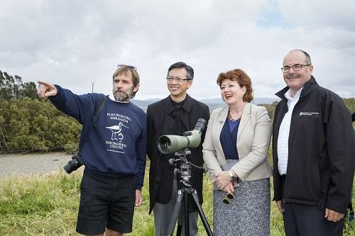

Miranda Wetlands, New Zealand ©EAAFP
From left to right: Mr Adrian Riegen, Vice Chair of Pukorokoro Miranda Naturalists Trust, Wang Lutong, Chinese Ambassador to New Zealand, Honourable Maggie Barry, New Zealand Minister of Conservation, Mr Lou Sanson, Director General of Conservation New Zealand.

4.5 CASE STUDY - SISTER SITE ACTIVITY / WORK PLAN

Yalu Jiang National Nature Reserve (FNS in China) & Pukorokoro Miranda (FNS in New Zealand)
These two Sites had a finite goal and purpose, set about achieving it and published a research document in both Mandarin and English. Below is an example of one objective and associated proposed activities. More details are in the Sister Site Guideline document.

Objective | Proposed activities
To develop and implement a mutually agreed shorebird conservation project. | - Jointly conduct comprehensive mapping and assessment of shorebird habitat to identify the distribution and threats to essential shorebird areas in both Sites.  - Implement a long-term monitoring program for Bar-tailed Godwits to gather data on the species, habitats, and main threats at both Sites.  - Set up a wetlands/shorebird center for Yalu Jiang NNR, drawing on the experience and results of Miranda Shorebird Center operated by Miranda Naturalists’ Trust.  - Develop and implement eco-tour programs for Yalu Jiang NNR in conjunction with Miranda Naturalists’ Trust.  - Prepare and finalize a draft Shorebird Management Strategy for the Firth of Thames and Yalu Jiang NNR.

4.6 OTHER RELATIONSHIPS WITH FLYWAY NETWORK SITES

Although a Sister Site Programme has many benefits, it is not the only type of relationship between Flyway Network Sites. Other international relationships exist between Sites across the Flyway. These may be one-off exchanges, ongoing informal exchanges with other Sites with the same species, or may grow into Sister Site Programmes.

4.6.1 TYPES OF RELATIONSHIPS

- Informal relationships.
- Special purpose exchanges.
- Migratory waterbird species-specific networks that link two or more Sites.
- Relationships based on the monitoring.
- Building on existing regional networks.
- Virtual Relationships.
- Relationships with wetlands that are not EAAFP Sites.
- Relationships between Flyway Network Sites and research bodies, universities, education, etc.
- Indigenous exchange.
- Relationships based on CEPA collaboration.

Regional Partnerships are also an important part of the relationships across the Flyway. For example, they may follow the migration of a particular species such as the crane migration or the critically endangered Spoon-billed Sandpiper. The ASEAN Flyway Network is a formal regional network supporting the conservation of migratory waterbirds in Southeast Asia.

Important relationships include Indo-Burma Ramsar Regional Initiative (IBRRI), Ramsar Regional Centre – East Asia (RRC-EA), Ramsar Wetland Cities Network and Wetland Link International (WLI).

The Sister Site Guideline Document provides information for a range of other relationships, including MOU templates.

SECTION 5: AGREEMENT TO COLLABORATE

5.1 MEMORANDUM OF UNDERSTANDING

A Memorandum of Understanding (MOU) sets out the purpose and intention of the parties. It is a high-level document that outlines the kinds of collaboration activities agreed by both Sites. The details are discussed with the National Focal Point and Site Manager of both countries. Examples of the matters for discussion are in the following case studies.

MOU STRUCTURE
- The “Background” to the agreement sets out the shared purpose of the MOU.
- The “operative” part of the agreement sets out the mechanisms of how it will work and what is intended to be achieved, including a possible exit or end event that may conclude the agreement or determine that a new plan or agreement is required.
- How the MOU will be implemented and potential renewals.
- The signatories to the MOU and date of execution.

MULTIPLE LANGUAGES
An MOU is prepared in both national languages where the parties do not share a common language.

ADDITIONS TO AN MOU
Where there are details of an activity, program or a list of species, etc, appendices can be added to the MOU.

A range of MOU precedents are available by contacting the EAAFP Secretariat. They may be able to discuss the most suitable MOU for your Site and facilitate options if there is no suitable precedent available.

ALLOW FOR REVIEW
To accommodate changing objectives as relationships evolve and develop, build in regular review periods, for example a 3-year work plan. Having clear time-limited objectives provides an opportunity to re-evaluate the Partnership at the end of 3 years, bring it to an end, take a new direction or agree to continue with existing objectives.

APPENDICES

APPENDIX 1: TEMPLATE FOR NATIONAL PARTNERSHIP WORKPLAN

TEMPLATE OUTLINE See also National Partnership Guideline document

OBJECTIVES FROM THE EAAFP STRATEGIC PLAN | ACTIVITIES THAT YOU MIGHT INCLUDE - WITH TIME FRAMES - TO IMPLEMENT EACH OBJECTIVE OVER THE COMING YEAR
Objective 1
Development of the Network of Sites of international importance for the conservation of migratory waterbirds along the East Asian- Australasian Flyway.
Objective 2
Enhance communication, education and public awareness of the values of migratory waterbirds and their habitats
Objective 3
Enhance flyway research and monitoring activities, build knowledge and promote exchange of information on waterbirds and their habitats.
Objective 4
Build the habitat and waterbird management capacity of natural resource managers, decision makers and local stakeholders.
Objective 5
Develop, especially for priority species and habitats, Flyway wide approaches to enhance the conservation status of migratory waterbirds.

APPENDIX 2: TEMPLATE FOR SITE PARTNERSHIP WORKPLAN

The following template starts with the objectives of the EAAFP Strategic Plan and is the format the National Focal Point uses to report to the MOP. Therefore, it helps to establish consistency for the Site Managers reporting to the National Focal Point and streamlines the process.

TEMPLATE OUTLINE See also Site Partnership Guideline document.

OBJECTIVES FROM THE EAAFP STRATEGIC PLAN | ACTIVITIES YOUR SITE PLANS TO UNDERTAKE OVER THE COMING YEAR
Objective 1
Development of the Network of Sites of international importance of conserving migratory waterbirds along the East Asian-Australasian Flyway.
Objective 2
Enhance communication, education and public awareness of the values of migratory waterbirds and their habitats.
Objective 3
Enhance flyway research and monitoring activities, build knowledge and promote exchange of information on waterbirds and their habitats.
Objective 4
Build the habitat and waterbird management capacity of natural resource managers, decision-makers and local stakeholders.

Wilson, Marion - "The New Frontier in Sustainable Development: World Summit on Sustainable Development Type II Partnerships" [2005] VUWLawRw 16; (2005) 36 Victoria University of Wellington Law Review 389
https://www.eaaflyway.net/cepa-working-group/

