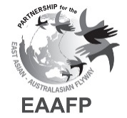
ELEVENTH MEETING OF PARTNERS OF THE EAST ASIAN – AUSTRALASIAN FLYWAY PARTNERSHIP
Brisbane, Queensland, Australia, 12-17 March 2023

Draft Decision xx

Title

Submitted by (Name of Organization)

Summary

Background
- xxxx
- xxxx
- xxxx

Decision:

Annex 1

Draft Decision xx
Title
Submitted by (Name of Organization)

Recalling,
Recognizing,
Further recognizing,
Acknowledging,

The 11th Meeting of Partners
of the East Asian – Australasian Flyway Partnership

- Agrees to
- Requests

