TENTH MEETING OF PARTNERS OF THE EAST ASIAN – AUSTRALASIAN FLYWAY PARTNERSHIP
Changjiang, China, 10-14 December 2018

Draft Decision 12
Development of a Conservation Status Review of
Migratory Waterbird Populations for the EAAFP

Submitted by Wetlands International with support from the Wildfowl & Wetlands Trust
Summary

The Partnership depends on the availability of up-to-date information on the status of populations of migratory waterbirds for a range of purposes. To address this, the EAAFP Strategic Plan 2019-2028, Key Result Area 3.2 states “Conservation status reviews for waterbird populations are periodically produced to set and adapt priorities for action”.

A recent rapid assessment of Anatid populations provides a preliminary example of the generation of information that could feed into a formal EAAF CSR and demonstrates the value of such a review process.

Partners at the 10th Meeting of the Partners are requested to adopt this Decision which seeks to adopt a systematic process to maintain up-to-date information on all waterbird population estimates, trends and 1% thresholds through the preparation of a periodic EAAF Conservation Status Review.

Background

- The East Asian – Australasian Flyway Partnership (EAAFP) provides an international framework for the conservation of migratory waterbirds in the EAAF and aims to enhance the conservation status of the migratory waterbird groups covered by the Partnership (in Appendix III).

- Providing sound guidance for the work of the Partnership for a range of purposes depends on the availability of up-to-date information on the status of populations of migratory waterbirds. In addition, up-to-date population size estimates provide the basis for deriving the EAAF Flyway Site Network thresholds (1%). This information also provides an essential international context for prioritization of the work of the Partnership by supporting the identification of threatened populations and calling for cooperative actions through developing and implementing of conservation action plans for these populations. Additionally, this information assists in measuring the success of the Partnership in achieving its goal that “Migratory waterbirds and their habitats in the East Asian – Australasian Flyway are recognised and conserved for the benefit of people and biodiversity” and to do so by “enhancing the conservation status of all populations and in halting and reversing their declines”.

- As per Decision 7.4, the EAAFP is to use the “Waterbird Population Estimates” (WPE) process to: (a) provide updated information on waterbird population sizes and trends, and (b) provide the basis for deriving the EAAF Flyway Site Network thresholds (1%).

- The WPE is produced by Wetlands International (http://wpe.wetlands.org) and provides an authoritative list of recognised migratory waterbird species and their biogeographic populations in the EAAF and all other flyways. The last global update of the WPE was in 2012 with resources provided by the Ramsar Secretariat, Environment Canada, African-Eurasian Waterbird Agreement and others.

- Since 2012, the scientific and grey literature have proposed new estimates of abundance for some species and populations, with declines identified for several populations, particularly in the EAAF, including some Anatid species in East Asia and shorebirds that spend the non-breeding period in Australasia. In the absence of a comprehensive update of WPE, such revised estimates and trends have not been formally adopted and official estimates therefore remain outdated. Such an updated global assessment has not been possible due to the lack of resources.

- Noting that the coverage of taxonomic groups of waterbirds (as per Appendix III of the Partnership Agreement) by Working Groups or Task Forces is incomplete and therefore cannot provide for the generation of updated estimates on all waterbird groups, requiring additional consultation and review processes.

- The EAAFP Strategic Plan 2012-2016 called for information on the status (population size and trend) of populations in Outcome 6.1. “Assessment and monitoring programmes are enhanced through increased collaboration and integration of activities to provide scientifically sound information on the status and trends of migratory waterbird populations.”

- In the EAAFP Strategic Plan 2019-2028, Key Result Area 3.2 states “Conservation status reviews for waterbird populations are periodically produced to set and adapt priorities for action”. Achieving this will be measured by actions to ensure that “Data describing waterbird population estimates, trends and distributions is maintained by the Partnership” and “Two updates have been produced and published” over the course of the ten year strategic plan period. It identifies that this work should be undertaken by Partners, Wetlands International, Technical Committee, relevant working groups and research institutions.

- Recognising that updated information on waterbird population status is critical to the work of the EAAFP, there is an urgent need to establish a process for the Partnership to generate this updated information on a regular basis.

- Detecting changes in populations requires the generation of new information through the ongoing monitoring of waterbirds over several years and the collation and review of these data. Given the timeframe for such work, it is recommended that a Conservation Status Review (CSR) be produced about every four years and be adopted by every alternate MOP. The CSR would describe the latest estimates of population size and trend and provide the official resource document to all Partners as well as other stakeholders in the flyway and globally.

- As a parallel, in the African-Eurasian flyway, Parties to the African-Eurasian Migratory Waterbird Agreement (AEWA) contribute resources to ensure that a CSR is produced and formally adopted at every triennial Meeting of Parties. Preparation of the CSR is coordinated by Wetlands International, based on the International Waterbird Census dataset and other regional and species-specific monitoring data, to collate information, review it through an extensive consultation process with partners and experts and to seek agreement on the latest estimates. The CSR also serves as an official contribution for the African-Eurasian flyway to the global WPE Portal.

- Globally, the Ramsar Convention Resolution VI.4 stresses "the need for close technical co-ordination between the Ramsar Convention and the Bonn Convention's Agreement on the Conservation of African-Eurasian Migratory Waterbirds, and also with other international treaties and agreements, to ensure consistency in the use of international waterfowl population estimates and [waterbird population] 1% thresholds", and Resolution VIII.38 desires "to promote the application of a single global source of information on [waterbird population] 1% thresholds"; and “REQUESTS Wetlands International to continue to bring an updated edition of Waterbird Population Estimates to each future Conference of the Parties, having first undertaken international scientific consultation on its contents, so that the population estimates and 1% thresholds it contains may be used as the basis for the application of Criterion 6 in the succeeding triennium”.

- Similarly, the Convention on Migratory Species (CMS) Resolution XII.11 “Recommends that Parties enhance and strengthen monitoring of migratory bird populations and the important sites they rely upon (including surveying new sites to fill information gaps), and to increase capacity for and sustainability of such monitoring in the long term, where appropriate by institutionalizing it as an ongoing activity within government, in partnership with other organizations, including through provision of support initiatives such as the Global Waterbird Fund (established in response to the invitation of AEWA and the Ramsar Convention and managed by Wetlands International) in order to present to key stakeholders with up-to-date information on the distribution, status and trends of migratory birds and the sites and habitats that they need;”.

- A preliminary assessment of Anatid populations has been undertaken by the Anatidae Working Group, with the support of the Wildfowl & Wetlands Trust and Wetlands International, and provides a provisional framework for how future EAAFP status assessments could be presented, as well as recommendations for further work (Annex II). It is important to note that official population status estimates remain those published in WPE5 and that those presented in this report are simply recommended updates that could be considered in any future full update of WPE.

Decision

The 10th Meeting of Partners to the EAAFP is requested to adopt the Draft Decision.

Draft Decision 12
Development of a Conservation Status Review of
Migratory Waterbird Populations for the EAAFP

Submitted by Wetlands International with support from the Wildfowl & Wetlands Trust

Recalling the East Asian – Australasian Flyway Partnership (EAAFP) provides an international framework for the conservation of migratory waterbirds in the EAAF and aims to enhance the conservation status of the migratory waterbird groups covered by the Partnership (in Appendix III).

Aware that the EAAFP requires up-to-date information on the status of populations of migratory waterbirds for a range of prioritization and review purposes, including: (a) deriving the EAAF Flyway Site Network thresholds (1%), (b) providing an international context for prioritization and supporting the identification of changes in the status of populations, including threatened populations, (c) providing a technically sound basis for cooperative actions to develop and implement conservation action plans for these populations, and (d) assisting in measuring the success of the Partnership in achieving its goal that “Migratory waterbirds and their habitats in the East Asian – Australasian Flyway are recognised and conserved for the benefit of people and biodiversity”.

Recognising EAAFP Decision 7.4 to use the “Waterbird Population Estimates” (WPE) process to:
(a) Provide updated information on waterbird population sizes and trends, and
(b) Provide the basis for deriving the EAAF Flyway Site Network thresholds (1%),

Further recognising the need for comprehensive national waterbird monitoring programmes to generate up to date information on waterbird populations and underpin the assessment of conservation status,

Recalling the EAAFP Monitoring Task Force recommendation to MOP9 for development of a cooperative programme that builds on the existing monitoring activities, to strengthen and enhance waterbird and site monitoring across the Flyway. And an agreement for BirdLife International and Wetlands International to lead on its development in consultation with the TF and other Partners.,

Noting that the coverage of taxonomic groups of waterbirds (as per Appendix III of the Partnership Agreement) by Working Groups or Task Forces is incomplete for obtaining information on all waterbird groups (Annex I) and that additional consultation and review processes are required to generate this information,

Further noting the recent assessment of Anatid populations that provides a preliminary example of the generation of information that could feed into a formal EAAF CSR (Annex II),

Conscious that the Asian Waterbird Census (a regional component of the International Waterbird Census) by Wetlands International is one of the largest harmonised global schemes for the collection of biodiversity data, providing essential inputs for the publication of the report series Waterbird Population Estimates, which summarises best available information on the status of the world's waterbird populations,

Recalling that the International Waterbird Census and the Waterbird Population Estimates are recognised as of high priority for the implementation of the EAAFP through their inclusion in the EAAFP Strategic Plan 2019-2028,

Recalling further that Resolution VI.4 of the Ramsar Convention stressed "the need for close technical co-ordination between the Ramsar Convention and the Bonn Convention's Agreement on the Conservation of African-Eurasian Migratory Waterbirds, and also with other international treaties and agreements, to ensure consistency in the use of international waterfowl population estimates and [waterbird population] 1% thresholds",

Aware that Convention on Migratory Species (CMS) in Resolution XII.11 “Recommends that Parties enhance and strengthen monitoring of migratory bird populations and the important sites they rely upon (including surveying new sites to fill information gaps), and to increase capacity for sustaining such monitoring in the long term, where appropriate by institutionalizing it as an ongoing activity within government, in partnership with other organizations, including through provision of support initiatives such as the Global Waterbird Fund (established in response to the invitation of AEWA and the Ramsar Convention and managed by Wetlands International) in order to present to key stakeholders with up-to-date information on the distribution, status and trends of migratory birds and the sites and habitats that they need”,

Further aware that the wide geographic scale of the International Waterbird Census, its long history in some parts of the world, and its annual basis, all provide a highly responsive means of assessing fulfilment of the Convention on Biological Diversity 2020 Aichi targets, and

Recognising that updated and accurate information on waterbird populations is critical to the ongoing work of the EAAFP and, given changes to many populations, of the urgent need to institute a mechanism for the Partnership to generate this updated information on a regular basis through production of an EAAF Conservation Status Review to inform and underpin the effectiveness of its work (a preliminary table of contents is provided in Annex III).

The 10th Meeting of the Partners of the
East Asian – Australasian Flyway Partnership:

- Adopts a systematic process to maintain up-to-date information on waterbird population estimates, trends and 1% thresholds through the preparation of a periodic EAAF Conservation Status Review;

- Calls on the Partners and the Secretariat to secure necessary resources to support periodic production of the EAAF Conservation Status Review (at least every alternate MOP or not more than four yearly);

- Mandates Wetlands International to coordinate preparation of the EAAF Conservation Status Review in consultation with Partners, Working Groups, Task Forces and other experts, with a target for a first edition to be produced by end 2019 (with a draft structure provided in Annex III);

- Calls on Secretariat in liaison with Wetlands International to ensure that the EAAF Conservation Status Review updates feed into the global WPE updates.

- Calls on Partners to develop standardised guidance required for development and implementation of comprehensive national waterbird monitoring programmes.
Annex I. Overview of coverage of taxonomic groups of waterbirds included in the East Asian - Australasian Flyway Partnership (as per Appendix III of the Partnership Agreement) by Working Groups or Task Forces.

Taxonomic Group | English Name | EAAFP Working Groups or Task Forces listing populations of the group in their mandate
Gaviidae | Divers/Loons | One of two species included in Seabird priority list of Seabird Working Group
Podicipedidae | Grebes | None
Phalacrocoracidae | Cormorants | Some species included in Seabird priority list of Seabird Working Group, status to be confirmed
Procellarridae | Shearwaters | Yes
Oceanitidae | Storm Petrels | Yes
Pelecanidae | Pelicans | Both species included in Seabird priority list of Seabird Working Group
Ardeidae | Herons, Egrets and Bitterns | None
Ciconiidae | Storks | Two species (Oriental Stork and Black Stork) covered by the Crane Working Group; other storks not covered
Threskiornithidae | Ibises and Spoonbills | Black-faced Spoonbill Working Group for single species, other spoonbill and ibises not covered
Anatidae | Swans, Geese and Ducks | All covered by the Anatidae Working Group
Gruidae | Cranes | All covered by the Crane Working Group
Rallidae | Rails, Gallinules and Coots | None
Heliornithidae | Finfoots | None
Jacanidae | Jacanas | None
Haematopodidae | Oystercatcher | All covered by the Shorebird Working Group
Recurvirostridae | Stilts and Avocet | All covered by the Shorebird Working Group
Glareolidae | Pratincoles | All covered by the Shorebird Working Group
Charadriidae | Plovers | All covered by the Shorebird Working Group
Scolopacidae | Sandpipers | All covered by the Shorebird Working Group
Laridae | Gulls, Terns and Skimmers | Some species included in priority list of Seabird Working Group
Stercorariidae | Skuas | All covered by the Seabird Working Group
Alcidae | Auks | All covered by the Seabird Working Group

Annex II. An assessment of population and conservation status of migratory Anatidae populations in the East Asian – Australasian flyway

Submitted by the Anatidae Working Group, with support from the Wildfowl & Wetlands Trust and Wetlands International

1. Introduction

The regular assessment of population status is a key part of the conservation process as it allows changes in status to be identified and the reprioritisation of conservation activities to be made accordingly. Li et al. (2009) summarised the first assessment of the trends of selected migratory duck populations in East Asia based on the data submitted to the International Waterbird Census (IWC) and the population status of all waterbirds in the East Asian – Australasian flyway (EAAF) was formally assessed in the 5th edition of Waterbird Population Estimates (Wetlands international 2012, hereafter WPE5). Since then, there have not been further comprehensive updates of the population status of waterbirds in the EAAF, other than updates of the global IUCN Red List, and currently there is no established cycle, or resourcing, for the production of updated status assessments for EAAF waterbirds.

Given this, the East Asian – Australasian Flyway Partnership’s (EAAFP) Anatidae Working Group (AWG) has produced this assessment in order to (i) ensure that the latest knowledge on the status of migratory Anatidae populations is available to EAAFP Partners, and (ii) demonstrate the value of doing this, and a method of how this could be done in future, in order to support the development of a routine process of assessment by the EAAFP for all migratory waterbird populations within the EAAF.

Essential to the functioning of such population status assessments are: (i) comprehensive national / regional monitoring schemes that track population size and/or trend and are coordinated at the population scale (i.e. in most cases internationally), and (ii) the sharing and collation of count data in order that population scale assessments can be undertaken. We therefore also recommend that EAAFP Partners consider the production of guidelines to support the development of comprehensive national monitoring programmes.

2. Methods

In order to update assessments of population status (size and trend) for as many of the 60 populations (of 50 species) as possible, we reviewed recently published literature and undertook a new analysis of trends for the majority of duck populations using data in the IWC dataset (collected under the Asian Waterbird Census (AWC) programme, maintained by Wetlands International). This included, for the first time, an extensive dataset from the Yangtze floodplain in central China collected by WWF China (e.g. Tao et al. 2017). All these data were collected during counts made during the non-breeding period (northern winter) of December-February.

Trends were calculated by largely following the methods employed for the African-Eurasian Migratory Waterbird Agreement (AEWA) Conservation Status Report, 7th edition (Wetlands International 2017). To ensure consistency in site coverage over time, IWC sites were selected for analysis that have at least one visit before and after 2005, the approximate halfway point of the trend periods. For the purpose of trend analyses, we considered the IWC as a full list method for waterbirds because observers are requested by the national coordinators to record all species they have seen even if they were not able to count them. Unreported species were considered absent, unless a relevant multispecies group (e.g. unidentified ducks) was reported during the count.

Prior to flyway-scale analyses, we calculated regional East Asian and Southeast Asian trends. This was to reduce the influence of countries with large count numbers on missing count information outside their region. The regions were then combined to calculate an East Asian flyway trend. To reduce the impact of spurious imputing, years with less than 30% of observed data in the imputed totals of the regional runs were excluded and were treated as missing years. We estimated missing values using the R-version of TRIM (Bogaart et al. 2016), first attempting models with the following settings: Model 2 (i.e. year-effect), automatic change-point removal, serial correlation and over dispersion. For populations with insufficient data, models were attempted without the conditions of serial correlation and/or automatic change-point removal. Trends were classified following the TRIM classification system, which compares the trend to a population change of 20% over 20 years (see Appendix C in Pannekoek & van Strien 2005).

Where no updated information was available from the literature or new analysis, we used the existing population information from WPE5.

For all populations, assessments of the quality of the population size and trend estimates are also presented, based on the criteria used for WPE5 (Tables 1 and 2). In most cases, these quality assessments are those from WPE5, though in some cases, where WPE5 did not estimate quality, we have done so.

Table 1. Categories used to assess the quality of population size estimates.
Category | Definition
Census based | Population estimate is based on almost complete census or statistically adequate sampling;
Expert opinion | Population estimate is based on incomplete survey and monitoring data and population size has been developed employing some expert opinion for extrapolating from this data with greater accuracy than a best guess;
Best guess | Population estimate is only possible with large or uncertain ranges;
No estimate | No population estimate is available.

Table 2. Categories used to assess the quality of population trend estimates.
Category | Definition
Good | International monitoring in either breeding or non-breeding/wintering periods that is adequate in quality or scope to track direction of population changes with defined statistical precision;
Reasonable | International monitoring in either breeding or non-breeding/wintering periods that is adequate in quality or scope to track direction of population changes;
Poor | Some international monitoring in either breeding or wintering periods although inadequate in quality or scope. Trends assumed through partial information;
No idea | No monitoring at international scale in either breeding or non-breeding/wintering periods. Trends unknown. This category also includes populations where trends are statistically uncertain unless other evidence allows estimation of the trend.

The estimates of population size and trend were then used to categorise the conservation status of all populations, following the framework currently used by AEWA.

3. Results

3.1 Population status assessment

The population status data for the 59 populations assessed are shown in Table 3.

This shows that the trends of migratory Anatidae populations in the EAAF, where known, are predominantly negative, i.e. the population is considered likely to be in decline. This preliminary assessment indicates that currently 25 populations (42%) are thought to be in decline, 12 (20%) are stable or fluctuating, and eight (14%) are increasing. Trend is unknown for the remaining 14 (24%) populations (Figure 1).

Trends for the ducks generated for this report are shown in Appendix 1.

Figure 1. The population trends of migratory populations of Anatidae in the East Asian – Australasian flyway.

However, the assessments of trend estimate quality show that these are adequate for accurately tracking trend in just 16 (27%) populations, only four (7%) of which have trend estimates based on an adequate level of statistical precision. Conversely, 73% (n = 43) of populations have either no trend estimate or a poor quality one (Figure 2).

Figure 2. The quality of population trend estimates for migratory populations of Anatidae in the East Asian – Australasian flyway.

The quality of the population size estimates show that 66% (n = 39) of populations have either no size estimate or one considered to be best guess. Only 15 populations (25%) have an estimate based on partial census data, and just five populations (9%) have size estimates based on a complete census or statistically adequate sampling (Figure 3); Whooper Swan, Cackling Goose, Emperor Goose and two populations of Greater White-fronted Goose.

Figure 3. The quality of population size estimates for migratory populations of Anatidae in the East Asian – Australasian flyway.

It is important to note that formal population status estimates remain those published in WPE5 and that those presented in this report are simply recommended updates that could be considered in any future full update of WPE.
Table 3. The population status of all migratory populations of Anatidae in the East Asian – Australasian flyway.
Population | Population size | Qualityª | Source^{c} | Year | Trend | Quality^{b} | Source^{c} | Year
Anseranas semipalmata (Magpie Goose)
N Australia, S New Guinea | 1,000,000 – 1,000,001 | 3 | WPE5 | 2008 | FLU | 3 | WPE5 | 2011
Dendrocygna bicolor (Fulvous Whistling-duck)
South Asia | 50,000 | 3 | WPE5 |  | DEC | 3 | WPE5 | 1991
Dendrocygna arcuata (Wandering Whistling-duck)
Ssp. Australis | 100,000 – 1,000,000 | 3 | WPE5 | 2008 | UNK | 4 | WPE5
Dendrocygna javanica (Lesser Whistling-duck)
East and Southeast Asia | 100,000 – 1,000,000 | 3 | WPE5 | 1991 | DEC | 3 | WPE5 | 1991
Cygnus olor (Mute Swan)
East Asia | 1000 – 3000 | 2 | WPE5 |  | UNK | 4 | WPE5
Cygnus cygnus (Whooper Swan)
East Asia | 42,000 - 47,000 | 1 | Jia et al. 2016 |  | INC | 2 | Jia et al. 2016 | 1988-2011
Cygnus columbianus (Tundra Swan)
Ssp. jankowskii | 99,000 – 141,000 | 2 | Jia et al. 2016 |  | STA? | 2 | Jia et al. 2016 | 1988-2011
Branta bernicla (Brent Goose)
nigricans, Japan (non-bre) | 10,000 | 3 | CAFF 2018 | 2015 | STA? | 3 | CAFF 2018
nigricans, China (non-bre)
Branta hutchinsii (Cackling Goose)
leucopareia, Aleutian (Buldir-California) | 156,000 | 1 | CAFF 2018 | 2016 | INC | 1 | CAFF 2018 | 1975-2015
Anser caerulescens (Snow Goose)
caerulescens, East Asia | 28 – 52 | 2 | WPE5 | 2011 | STA | 2 | WPE5
Anser canagicus (Emperor Goose)
N Pacific | 158,000 | 1 | Dooley et al. 2016 | 2015 | INC | 1 | USFWS 2018 | 1990-2015
Anser indicus (Bar-headed Goose)
C, S & SE Asia | 97,000 – 118,000 | 2 | Liu et al. 2017 | 2016 | INC? | 3 | Liu et al. 2017 | 2005-2014
Anser anser (Greylag Goose)
rubrirostris, E Asia (non-bre) | 15,000 | 3 | CAFF 2018 | 2014 | DEC | 3 | CAFF 2018
Anser cygnoid (Swan Goose)
C & E Asia | 56,000 – 98,000 | 2 | Jia et al. 2016 |  | DEC | 3 | CAFF 2018
Anser fabalis (Bean Goose)
serrirostris, Kamchatka/Japan | 2,000 | 2 | CAFF 2018 | 2011 | STA? | 3 | CAFF 2018
serrirostris, Central & Eastern Siberia | 112,000 – 216,000 | 2 | CAFF 2018 | 2011 | STA? | 3 | CAFF 2018
middendorffi, Okhotsk/Kamchatka-Japan | 6,000 | 2 | CAFF 2018 | 2011 | DEC | 2 | CAFF 2018
middendorffi, Yakutia/E Asia | 6,000 | 3 | CAFF 2018 | 2011 | DEC | 3 | CAFF 2018
middendorffi, Sayan/E China | 6,000 | 2 | CAFF 2018 | 2011 | DEC | 3 | CAFF 2018
Anser albifrons (Greater White-fronted Goose)
frontalis, China | 55,000 | 2 | CAFF 2018 | 2015 | DEC | 3 | CAFF 2018 | 2002-2014
frontalis, Japan | 138,000 | 1 | CAFF 2018 | 2011 | INC | 1 | CAFF 2018 | 1996-2011
frontalis, Korea | 85,000 | 1 | CAFF 2018 | 2011 | INC | 1 | CAFF 2018 | 1999-2011
Anser erythropus (Lesser White-fronted Goose)
C & E Siberia | 16,000 | 2 | CAFF 2018 | 2015 | DEC | 2 | CAFF 2018
Clangula hyemalis (Long-tailed Duck)
E Asia (non-bre) | 500,000 – 1,000,000 | 3 | WPE5 |  | UNK | 4 | WPE5
Somateria fischeri (Spectacled Eider)
E Siberia, N & W Alaska | 360,000 – 400,000 | 2 | WPE5 | 2011 | STA | 2 | WPE5 | 1985-2011
Somateria spectabilis (King Eider)
E Asia (bre) | UNK | 4 | WPE5 |  | UNK | 4 | WPE5
Somateria mollissima (Common Eider)
v-nigrum | 130,000 - 170,000 | 3 | WPE5 |  | STA | 3 | WPE5
Polysticta stelleri (Steller's Eider)
N Pacific (non-bre) | 180,000 - 180,000 | 2 | WPE5 |  | STA? | 4 | WPE5
Melanitta stejnegeri (Siberian Scoter)
E Asia | 600,000 - 1,000,000 | 3 | WPE5 |  | UNK | 4 | WPE5
Melanitta americana (Black Scoter)
americana, E Asia | 300,000 - 500,000 | 3 | WPE5 |  | UNK | 4 | WPE5
Bucephala clangula (Common Goldeneye)
clangula, E Asia (non-bre) | 100,000 - 1,000,000 | 3 | WPE5 |  | UNK | 4 | WPE5
Mergellus albellus (Smew)
E Asia (non-bre) | 25,000 | 3 | WPE5 |  | UNK | 4 | WPE5
Mergus merganser (Common Merganser)
orientalis, E Asia (non-bre) | 50,000 - 100,000 | 3 | WPE5 | 1998 | UNK | 4 | WPE5
Mergus squamatus (Scaly-sided Merganser)
E & SE Asia | 2,400 - 10,000 | 3 | WPE5 | 2010 | DEC | 2 | WPE5 | 1990-2005
Mergus serrator (Red-breasted Merganser)
East Asia | 25,000 - 100,000 | 3 | WPE5 |  | UNK | 4 | WPE5
Histrionicus histrionicus (Harlequin Duck)
pacificus, East Asia | 25,000 - 100,000 | 3 | WPE5 |  | UNK | 4 | WPE5
Tadorna tadorna (Common Shelduck)
South Asia (non-bre) | 25,000 - 100,000 | 3 | WPE5 |  | UNK | 4 | WPE5
E Asia (non-bre) | 100,000 - 150,000 | 3 | WPE5 |  | DEC? | 3 | WI 2018 | 2005-2015
Tadorna ferruginea (Ruddy Shelduck)
E Asia (non-bre) | 50,000 - 100,000 | 3 | WPE5 |  | UNK | 4 | WI 2018
Nettapus coromandelianus (Cotton Pygmy-goose)
coromandelianus, E & SE Asia | 25,000 – 1,000,000 | 3 | WPE5 | 1991 | DEC? | 3 | WI 2018 | 1990-2015
Aix galericulata (Mandarin Duck)
China (non-bre) | 20,000 | 3 | WPE5 |  | DEC | 3 | WPE5 | 1980-1990
Korea (non-bre) | 3000 – 4000 | 2 | WPE5 | 2008 | DEC | 3 | WPE5 | 1980-1990
Japan (non-bre) | 40,000 | 3 | WPE5 |  | STA | 3 | WPE5 | 1980-1990
Aythya ferina (Common Pochard)
E Asia (non-bre) | 300,000 | 3 | WPE5 |  | DEC | 2 | WI 2018 | 2000-2015
Aythya baeri (Baer's Pochard)
C, E, SE & S Asia | 800 – 1000 | 2 | BPTF | 2018 | DEC | 3 | BPTF | 2018
Aythya nyroca (Ferruginous Duck)
S, E & SE Asia (non-bre) | 100,000 | 3 | WPE5 | 2005 | DEC | 3 | WPE5 | 1977-1991
Aythya fuligula (Tufted Duck)
E & SE Asia (non-bre) | 200,000 - 300,000 | 3 | WPE5 |  | DEC | 2 | WI 2018 | 1990-2015
Aythya marila (Greater Scaup)
nearctica, E Asia | 200,000 - 300,000 | 3 | WPE5 |  | UNK | 4 | WPE5
Spatula querquedula (Garganey)
E & SE Asia (non-bre) | 100,000 - 200,000 | 3 | WPE5 |  | DEC | 3 | WPE5 | 1994-2004
Spatula clypeata (Northern Shoveler)
E & SE Asia (non-bre) | 500,000 | 3 | WPE5 |  | FLU | 4 | WI 2018 | 2000-2015
Sibirionetta formosa (Baikal Teal)
E Asia | 500,000 – 1,000,000 | 3 | WPE5 | 2010 | INC? | 2 | WI 2018 | 2000-2015
Mareca falcata (Falcated Duck)
C & E Asia | 78,000 - 89,000 | 3 | WPE5 | 2007 | INC? | 3 | WI 2018 | 2005-2015
Mareca strepera (Gadwall)
strepera, E Asia (non-bre) | 500,000 – 1,000,000 | 3 | WPE5 |  | STA | 3 | WI 2018 | 2010-2015
Mareca penelope (Eurasian Wigeon)
E Asia (non-bre) | 500,000 – 1,000,000 | 3 | WPE5 |  | DEC? | 3 | WI 2018 | 1990-2015
Anas zonorhyncha (Chinese Spot-billed Duck)
Zonorhyncha | 800,000 – 1,600,000 | 3 | WPE5 |  | DEC? | 3 | WI 2018 | 2000-2015
Anas poecilorhyncha (Indian Spot-billed Duck)
Haringtoni | 10,000 – 100,000 | 3 | WPE5 |  | DEC? | 3 | WI 2018 | 1995-2015
Anas platyrhynchos (Mallard)
platyrhynchos, E Asia (non-bre) | 1,500,000 | 3 | WPE5 |  | DEC | 2 | WI 2018 | 2000-2015
Anas acuta (Northern Pintail)
E & SE Asia | 200,000 – 300,000 | 3 | WPE5 |  | DEC | 2 | WI 2018 | 1990-2015
Anas crecca (Common Teal)
crecca, E & SE Asia (non-bre) | 600,000 – 1,000,000 | 3 | WPE5 |  | DEC? | 3 | WI 2018 | 2000-2015

ª Population size estimate quality:
1 = Census based; population estimate is based on almost complete census or statistically adequate sampling;
2 = Expert opinion; population estimate is based on incomplete survey and monitoring data and population size has been developed employing some expert opinion for extrapolating from this data with greater accuracy than a best guess;
3 = Best guess; population estimate is only possible with large or uncertain ranges;
4 = No estimate; no population estimate is available.

^{b} Population trend estimate quality:
1 = Good; international monitoring in either breeding or non-breeding/wintering periods that is adequate in quality or scope to track direction of population changes with defined statistical precision;
2 = Reasonable; international monitoring in either breeding or non-breeding/wintering periods that is adequate in quality or scope to track direction of population changes;
3 = Poor; some international monitoring in either breeding or wintering periods although inadequate in quality or scope. Trends assumed through partial information;
4 = No idea; no monitoring at international scale in either breeding or non-breeding/wintering periods. Trends unknown. This category also includes populations where trends are statistically uncertain unless other evidence allows estimation of the trend.

^{c} Sources:
BPTF = EAAFP Baer’s Pochard Task Force.
CAFF 2018 = Fox & Leafloor (2018).
USFWS 2018 = U.S. Fish and Wildlife Service (2018).
WI 2018 = trend analysis undertaken by Wetlands International for this report.
WPE5 = Waterbird Population Estimates, 5th edition, published 2012; available at http://wpe.wetlands.org/.
3.2 Conservation status assessment

In order to define Anatidae conservation status in the EAAF, we used the population status information above to classify each Anatidae population according to the following criteria, as currently used by AEWA. This shows that 21 Anatidae populations are placed in column A (the highest conservation priority), 17 in column B and 21 in column C (the lowest conservation priority) (Table 4).

Column A

Category 1: (a) Species, which are included in Appendix I to the Convention on the Conservation of Migratory species of Wild Animals;
(b) Species, which are listed as threatened on the IUCN Red list of Threatened Species, as reported in the most recent summary by BirdLife International; or
(c) Populations, which number less than around 10,000 individuals.

Category 2: Populations numbering between around 10,000 and around 25,000 individuals.

Category 3: Populations numbering between around 25,000 and around 100,000 individuals and considered to be at risk as a result of:

(a) Concentration onto a small number of sites at any stage of their annual cycle;
(b) Dependence on a habitat type, which is under severe threat;
(c) Showing significant long-term decline; or
(d) Showing large fluctuations in population size or trend.

Category 4: Species, which are listed as Near Threatened on the IUCN Red List of Threatened species, as reported in the most recent summary by BirdLife International, but do not fulfil the conditions in respect of Category 1, 2 or 3, as described above, and which are pertinent for international action.

Column B

Category 1: Populations numbering between around 25,000 and around 100,000 individuals and which do not fulfil the conditions in respect of Column A, as described above.

Category 2: Populations numbering more than around 100,000 individuals, which do not fulfil the conditions in respect of Column A, and considered to be in need of special attention as a result of:

(a) Concentration onto a small number of sites at any stage of their annual cycle;
(b) Dependence on a habitat type, which is under severe threat;
(c) Showing significant long-term decline; or
(d) Showing large fluctuations in population size or trend.

Column C

Category 1: Populations numbering more than around 100,000 individuals which could significantly benefit from international cooperation and which do not fulfil the conditions in respect of either Column A or Column B, above.

Table 4. The proposed conservation status of migratory populations of Anatidae in the East Asian – Australasian flyway.
Population | A | B | C
Anseranas semipalmata (Magpie Goose)
N Australia, S New Guinea |  |  | 1
Dendrocygna bicolor (Fulvous Whistling-duck)
South Asia | 3c
Dendrocygna arcuata (Wandering Whistling-duck)
Ssp. Australis |  |  | 1
Dendrocygna javanica (Lesser Whistling-duck)
East and Southeast Asia |  | 2c
Cygnus olor (Mute Swan)
East Asia | 1c
Cygnus cygnus (Whooper Swan)
East Asia |  | 1
Cygnus columbianus (Tundra Swan)
Ssp. jankowskii |  | 2a
Branta bernicla (Brent Goose)
nigricans, Japan (non-bre) | 2
nigricans, China (non-bre)
Branta hutchinsii (Cackling Goose)
leucopareia, Aleutian (Buldir-California) |  |  | 1
Anser caerulescens (Snow Goose)
caerulescens, East Asia | 1c
Anser indicus (Bar-headed Goose)
C, S & SE Asia |  |  | 1
Anser canagicus (Emperor Goose)
N Pacific | 4
Anser anser (Greylag Goose)
rubrirostris, E Asia (non-bre) | 2
Anser cygnoid (Swan Goose)
C & E Asia | 3c
Anser fabalis (Bean Goose)
serrirostris, Kamchatka/Japan | 1c
serrirostris, Central & Eastern Siberia |  |  | 1
middendorffi, Okhotsk/Kamchatka-Japan | 1c
middendorffi, Yakutia/E Asia | 1c
middendorffi, Sayan/E China | 1c
Anser albifrons (Greater White-fronted Goose)
frontalis, China | 3c
frontalis, Japan |  |  | 1
frontalis, Korea |  | 1
Anser erythropus (Lesser White-fronted Goose)
C & E Siberia | 2
Clangula hyemalis (Long-tailed Duck)
E Asia (non-bre) | 1b
Somateria fischeri (Spectacled Eider)
E Siberia, N & W Alaska |  |  | 1
Somateria spectabilis (King Eider)
E Asia (bre) |  |  | 1
Somateria mollissima (Common Eider)
v-nigrum |  |  | 1
Polysticta stelleri (Steller's Eider)
N Pacific (non-bre) |  |  | 1
Melanitta stejnegeri (Siberian Scoter)
E Asia |  |  | 1
Melanitta americana (Black Scoter)
americana, E Asia | 4
Bucephala clangula (Common Goldeneye)
clangula, E Asia (non-bre) |  |  | 1
Mergellus albellus (Smew)
E Asia (non-bre) |  | 1
Mergus merganser (Common Merganser)
orientalis, E Asia (non-bre) |  | 1
Mergus squamatus (Scaly-sided Merganser)
E & SE Asia | 1b
Mergus serrator (Red-breasted Merganser)
East Asia |  | 1
Histrionicus histrionicus (Harlequin Duck)
pacificus, East Asia |  | 1
Tadorna tadorna (Common Shelduck)
South Asia (non-bre) |  | 1
E Asia (non-bre) |  |  | 1
Tadorna ferruginea (Ruddy Shelduck)
E Asia (non-bre) |  | 1
Nettapus coromandelianus (Cotton Pygmy-goose)
coromandelianus, E & SE Asia |  |  | 1
Aix galericulata (Mandarin Duck)
China (non-bre) | 2
Korea (non-bre) | 1c
Japan (non-bre) |  | 1
Aythya ferina (Common Pochard)
E Asia (non-bre) | 1b
Aythya baeri (Baer's Pochard)
C, E, SE & S Asia | 1b
Aythya nyroca (Ferruginous Duck)
S, E & SE Asia (non-bre) | 4
Aythya fuligula (Tufted Duck)
E & SE Asia (non-bre) |  | 2c
Aythya marila (Greater Scaup)
nearctica, E Asia |  |  | 1
Spatula querquedula (Garganey)
E & SE Asia (non-bre) |  | 2c
Spatula clypeata (Northern Shoveler)
E & SE Asia (non-bre) |  |  | 1
Sibirionetta formosa (Baikal Teal)
E Asia |  |  | 1
Mareca falcata (Falcated Duck)
C & E Asia |  | 1
Mareca strepera (Gadwall)
strepera, E Asia (non-bre) |  |  | 1
Mareca penelope (Eurasian Wigeon)
E Asia (non-bre) |  |  | 1
Anas zonorhyncha (Chinese Spot-billed Duck)
zonorhyncha |  |  | 1
Anas poecilorhyncha (Indian Spot-billed Duck)
haringtoni |  | 1
Anas platyrhynchos (Mallard)
platyrhynchos, E Asia (non-bre) |  | 2c
Anas acuta (Northern Pintail)
E & SE Asia |  | 2c
Anas crecca (Common Teal)
crecca, E & SE Asia (non-bre) |  |  | 1

4. Discussion

4.1 Data quality and availability

Any analysis of population and conservation status such as this is only as good as the data available for analysis. For this report we primarily used the International Waterbird Census dataset, to which we added data from four coordinated surveys of the central and lower Yangtze floodplain (in 2004, 2005, 2011 and 2015), and other published sources of information. However, other datasets that likely contain important and relevant data have not yet been incorporated.

Whilst this provided the basis for an adequate assessment of conservation status of migratory Anatidae in the EAAF, there are many gaps in geographic and habitat coverage among existing monitoring schemes, meaning that confidence in these assessments is low for many populations. For example, it has not been possible to revise assessments for most seaducks, as surveys of the inshore marine areas where they spend the non-breeding period are extremely limited and estimates from the breeding range are not available.

While reporting on Anatidae during the January period through the Asian Waterbird Census has generally improved over time, particularly in the Republic of Korea, parts of China and Japan, coverage in southeast Asia, particularly in Indonesia, Malaysia, and Viet Nam is poor, with no counts currently being provided from Laos and Papua New Guinea. Additionally, there is variability in the consistency of annual coverage of freshwater sites across the region, with improved coverage in the Republic of Korea, parts of mainland China, Taiwan, Thailand, and Japan, but significant gaps in coverage in Bangladesh, Cambodia, Myanmar and Philippines.

In addition to the gaps in monitoring coverage, there are also important existing datasets that were not available for this analysis, particularly from those countries where there is not yet any national coordination (e.g. Lao PDR and Papua New Guinea). It is important that future assessments of conservation status are able to make use of all suitable waterbird count data. This requires the standardisation of methods and the establishment of comprehensive national and international coordination mechanisms.

An additional current constraint is the limited information on survey coverage, which meant that some available data were excluded from the analysis. Recording site boundaries and survey coverage at individual sites is crucial for the accurate estimation of population trends.

4.2 Population definition

We followed the current classification of populations used by Wetlands International (2012). However, this highlighted a few areas of uncertainty where clarification of population delineation is required.

Both East Asian populations of Brent Goose recognised by WPE5 (Japan and China) are treated as a single population by Fox & Leafloor (2018). In contrast, the two populations of serrirostris Bean Goose recognised by WPE5 (Japan and East China/Korea) are treated as three populations by Fox & Leafloor (2018); the latter being separated into those spending the non-breeding period in (i) China and (ii) Korean peninsula.

The South Asia population of Red-crested Pochard is not listed by WPE5 for the EAAF, but part of its range is in Mongolia (breeding) and south China and Bangladesh (non-breeding) so this population should be considered as an EAAFP population.

5. Recommendations

Based on the key issues highlighted by this report, the Anatidae Working Group makes the following recommendations:

- That population and conservation status assessments for all migratory waterbird populations in the EAAF should, subject to available resources, be embedded into the routine work of the EAAFP, coordinated by Wetlands International with the support of the Technical Committee, Working Groups, Task Forces and other experts.
- That, subject to available resources, full assessment of population and conservation status for all migratory waterbirds in the EAAF should be carried out at the earliest opportunity. The format and method to be used for the assessment should be set out by the EAAFP Secretariat in early 2019 and finalised in consultation with the Partners, the EAAFP Technical Committee and other relevant bodies and individuals.
- Thereafter, such assessments should be repeated not less than every other MOP (or every four years, whichever is the shortest period).
- That the Monitoring of Waterbird Populations and Sites Task Force develops strong waterbird monitoring guidelines that are coordinated internationally through existing mechanisms such as the AWC, in consultation with the Technical Committee, Partners and relevant national and international authorities.
- That national monitoring scheme coordinators are encouraged to follow established best practice guidelines regarding issues such as data management and sharing, mapping of count site boundaries and recording of survey coverage. Strengthening the support for AWC national coordinators and capacity building of the monitoring networks is needed to achieve this.
- That the EAAFP Technical Committee, in consultation with Partners, revises the list of migratory Anatidae populations considered by the EAAFP in accordance with MOP9/D9 and submit their recommendations for approval at MOP11.
- That the EAAFP Technical Committee develops maps of flyway boundaries that give a clear understanding of population delineation for all EAAFP populations.
- Recommendations 1-3, 6 and 7 should be linked to process of development of an EAAFP Conservation Status Review, while recommendations 4 and 5 should be linked to the work of the EAAFP Monitoring of Waterbird Populations and Sites Task Force.

6. References

Bogaart, P., M. van der Loo & J. Pannekoek. 2016. rtrim: Trends and Indices for Monitoring Data. URL: https://CRAN.R-project.org/package=rtrim

Dooley, J., E. Osnas & G. Zimmerman. 2016. Analysis of emperor goose survey data and harvest potential. Report to U.S. Fish and Wildlife Service, Division of Migratory Bird Management, Region 7 and Alaska Migratory Bird Co-Management Council, Anchorage, AK.

Fox, A.D. & Leafloor, J.O. (eds.) 2018. A global audit of the status and trends of Arctic and Northern Hemisphere goose populations. Conservation of Arctic Flora and Fauna International Secretariat: Akureyri, Iceland. ISBN 978-9935-431-66-0.

Jia, Q., K. Koyama, C.-Y. Choi, H.-J. Kim, L. Cao, D. Gao, G. Liu & A.D. Fox. 2016. Population estimates and geographical distributions of swans and geese in East Asia based on counts during the non-breeding season. Bird Conservation International 26: 397-417.

Li, Z.W.D., A. Bloem, S. Delany, G. Martakis & J.O. Quintero. 2009. Status of Waterbirds in Asia – Results of the Asian Waterbird Census: 1987-2007. Wetlands International, Kuala Lumpur, Malaysia.

Liu, D., G. Zhang, F. Li, T. Ma, J. Lu & F. Qian. 2017. A revised species population estimate for the Bar-headed Goose (Anser indicus). Avian Research 8:7.

Pannekoek, J. & A. van Strien. 2005. TRIM 3 Manual. Statistics Netherlands, The Hague. URL: http://www.bc-europe.eu/upload/EurButtInd/trim3man.pdf

Tao, X., J. Lei, R.D. Hearn & G. Lei. 2017. Report on the coordinated survey for wintering waterbirds of the Central and Lower Yangtze in 2015. WWF China, Wuhan.

U.S. Fish and Wildlife Service. 2018. Waterfowl population status, 2018. U.S. Department of the Interior, Washington, D.C. USA.

Wetlands International. 2012. Waterbird Population Estimates 5. Retrieved from wpe.wetlands.org.

Wetlands International. 2017. Flyway trend analyses based on data from the African-Eurasian Waterbird Census from the period of 1967-2015. Online publication. Wetlands International, Wageningen, The Netherlands. http://iwc.wetlands.org/static/files/0-IWC-trendanalysis-report-2017-final.pdf

Appendix 1. Trend graphs for duck populations included in the analyses undertaken for this report.

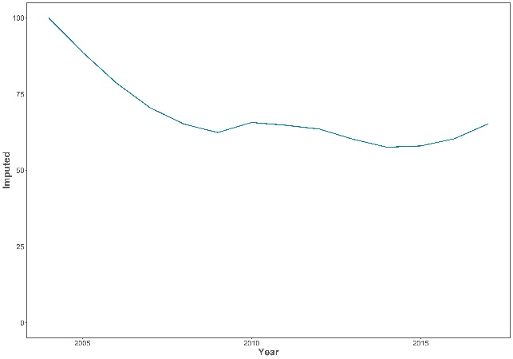  - Common Shelduck (East Asia) | 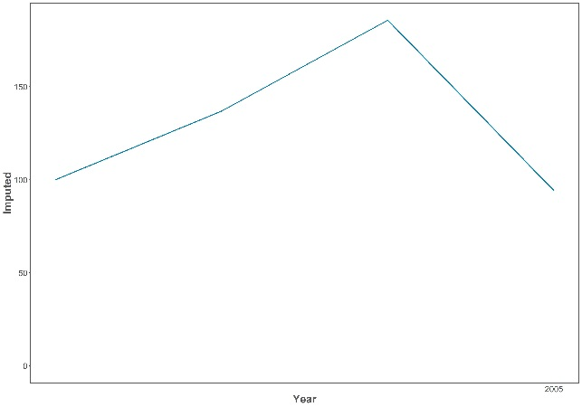  - Ruddy Shelduck
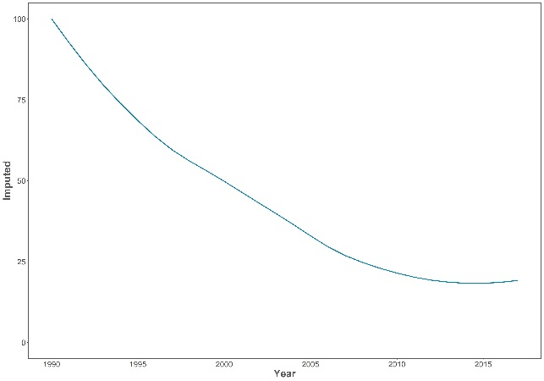  - Cotton Pygmy-goose | 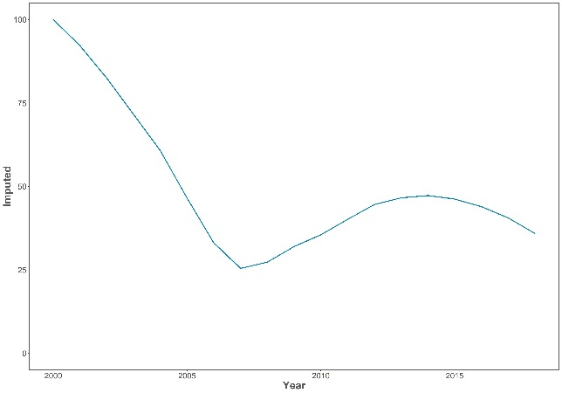  - Mandarin
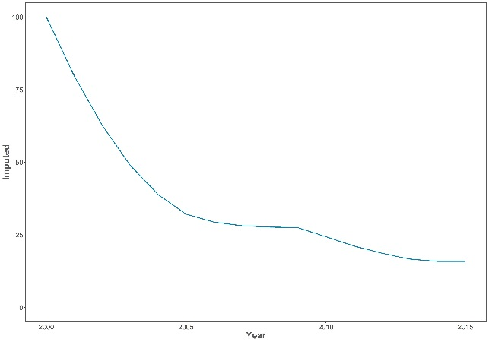  - Common Pochard | 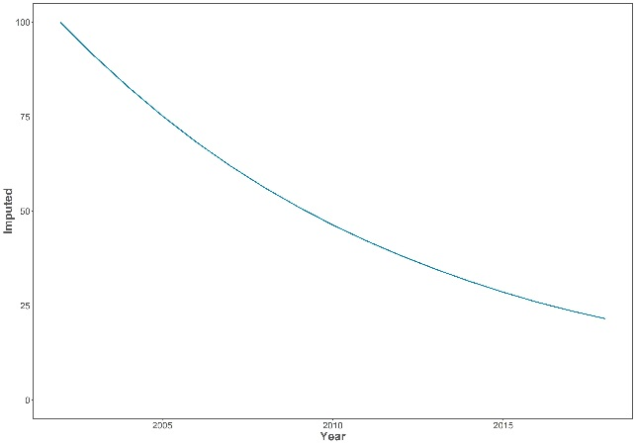  - Ferruginous Duck
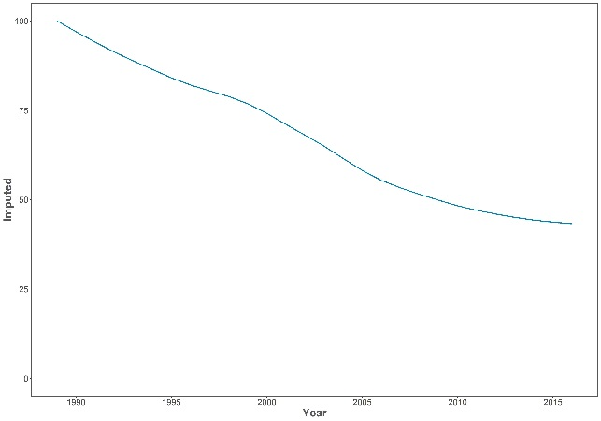  - Tufted Duck | 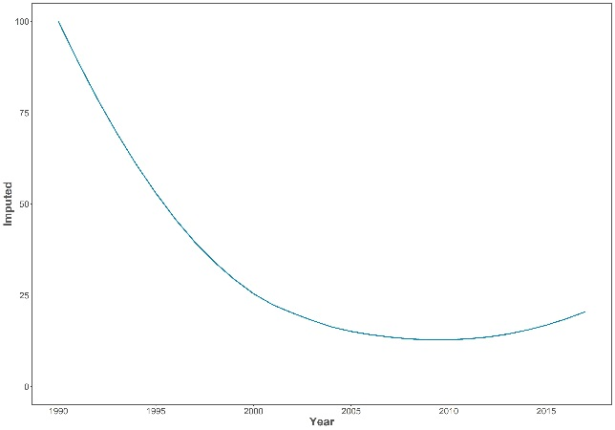  - Garganey
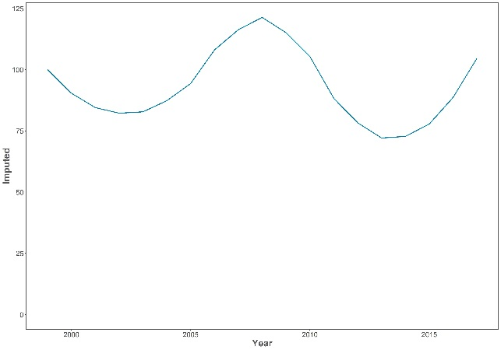  - Northern Shoveler | 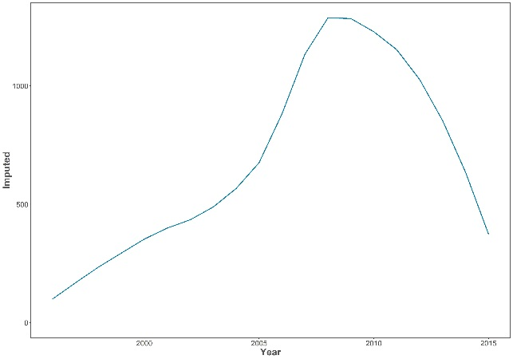  - Baikal Teal
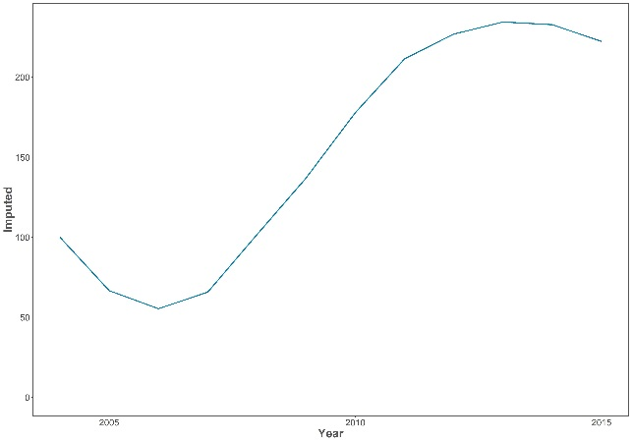  - Falcated Duck | 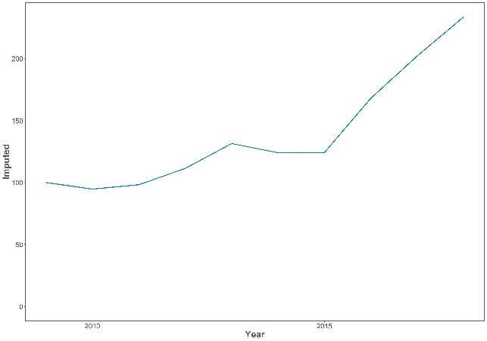  - Gadwall
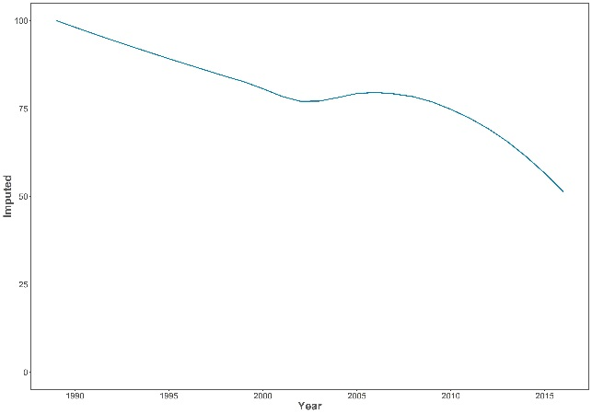  - Eurasian Wigeon | 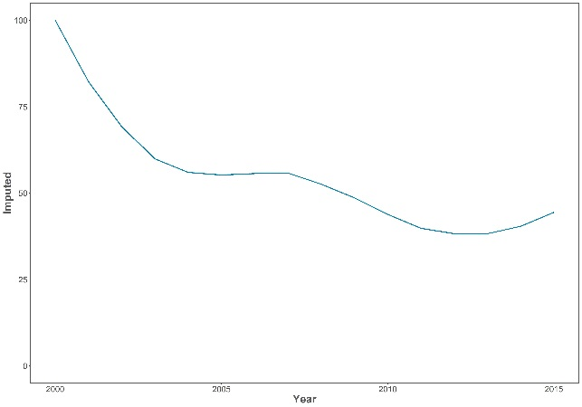  - Chinese Spot-billed Duck
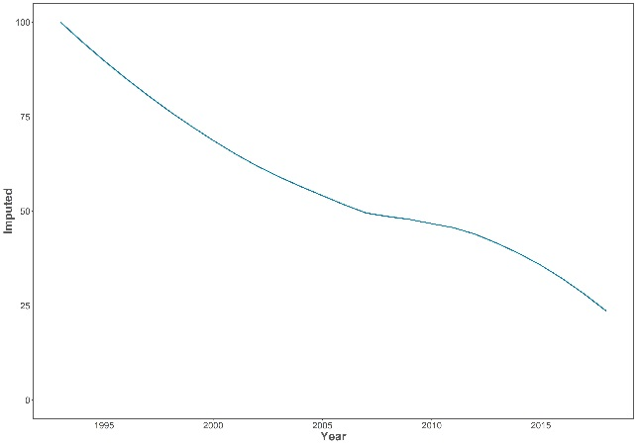  - Indian Spot-billed Duck | 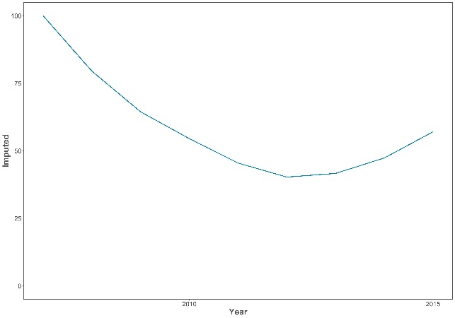  - Mallard
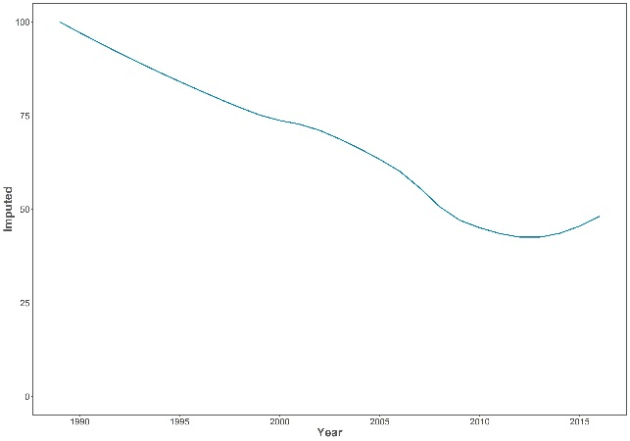  - Northern Pintail | 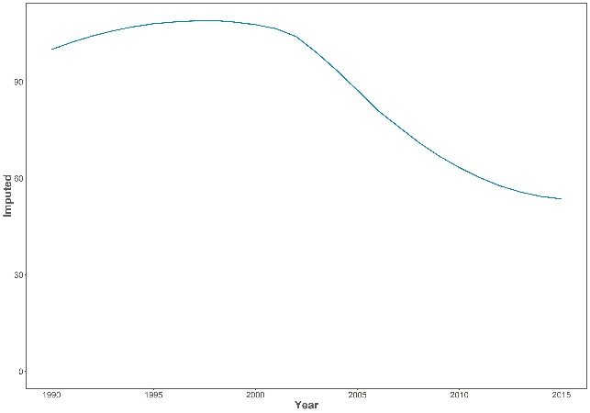  - Common Teal

Annex III. Draft Structure for EAAFP Conservation Status Review.

A proposed structure for the EAAFP Conservation Status Review is outlined below:

Executive Summary
Acknowledgements
Introduction

Part 1. Taxonomic and geographic patterns of migratory waterbird populations included in the EAAFP
Part 2. Population sizes – summarizing information available on population estimates and gaps
Part 3. Population trends – summarizing information available on population trends and 1% for the Flyway Site Network application
Part 4. Species of global conservation concern - summarizing information on species and biogeographic populations of global conservation concern, based on the IUCN Red List of Threatened Species
Part 5. Progress towards the targets set in the EAAFP Strategic Plan

Annex 1. Population sizes and trends of waterbird species included in the Partnership - the most recent population estimate of each population covered as is presented in the Waterbird Population Estimates Online Database

https://waterbird.fund/
http://wpe.wetlands.org/
Note that currently there is not a complete list of recognised EAAFP waterbird populations and most true seabird families within the EAAF are not currently included within the mandate of the WPE.
Red List updates are carried out annually for a suite of species for which a potential change in status is justified, and every five years for all species regardless of whether a potential change in status is likely.
Results presented here are for 59 populations, rather than the 60 currently recognised by EAAFP, since the key source of information for geese (Fox & Leafloor 2018) reported the two populations of Brent Goose as a single population (see Table 1).
Quality scores in italics are not available in WPE5 and have been estimated here for the first time.
Both East Asian populations recognised by Wetlands International are treated as a single population by CAFF (2018).
Estimated trend of INC? selected based on Liu et al. (2016), who compiled data from a broad period and also identified short-stopping as an explanation for the large increase in the number of Bar-headed Geese spending the non-breeding period in Tibet.
Treated as two separate populations by CAFF (2018) spending the non-breeding period in (i) China and (ii) Korean peninsula.
Both East Asian populations recognised by Wetlands International are treated as a single population by Fox & Leafloor (2018).

