“迁徒之路–连接人与迁徙水鸟”
FLYWAYS – CONNECTING PEOPLE ANDMIGRATORY WATERBIRDS

东亚-澳大利西亚迁飞区伙伴关系
第十次成员大会
10TH MEETING OF PARTNERS TO
THE PARTNERSHIP FOR EAST ASIAN – AUSTRALASIAN FLYWAY

会议手册
PROGRAMME

2018年12月9日-14日
Dec.9-14, 2018

中国·海南·昌江
Changjiang, Hainan, China
主办单位 Hosts
东亚-澳大利西亚迁飞区伙伴关系秘书处
The Secretariat of East Asian – Australasian Flyway Partnership
中国国家林业和草原局野生动植物保护司
Department of Wildlife Conservation, National Forestry and Grassland Administration, PR China
中国海南省林业局
Forestry Department of Hainan Province, PR China

承办单位 Organizer
北京林业大学东亚-澳大利亚候鸟迁徙研究中心
Center for EAAF Studies, Beijing Forestry University

协办单位 Co-organizer
中国林业科学研究院全国鸟类环志中心
National Bird Banding Center of China, Chinese Academic of Forestry

支持单位 Sponsors
Lotek无线电公司
Lotek Wireless Inc.
杭州粤海科技有限公司
Hangzhou Yuehai Technology Co., ltd
百鸟数据科技（北京）有限责任公司
Birds Data Technologies (Beijing) LLC.
EcoTone
EcoTone无线遥测技术公司
Equipment supported by Sony (China) Limited
器材由索尼（中国）支持
一、会议概况 General Information
（一）会议日期 Meeting Schedule
日期  Date | 内容  Content | 地点  Venue
12月9日星期日  Dec.9,Sun. | 工作组平行会议  WG/TF Meetings | 见会议日程  Please refer to the agenda
12月10日星期一  Dec.10,Mon. | 开幕式及会议  Opening ceremony & Plenary Meeting | 开元厅&恒盛厅  New Century Hall & Hengsheng Hall
12月11日星期二  Dec.11,Tue. | 会议  Plenary Meeting | 恒盛厅  Hengsheng Hall
12月12日星期三  Dec.12,Wed. | 会议  Plenary Meeting | 恒盛厅  Hengsheng Hall
12月13日星期四  Dec.13, Thu. | 实地考察  Field trip | 海南东方黑脸琵鹭省级自然保护区/Dongfang Black-faced Spoonbill Nature Reserve  海南尖峰岭国家级自然保护区/Jianfengling National Nature Reserve
12月14日星期五  Dec.14, Fri. | 闭幕式  Closing ceremony | 恒盛厅  Hengsheng Hall

（二）会议地点 Venue
海南棋子湾开元度假村
New Century Resort Qizi Bay Hainan.
详细地址：海南省昌江黎族自治县昌化镇广德路
Add.: Guangde Road, Qizi Bay, 572731，Hainan

（三）会议官方语言 Official Language
大会官方语言为英语。
Official languages of the Conference is English.
开幕式期间提供中英文同传。
English-Chinese simultaneously translation will be provided for opening ceremony.

（四）办理注册 Registration
1、请12月8-9日抵达会议地点的代表在酒店大堂签到台注册；12月10日开幕式开始前在开元厅门口签到台注册。
1. Registration in the lobby on Dec 8-9; or registration at the door of New Century Hall on Dec 10.
- 请参会代表领取会议资料并确认其它信息，如返程航班信息、13日野外考察信息等。
2. Receive conference materials and confirm additional information. Confirm departure time of return flights for delegates and the field trip on Dec 13.
3、请申请免签的代表将手续费30元交到酒店前台。
3. For those who applied for visa-on-arrival, please pay RMB 30 at the Hotel front desk with your visa document.

（五）办理入住 Accommodations
会议住房时间：12月8日—14日
Accommodation Duration: Dec. 8 to 14
参会代表领取会议资料后，直接到酒店前台办理入住手续。刷卡时使用其他货币者按照付款当天的汇率结算。已正式注册代表凭预定名单入住并享受会议折扣。未正式注册代表请自行办理酒店入住，实行当季商业价格。请提供银联或维萨卡，其他卡可能会存在问题，或使用现金结账。
Representatives shall check in at their respective hotels after obtaining conference materials. For card payment in other currencies, please pay as per the current rate of the day. Formally registered participants check in by confirmation list which the secretariat provided to the hotel and pay the meeting discount price. Non-registered participants check in as regular customer without meeting discount. Try to take your UnionPay or Visa credit card, other cards may not work, or pay by cash (USD or RMB).
办理入住时，酒店将根据入住天数收取相应数额的押金，建议刷信用卡预授权。参会者应与酒店结清所有费用后方可离店，包括食宿费及其他房间消费，如本地及长途电话费、商务中心消费、洗衣费、客房及酒店交通服务、迷你酒吧物品使用、餐厅及酒吧服务等费用。
The participant will pay the corresponding deposit when check in. A pre-authorization of your credit card is recommended. After paying all bills, you can leave from the hotel, including room charges and other expenses, such as for local and long-distance telephone calls, business center use, laundry, room and hotel transportation services, mini-bar items, as well as restaurant and bar services.
迟到或改期的参会者应及时提前告知会务组，以便更改或取消房间预定；否则需要对其预定的房间因空置而产生的费用负责。
Please inform the organizer to change or cancel your room reservation in advance, if you arrive late or want to change check-in time; or you are responsible for covering the cost of your un-used room.
入住时间：14:00；退房时间：12:00.
Check-in: 14:00; Check-out: 12:00.

房间信息Room Rate
酒店名称  Hotel | 详细地址  Add. | 房间类型  Room type
会议酒店  Conference hotel  海南棋子湾开元度假村  New Century Resort Qizi Bay Hainan. | 棋子湾广德路，5272731  Guangde Road, Qizi Bay, 572731.  TEL: (86)- 898-3115 6666 | 豪华大床房150美元/间/晚  Deluxe King Bed Room for one person  USD 150/Room/ Night  豪华双床房182美元/间/晚  Deluxe Twin Bed Superior Room for two people USD 182/Room/ Night  海景大床房170美元/间/晚  Seaview King Bed Room for one person  USD 170/Room/ Night  海景双床房202美元/间/晚  Seaview Twin Bed Room for two people  USD 202/Room/ Night  海景家庭房270美元/间/晚  Seaview Twin Bed room with an extra bed for three people  USD 270/Room/ Night

（六）用餐安排 Meals
用餐时间及地点安排如下：
Time and venue:
- 早餐7:00—8:30：二楼祺·咖啡；
1. Breakfast, at 7:00—8:30: 2F Chi Coffee
2、午餐12:00—13:30：二楼祺·咖啡；
2. Lunch, at 12:00—13:30: B1, 2F Chi Coffee
3、晚餐18:00—20:00；二楼祺·咖啡；
3. Dinner, at 18:00—20:00: 2F Chi Coffee
4、12月10日欢迎晚宴晚餐地点：开元厅。
4. Dinner on Dec. 10: New Century Hall
5、12月13 日欢送晚宴地点：一楼草坪。
5. Venue of closing reception on Dec. 13: 1F, Great Lawn
在会议期间（12月9日至14日），酒店提供三餐，包含12月8日的午餐和12月15日的早餐。 12月10日将举行欢迎晚宴，12月13日将举行欢送晚宴。鉴于穆斯林和素食者的特殊饮食要求，酒店将提供自助餐。如果参会人员对食物过敏或有其它特殊要求，可以联系组委会做出相应安排。由于菜品材料供应限制，酒店不提供固定菜单。
For hotel residents, meals (breakfast, lunch, and dinner) are provided as part of the accommodation package and are available during the meeting (9-14 December), but including the lunch on 8 December and the breakfast on 15 December. There will be a welcome dinner on 10 December and a closing reception on 13 December. Considering special dietary requirements for Muslim and vegetarian as examples, meals are provided in buffet style. And, other special arrangements can be made, should participants have any food restrictions or allergies. However, due to the hotel policy, there is no fixed menu for each day due to the balance between variety and daily material supply.
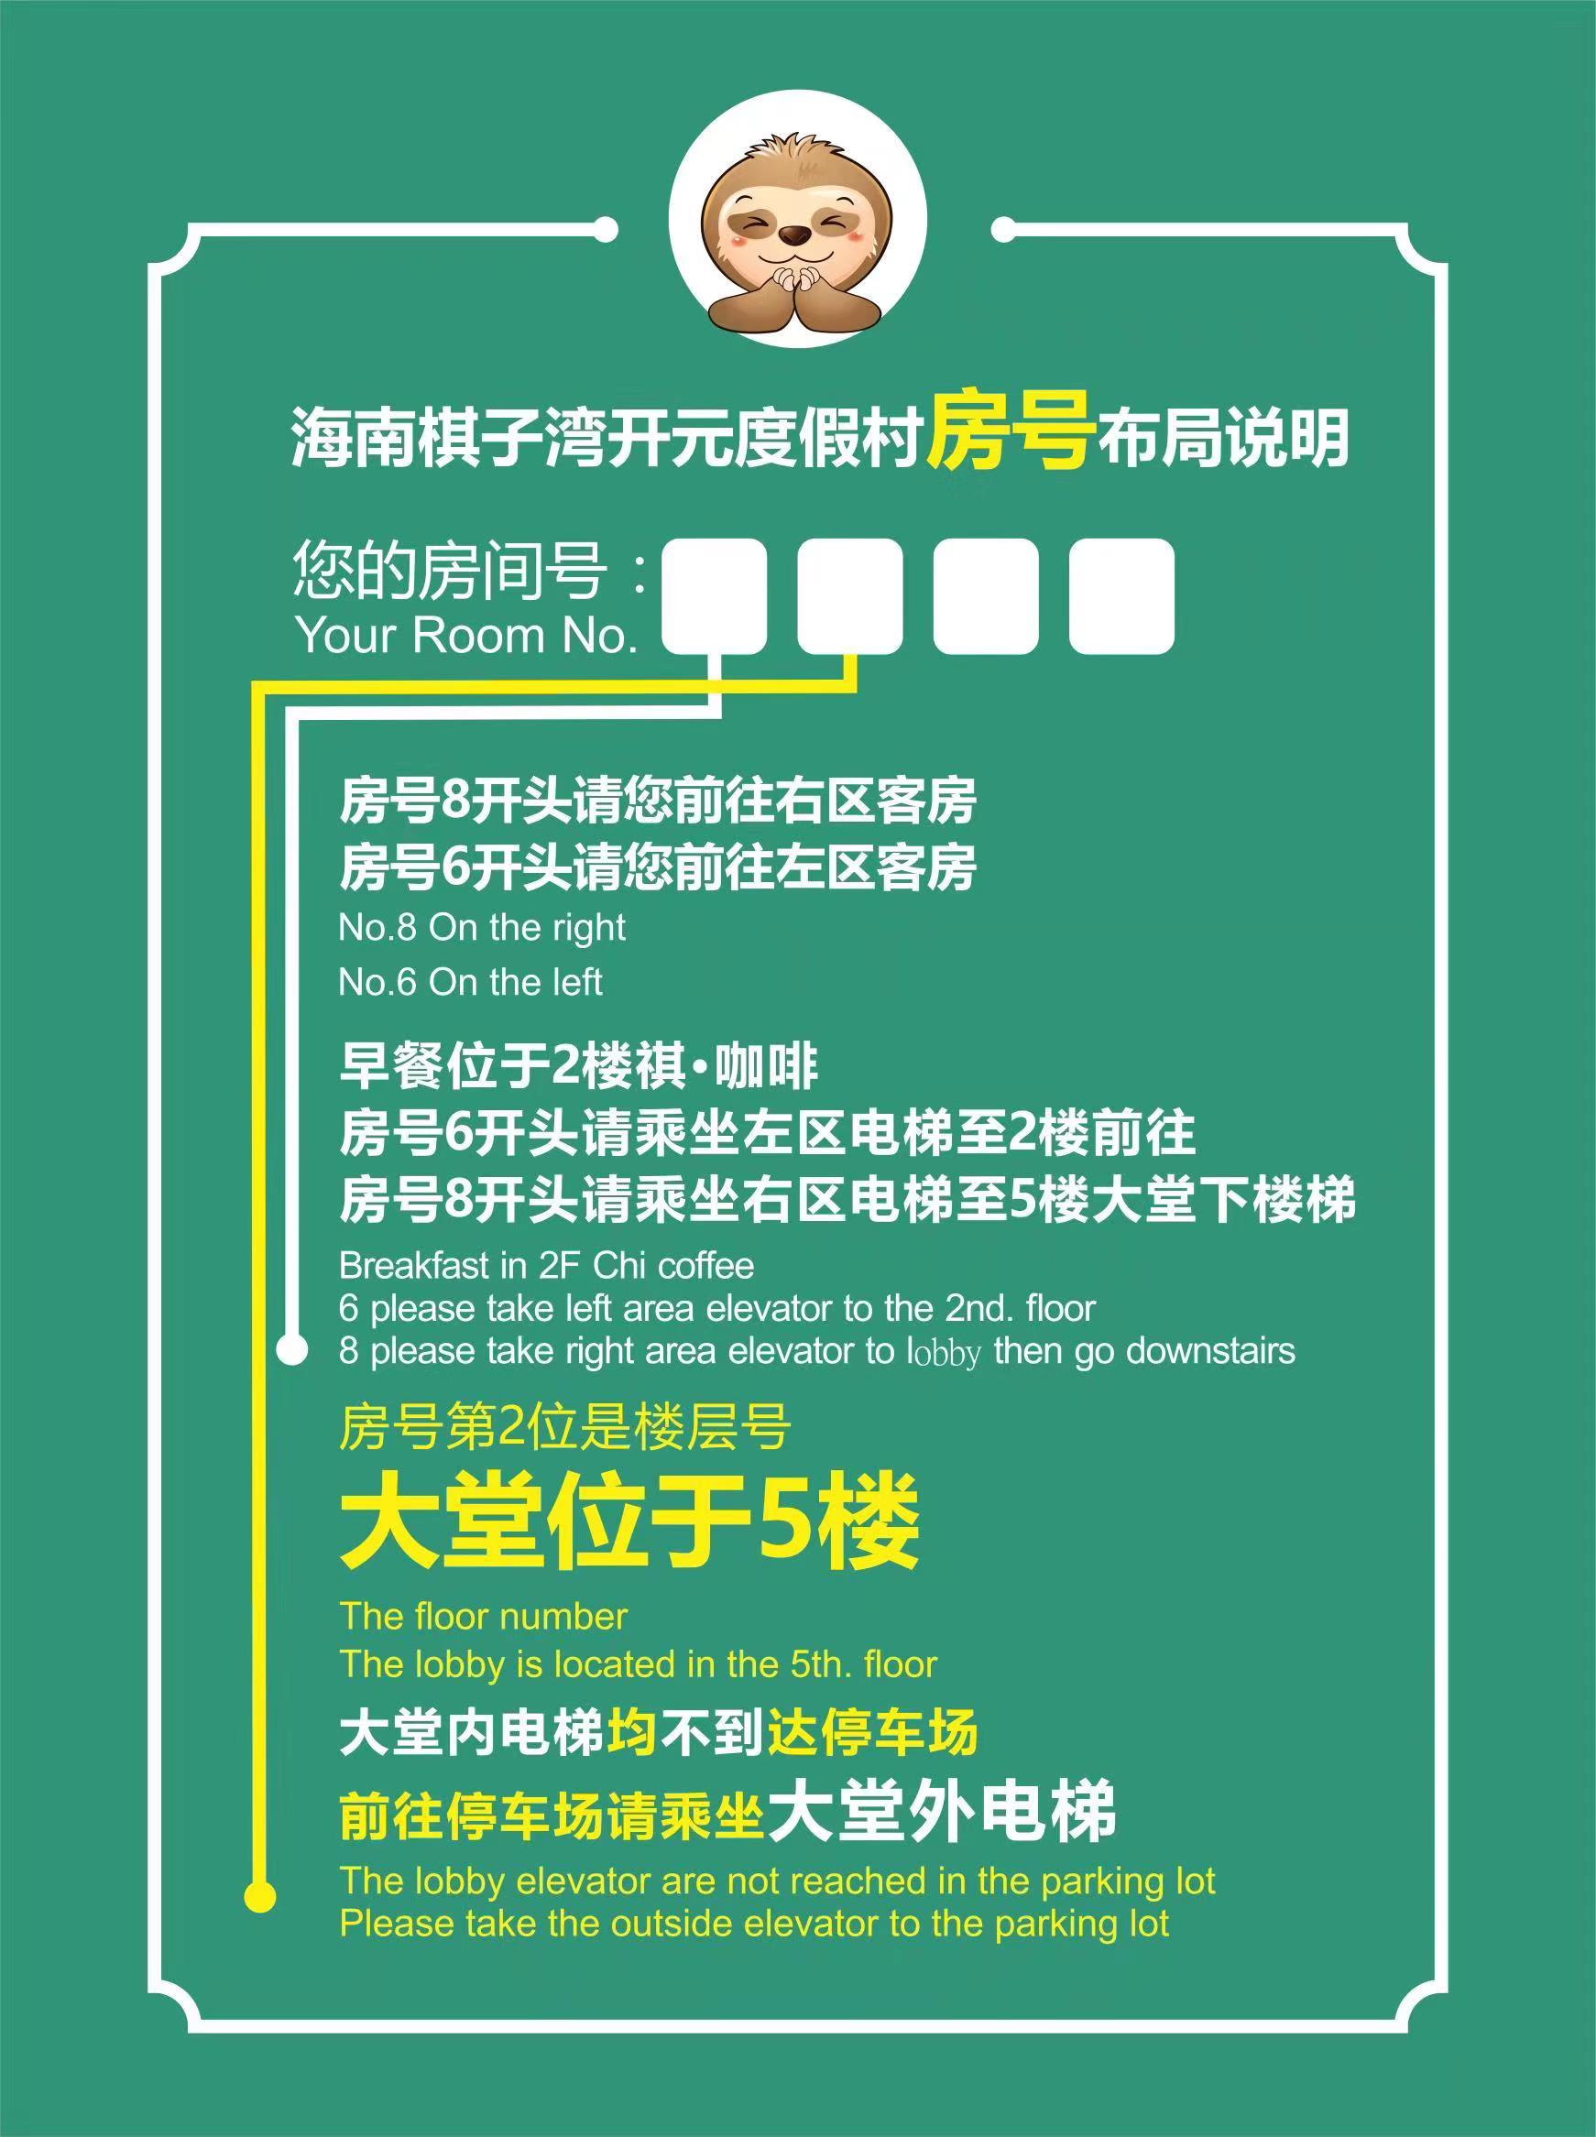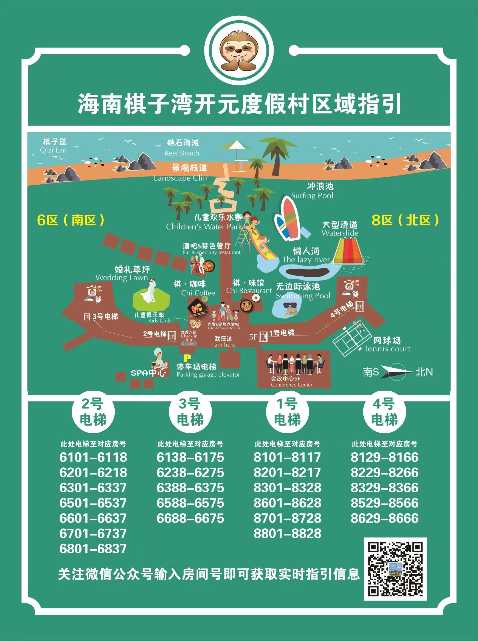

（七）会场
(VII) Conference Venues
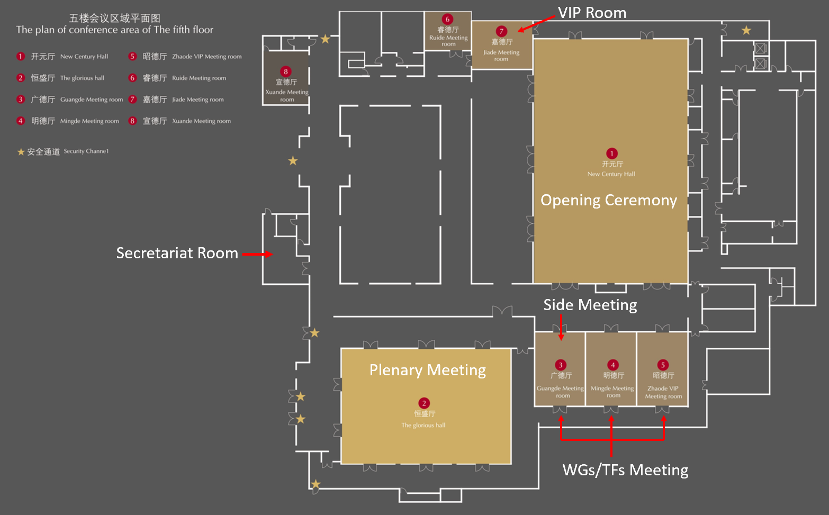

（八）报告交流须知
(VIII) Conference kind reminders
1、会议期间设有展台，并安排有特别报告及晚间会谈。
1. There are display booths, special presentations as well as evening talks for
participants between 10 and 14 December.
联系人/Contact person
- 展台/Display booth: Minshil Lee (EAAFP) and Jia Yifei (BFU)
- 特别报告/Special presentation: Vivian Fu (EAAFP)
- 晚间会谈/Evening Talks: Yeonah Ku (EAAFP) and Wu Lan (BFU)
2、报告PPT试放：ppt显示比例为16:9；请至少提前一天将ppt提交至会务组；若参会代表需对已提交ppt做出修改，请提前半天联系会务组人员。
2. PPT trial play: The display ratio of LED screen is 16:9. Please submit ppt to secretariat@eaaflyway.net (Secretariat) and ginkgoasis@foxmail.com(BFU) at least one day in advance. In case of any changes to the submitted ppt, please contact conference staff a half day in advance at the Secretariat Room.
3、交流发言时间：见会议日程。
3. Speech preparation: Please refer to the agenda.
4、主持人：请会议主持人提前确认会议日程，若有临时变动，请提前告知会务组。
4. Host: the host shall confirm the agenda in advance and inform conference agenda staff in case of any changes.

（九）野外考察
(IX) Field trips
12月13日，实地考察东方黑脸琵鹭省级自然保护区及尖峰岭国家级自然保护区，由大会承办方负责往返交通和午餐，当日往返，并在酒店举行欢送晚宴。
On December 13th, the field inspection of the Dongfang Black-faced Spoonbill Provincial Nature Reserve and the Jianfengling National Nature Reserve was carried out by the organizer of the conference. The round-trip transportation was held on the same day and a farewell dinner was held at the hotel.
请代表于注册时选择野外考察分组。
Please select your field trip group when you register.

（十）接送机安排 Transportation
1、海口美兰机场大巴接送 Bus transportation
海口美兰国际机场-棋子湾开元度假村：距离220公里，开车需2小时30分到3小时。
It’s about 220km from Haikou Meilan International Airport to New Century Resort of Qiziwan. It takes 2hr30min ~ 3hr by bus.
大巴时刻表 Bus timetable
美兰机场-棋子湾开元度假村 Haikou Meilan Airport – New Century Resort
12月8日/8 Dec. | 14:00；17:00；20:30
12月9日/9 Dec. | 14:00；17:30
棋子湾开元度假村-美兰机场 New Century Resort – Haikou Meilan Airport
12月14日/14 Dec. | 18:00
12月15日/15 Dec. | 06:00；11:00

请确保您已提前告知会务组您的抵达信息，以便会务组安排接机事宜。请在机场到达厅找寻带有EAAFP标志的指示牌，将有接站人员带您前往大巴。会务组仅提供海口美兰国际机场往返会议地点的接送服务，其他时间抵达的代表请参考火车信息，自行前往会议地点。若当天到达时间太晚，错过了乘坐大巴的时间，您可在机场附近入住，第二天再乘坐大巴或火车前往会场，但请提前告知会务组。
Please make sure that you have sent your flight information to the organizer at least one day in advance, which is convenient to pick up you. Please find the indicator with the logo of EAAFP, our staff will bring you to the bus. The organizer can only provide the bus transit between Haikou Meilan International Airport and New Century Resort; or please refer to train timetable as below, and travel to Qiziwan Station by yourself. If when you arrive at Meilan is too late to take the bus, you can check into a hotel near the airport, and take bus or train to the meeting venue.
14日会议结束后，会务组将安排大巴将当天离开的代表送至机场，请需要乘车的代表注意大巴发车时间。若您乘坐的航班早于大巴到达海口美兰国际机场的时间，请您选择合适的交通工具自行前往机场（参见火车信息）。
After the meeting finished, there is a bus taking those participants who must leave on 14 Dec to Haikou Meilan International Airport. Please note the departure time of this bus. If your flight on 14 Dec is earlier than the time when the bus arrive at the airport, please make a good choice for your travel in case missing your flight. Also you can refer to train timetable.

2、棋子湾火车接站
从海口美兰机场出发至棋子湾站需1小时40分到2小时；从三亚凤凰机场至棋子湾站需80到90分钟。酒店提供棋子湾站往返酒店的免费接送服务，行程约15分钟，请提前告知酒店您乘坐的车次，以便安排接站。酒店服务电话：+86-(0)898-3115 6666。
It’s 1hr 40min ~ 2hr from Haikou Meilan International Airport Station to Qiziwan Station by high-speed train; it’s 80 ~ 90min from Sanya Fenghuang Airport to Qiziwan Station. The hotel provides a free shuttle bus service from Qiziwan Station to hotel, which takes about 15 minutes. Please tell your train number to the hotel service (Tel: +86-(0)898-3115 6666) on your traveling day, so that the hotel will pick up you.

3、火车时刻表 Train timetable
无法乘坐大巴的代表请自行乘坐高铁前往会议地点，车票费用自理。购票时请出示护照，请使用人民币付款，购票处不支持使用VISA卡或万事达卡。
The participant taking high-speed train should buy tickets by himself/herself. Please offer your passport and use RMB by cash. VISA and Master cards are unavailable.
因铁路局运营调整，列出时刻表可能出现变化，请以最近的时刻表为准。您可在携程网（www.ctrip.com）上查询相关信息。
The train timetable might be adjusted occasionally by railway administration, please check the newest timetable on the website (www.ctrip.com) before you buy the train ticket.
美兰-棋子湾 Meilan – Qiziwan
车次  Train No. | 出发时间  Departure | 到达时间  Arrival | 票价  Ticket rate
D7210 (only Fri. – Sun) | 08:25 | 10:18 | 一等座113元  First Class: ￥113  二等座/无座71元  Second Class & No-seat-ticket: ￥71
D7102 | 08:50 | 10:31
D7165 | 10:20 | 13:37
D7106 | 12:55 | 14:36
D7214 (only Fri. – Sun) | 13:19 | 15:04
D7108 | 15:48 | 17:24
D7218 (only Fri. – Sun) | 17:56 | 19:41
D7112 (only Fri. – Sun) | 20:26 | 22:03

棋子湾-美兰 Qiziwan –Meilan
车次  Train No. | 出发时间  Departure | 到达时间  Arrival | 票价  Ticket rate
D7152 | 08:00 | 09:47 | 一等座113元  First Class: ￥113  二等座/无座71元  Second Class & No-seat-ticket: ￥71
D7113 | 08:02 | 11:14
D7154 | 10:40 | 12:16
D7212 (only Fri. – Sun) | 11:05 | 13:04
D7216 (only Fri. – Sun) | 15:49 | 17:41
D7220 (only Fri. – Sun) | 20:27 | 22:04
D7162 | 20:43 | 22:20

三亚凤凰机场-棋子湾 Sanya Fenghuang Airport – Qiziawan
车次  Train No. | 出发时间  Departure | 到达时间  Arrival | 票价  Ticket rate
D7202 | 08:10 | 09:41 | 一等座94元  First Class: ￥94  二等座/无座59元  Second Class & No-seat-ticket: ￥59
D7154 | 09:20 | 10:39
D7166 | 12:19 | 13:37
D7204 | 15:55 | 17:26
D7206 | 18:10 | 19:40
D7162 | 19:23 | 20:42

棋子湾-三亚凤凰机场Qiziwan – Sanya Fenghuang Airport
车次  Train No. | 出发时间  Departure | 到达时间  Arrival | 票价  Ticket rate
D7113 | 08:02 | 09:30 | 一等座94元  First Class: ￥94  二等座/无座59元  Second Class & No-seat-ticket: ￥59
D7201 | 09:01 | 10:31
D7101 | 10:32 | 11:46
D7203 | 13:16 | 14:46
D7105 | 14:37 | 15:56
D7107 | 17:25 | 18:44
D7109 | 19:23 | 20:47
D7119 | 20:18 | 21:42

海口美兰国际机场地图/Map of Haikou Meilan International Airport
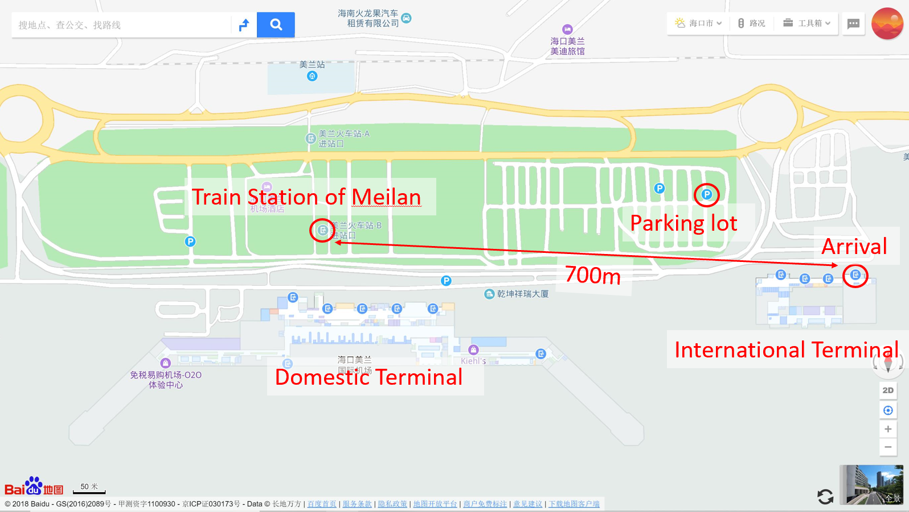

二、服务团队（会务组名单及联系电话）Support Team (Staff and Contacts)
（一）会议统筹协调Overall coordination:
秘书处EAAFP Secretariat:
Ms. Hyeseon DO 都惠宣
邮箱 Email：programme@eaaflyway.net
微信 Wechat ID: EAAFPhyeseon
国家林业和草原局National Forestry and Grassland Administration：
Ms. XIAO hong 肖红
电话Tel：+86-10-84238441
海南省林业局Forestry Department of Hainan Province：
Mr. WANG Shili 王世力
手机 Mobile：+86 18089776996
北京林业大学Beijing Forestry University：
Mr. LU Cai 吕偲
邮箱 Email：lucai.wetland@foxmail.com
微信 Wechat ID: onescoop
手机 Mobile：+86 13810000086
中国林业科学研究院全国鸟类环志中心National Bird Banding Center, CAF：
Mr. LU Jun 陆军
手机 Mobile：+86 13701228305
（二）议程与活动安排Programme and side meetings
Ms. Hyeseon Do 都惠宣
邮箱 Email：programme@eaaflyway.net
微信 Wechat ID: EAAFPhyeseon
Mr. LU Cai 吕偲
邮箱 Email：lucai.wetland@foxmail.com
微信 Wechat ID: onescoop
（三）签证及媒体 Visa and Communications
Ms. Vivian FU 傅咏芹
邮箱 Email：communication@eaaflyway.net
微信 Wechat ID: vivian_fu49
Ms. WU Lan 吴岚
邮箱 Email：wulan.pku@gmail.com
微信 Wechat ID: basket_wu
Ms. ZENG Qing 曾晴
邮箱 Email：ginkgoasis@foxmail.com
微信 Wechat ID: ginkgoasis
（四）财务负责人 Financial information
Ms. Yejin JUNG
邮箱 Email：finance@eaaflyway.net
Ms. LIU Yunzhu
邮箱 Email：rosie312@163.com
（五）企业联系人Corporate engagement
Ms. Yoon LEE
邮箱 Email：fundraising@eaaflyway.net
微信 Wechat ID: yoonlee2018
Mr. JIA Yifei
邮箱 Email：jiayifei@bjfu.edu.cn
微信 Wechat ID: jifbaggio
（六）当地联系人Local coordination
北京林业大学 Beijing Forestry University
Ms. LIU Yunzhu刘云珠：  手机 Mobile：+86 13699228415  邮箱 Email：rosie312@163.com,  微信 Wechat ID: xiaoP2001 | Ms. WU Lan吴岚：  手机 Mobile：+86 13811194908  邮箱 Email：wulan.pku@gmail.com,  微信 Wechat ID: basket_wu
海南省林业局 Forestry Department of Hainan Province
王世力 Mr. WANG Shili 手机 Mobile：+86 18089776996

三、会议议程一览表 Agenda
12月9日-14日
会场：海南棋子湾开元度假村
Dec. 9 to 14
Venue: New Century Resort Qizi Bay Hainan.
2018年12月9日（星期日）Sunday 09 December 2018
工作组内部会议Working Groups and Task Forces meetings
时间  Time | 广德厅  Guangde Hall | 明德厅  Mingde Hall | 昭德厅  Zhaode Hall
09:00-10:30 | 宣教工作组  CEPA WG | 黄海生态区工作组  Yellow Sea Ecoregion TF | 东盟迁飞区工作组  ASEAN Flyway Network
茶歇/Break
11:00-12:30
12:30-13:30 | 午 餐/ Lunch
13:30-15:00 | 雁鸭类工作组(及中华秋沙鸭和青头潜鸭特别行动组)；  Anatidae WG  (+Baer's pochard TF and Scaly-sided merganser TF) | 鸻鹬类工作组 (到17:30)  Shorebird WG (until 17:30)
茶歇/Break
15:30-17:00
18:00 | 晚 餐 /Dinner
19:00-21:00 | 海鸟工作组  Seabird WG | 技术委员会  Technical Committee | 管理委员会  Management Committee
2018年12月10日（星期一）
Monday 10 December 2018
09:00-09:10 | 文艺演出（10分钟）  Cultural Performance (10”) |  | 开幕式  Opening Ceremony  开元厅  New Century Hall  主持人/MC  Yoon Lee (  秘书处（  The Secretariat (TBC)  记录/Rapporteur:  Doug Watkins
09:10-09:40 | 欢迎辞（30分钟）  - EAAFP管理委员会主席Pete Probasco先生致辞  - 国家林业和草原局领导致辞  - 海南省林业局领导致辞  - 海南省昌江县政府领导致辞  Welcoming Address (30”)  - Chair, EAAFP Management Committee  - Representative of National Forestry and Grassland Administration  - Representative of Hainan Province  - Representative of Changjiang City  - (Gifts)
09:40-09:55 | 颁发新伙伴证书及代表发言（15分钟）  - 朝鲜政府代表  - 保尔森基金会代表  Certificates Ceremony and presentations from New Partners (15”)  - DPR Korea  - Paulson Institute
09:55-10:10 | 为新加入迁飞保护地网络的保护地颁发证书及代表（韩国华城市长）发言  - 孟加拉国（1）  - 朝鲜（2）  - 韩国（1）  - 缅甸（2）  - 新西兰（1）  Certificates Ceremony for new Flyway Netowrk Sites and presentations from Hwaseong City Mayor, Republic of Korea (15”)  - Bangladesh (1)  - Korea, DPR (2)  - Korea, RO (1)  - Myanmar (2)  - New Zealand (2)
10:10-10:35 | 主题演讲（25分钟）  - 中国迁徙水鸟及其栖息地的保护（雷光春教授，北京林业大学）  Key note presentation:  - Conservation of migratory waterbirds and their habitats in China (Prof. LEI Guangchun, BFU)
10:35-11:00 | 合影（酒店广场）  Group Photo
11:00-11:30 | 茶歇及媒体采访  （秘书处主席、伙伴成员、新加入伙伴）  Coffee Break & Media interview |  | 嘉德厅/Jiade Meeting Room
11:00-12:30 | 程序和行政事项  Procedural and Administrative Matters:  •通过暂定议程 (Doc.2)  Adoption of the Provisional Agenda (Doc.2)  •批准暂定方案 (Doc.3)  Adoption of the Provisional Program (Doc.3)  •批准暂定议程规则  Approval of the Provisional Rules of Procedure (Doc.1)  •任命会议主席和副主席  Appointment of Meeting of Chair and Vice-Chair for the meeting  •批准第九次合作伙伴会议纪要（MoP9）  Approval of Minutes of the 9th Meeting of Partners (MoP9) (Doc.4)  •接纳观察员  Admission of Observers (Doc.11) |  | 开元厅/New Century Hall
12:30-13:30 | 午 餐/Lunch
13:30-15:00 | 委员会报告及推荐  Report and Recommendations of the Committees: |  | 恒盛厅/Hengsheng Hall
 | •管理委员会报告（包括选举管理委员会）  Report of the Management Committee (including election to the Management Committee) (Doc. 5) |  | 记录/Rapporteur:  Sayam Chowdhury
•财务委员会报告（包括选举财务委员会）
Report of the Finance Committee (including election to the Finance Committee) (Doc. 6)
 | 秘书处报告  Reports from the Secretariat |  | 恒盛厅/Hengsheng Hall
•秘书处预算和活动报告
Report of the Secretariat Budget and Activities 2017-2018 (Doc. 7)
•秘书处预算和活动计划
Plan for the Secretariat Budget and Activities 2019-2020 (Doc. 8)
•伙伴关系执行情况
Implementation of the Partnership (Doc. 9)
•迁飞区网络现状
Status of Flyway Network Sites (Doc. 10)
•真正应该提上议程的事项
Implication of substantive agenda items (Doc. 12)
 | 审议伙伴、委员会和秘书处提交的决议草案  Consideration of the draft Decisions submitted by Partners, Committees and the Secretariat (See DD.1 to DD.14) |  | 恒盛厅/Hengsheng Hall
15:00-15:30 | 茶 歇/Break
15:30-17:00 | 审订决议草案（续）  Consideration of the draft Decisions (cont.) |  | 恒盛厅/Hengsheng Hall
18:00 | 欢迎晚宴/ Welcome Dinner |  | 主持人/Host
20:30-21:30 | 边会：非法狩猎工作组会议  Side Meeting: Illegal Hunting Task Force meeting |  | 广德厅/Guangde Hall
2018年12月11日（星期二）Tuesday 11 December 2018
恒盛厅/Hengsheng Hall
09:00-09:30 | 专题报告：  全球湿地的现状：我们能做什么？  The state of the world's wetlands: what can we do about it? |  | Nick Davidson教授、主席  EAAFP技术委员会  Prof. & Chair of EAAFP Technical Committee  记录/Rapporteur:  Micha Jackson
09:30-09:45 | EAAFP 2019 - 2028年战略计划讨论  Discussion on the EAAFP Strategic Plan 2019 - 2028
09:45-10:30 | 审订决议草案（续）  Consideration of the draft Decisions (cont.)
10:30 – 11:00 | 茶 歇/Break
11:00-12:30 | 审订决议草案（续）  Consideration of the draft Decisions (cont.)
12:30 – 13:30 | 午 餐/Lunch
13:30-15:00 | 审订决议草案（续）  Consideration of the draft Decisions (cont.) |  | 记录/Rapporteur:  Ding Li Yong
15:00 – 15:30 | 茶 歇/Break
15:30-17:00 | 审订决议草案（续）  Consideration of the draft Decisions (cont.)
17:00-18:00 | 专题报告：工作组/行动组关键行动  勺嘴鹬特别行动组（10分钟）  中华秋沙鸭特别行动组（10分钟）  非法狩猎特别行动组（10分钟）  水鸟监测特别行动组（10分钟）  青头潜鸭特别行动组（10分钟）  Special Presentation: Key activities of WGs/ TFs  Spoon-billed Sandpiper TF (10”)  Scaly-sided Merganser TF (10”)  Illegal Hunting TF (10”)  Monitoring TF (10”)  Baer’s Pochard TF (10”)
18:00-19:30 | 晚餐/Dinner
19:30-21:00 | 边会：迁飞网络保护区的互动与交流/Side Meeting : Interactive Session of EAAF Site Manager  伙伴对话/Partnership Talk （酒店大堂） |  | 广德厅/Guangde Hall
2018年12月12日（星期三）Wednesday 12 December 2018
恒盛厅/Hengsheng Hall
09:00-09:20 | 专题报告：东亚-澳大利西亚迁飞区的大数据与大保护  Special Presentation：Bigger Data and Bigger Conservation in the EAAF engaging Science |  | 吕偲 博士  北京林业大学EAAF研究中心  Dr. LU Cai  CEAAF, BFU  记录/Rapporteur:  Taej Mundkur
09:20-09:30 | 专题保护  勺嘴鹬项目简介（含签字仪式）  Special Presentation:  Initiation of Spoon-billed Sandpiper Project（including a quick signing ceremony on project agreement） |  | 孙莉莉  深圳红树林保护基金会  Sun Lili  Shenzhen Mangrove and Wetland Conservation Foundation
09:30-09:45 | EAAFP 2019 - 2028年战略计划讨论  Discussion on the EAAFP Strategic Plan 2019 - 2028
09:45-10:30 | 审订决议草案（续）  Consideration of the draft Decisions (cont.)
10:30-11:00 | 茶 歇/Break
11:00-12:30 | 审订决议草案（续）  Consideration of the draft Decisions (cont.)
12:30-13:30 | 午 餐/Lunch
13:30-15:00 | 审订决议草案（续）  Consideration of the draft Decisions (cont.) |  | 记录/Rapporteur:  Diana Solovyeva
15:00-15:30 | 茶 歇/Break
15:30-17:00 | 审订决议草案（续）  Consideration of the draft Decisions (cont.)
17:00-17:30 | 专题报告：企业的参与  Lotek无线电公司（15分钟）  索尼公司（15分钟）  Special Presentation: Corporate’s Engagement  Lotek Wireless Inc. (15”)  Sony (China) Limited (15”)
18:00-19:30 | 晚餐/Dinner
19:30-21:00 | 伙伴对话/Partnership Talk （酒店大堂）
2018年12月13日（星期四）
Thursday 13 December 2018
08:00-16:00 | 野外考察：东方黑脸琵鹭省级自然保护区及尖峰岭国家级自然保护区  Field Trip:  Dongfang Black-faced Spoonbill Provincial Nature Reserve  Jianfengling National Nature Reserve
18:00 （顺延） | 欢送晚宴（EAAFP秘书处主办）  Farewell Reception hosted by the EAAFP Secretariat
2018年12月14日（星期五）Thursday 13 December 2018
恒盛厅/Hengsheng Hall
09:00-09:15 | 专题报告：衡水湖和青头潜鸭保护  Special presentation：Hengshui Hu and Baer’s Pochard conservation |  | 王景武  衡水市委书记  Mr WANG Jingwu,  Hengshui Party Secretary  记录/Rapporteur:  Terry Townshend
09:15-09:30 | 专题报告：开放获取全球潮间带地图  Special presentation：An open access global map of tidal flats |  | Micha Jackson博士  昆士兰大学  University of Queensland
09:30-09:45 | EAAFP 2019 - 2028年战略计划讨论  Discussion on the EAAFP Strategic Plan 2019 – 2028
09:45-10:30 | 审订决议草案（续）  Consideration of the draft Decisions (cont.)
10:30-11:00 | 茶 歇/Break
11:00-12:30 | 审订决议草案（续）  Consideration of the draft Decisions (cont.)
12:30-13:30 | 午 餐/Lunch
13:30-15:00 | 各工作组及行动组报告工作现状、问题及趋势；探讨在2019-2028年战略计划中优先支持的五个领域。  Report back from each WG/TF on their current work, issues and trends, and the five priority areas from the new Strategic Plan 2019-2028 that they will support. |  | 记录/Rapporteur:  Nick Davidson
15:00-15:30 | 茶 歇/Break
15:30-17:00 | 报告和批准MoP10的关键决议  -通过秘书处2019 - 2020年工作计划和预算  -通过筹资提案  -选举和任命管理委员会和财务委员会  -选举和任命新的主席和副主席  -发布与韩国环境部的新备忘录  -确定下一届会议的日期和地点  Report and Approval of Key Decisions from MoP10  -Adoption on Secretariat’s Workplan and Budget for 2019 - 2020  - Core points for fund raising proposal  - Election and Appointment of Management Committee and Finance Committee  - Election and Appointment of new Chair and Vice Chair  - Announcement of new MoU with MOE-K  - Date and venue of the next Meeting of Partners
17:00-17:30 | 闭幕式/Closing Ceremony  - EAAFP秘书处与北京林业大学签署合作备忘录  MoU signing ceremony between the EAAFP Secretariat and Beijing Forestry University  闭幕致辞/Closing Remarks  - 国家林业和草原局保护地司司长  Director General, Protected Area Department of National Forestry and Grassland Administration  - EAAFP管理委员会主席  Chair, EAAFP Management Committee

四、其他信息
(IV) Other Information
安全事项
由于海边礁石较多、地形复杂且没有海滨浴场及救生员，我们强烈不建议您下海游泳。擅自下海后果自负。
园区内已开放的泳池均可免费使用。
NOTICE
Because of the rocky coast and no lifeguards, swimming in the seaside is strongly NOT recommend and very dangerous. But you can still do it at your own risk. The swimming pools are free.

低碳原则
会议期间将尽量减少纸张的使用，请您前往EAAFP网站下载所有会议文件。相关文件将在网上实时更新。
网址：https://www.eaaflyway.net/about-us/the-partnership/partners/meetings-of-partners/10th-meeting-of-partners-mop-10/
请各位代表节约资源，共同降低会议的碳足迹。
Low-Carbon Policy
The use of paper will be minimized during EAAFP MoP10 by providing all the papers for discussion on the website of the EAAFP for participants to download. The link is https://www.eaaflyway.net/about-us/the-partnership/partners/meetings-of-partners/10th-meeting-of-partners-mop-10/. Revised versions of any papers will be uploaded on to the website as soon as possible during the MoP10. Please save resources for protecting the earth our homestead.

时区
会议地点中国海南省位于东八区
Time Zone
Hainan in PR China is ahead of GMT by 8 hours
互联网和电子邮件服务.
酒店客房有免费WiFi， 参会者可携带自己的笔记本电脑或智能手机进行互联网访问。
Internet and e-mail services
Wi-Fi Internet service is available in the hotel rooms free of charge. Participants are encouraged to bring their own laptop computers for in-room internet access.
天气
海南省地跨亚热带和热带， 12月初的平均温度为23°C（74°F），建议参会人员备一件长袖外套。
Weather
Hainan varies from subtropical to fully tropical. The average temperature during early December is 23 °C (74 °F), so long-sleeve shirts and a light sweater are recommended.
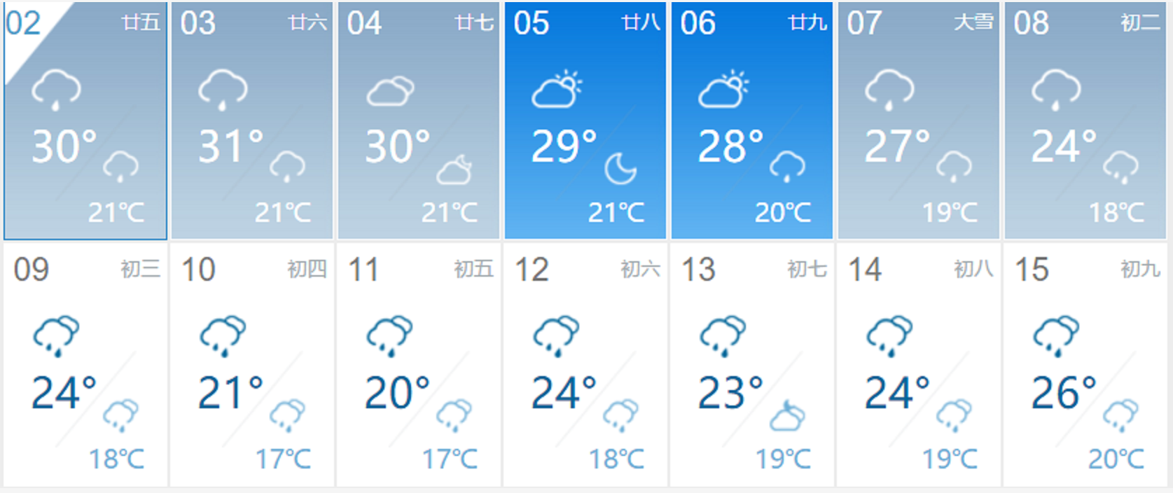
货币和银行
会议场地的前台不提供货币兑换服务。 为了您的方便，建议您事先在所在的国家或海口机场兑换货币。
Currency and Banking
The front desk at the meeting venue does not provide currency exchange services. For your comfort, it is recommended that you exchange money beforehand in your country or at Haikou airport.
插座
会议场地使用如图两种类型的插头。电源电压为220V，频率为50Hz的交流电。
Electrical Power
PR China uses two types of plugs – three-pronged angled pins, two flat pins (the most common). Electricity is 220 volts, 50 cycles AC.
The following plugs are used:

医疗服务
酒店提供常用药品医疗包。大型医院位于昌江县，距离开元度假村约40分钟路程。 如有特殊药物需求，建议自备常用药品。
Health Care
There are kit packs in the hotel. A large hospital is located in Changjiang County, where is about 40 minutes from New Century Resort. Taking your own regular medications for any contingency is strongly recommended.

Notice about visa-on-arrival
For those participants with visa-on-arrival, we kindly remind that all your itinerary information has been input in the police system, including your accommodation location. If you want to change your itinerary, please contact with the travel agency in advance to be recorded in the system. Once there is a new hotel accommodation records, the police will be notices.
If you plan to visit more places than the meeting venue, please make sure you will provide a solid travel itinerary within Hainan, or just apply a regular tourist visa.

五、机构简介
(V) Organization Introduction
东亚-澳大利西亚迁飞区伙伴关系
东亚-澳大利西亚迁飞区伙伴关系是一个候鸟迁飞区层面的、非正式的、自愿性的多边合作框架，于2006正式启动，已作为II类动议被纳入世界可持续发展首脑会议（WSSD）名录。目前有37个合作伙伴，包括18个国家政府，6个政府间组织，12个国际非政府组织，以及1个国际商业机构，每1-2年召开一次成员伙伴会议（Meeting of Partners, MoP）商讨各项工作事宜，会议地点在各成员国中轮流举行；各成员国轮流担任该伙伴关系轮值主席国。该伙伴关系于韩国仁川设立秘书处，负责日常事务。EAAFP下设14个工作组及特别行动组，针对重点关注的物种、区域等开展相应的保护研究及工作计划。
中国支撑着EAAF水鸟种数的73%，是整个迁徙路线的核心。考虑到中国对迁徙候鸟的重要地位，同时本着对全球自然环境负责的态度，中国政府成为了早期加入该伙伴关系成员国之一，由原国家林业局动植物保护与自然保护区管理司作为履约机构，在北京林业大学自然保护区学院设立中国秘书处，协助完成相关工作。
建设和扩展迁飞区保护地网络（FSN）是该伙伴协议最重要的目标及行动之一，也是其五大保护战略之一。其为保护地管理者提供一个平台，促进国家政府、网络保护地管理者和当地相关利益方共同合作，将确保对具有国际重要意义的水鸟栖息地进行可持续管理，从而整个迁飞区的迁徙水鸟得到长期而有效的保护。自1996年建立以来，目前整个迁飞区已有135个保护地纳入该网络，保护总面积超过2195万公顷。遵循一定的遴选标准和提名程序，我国已有19个自然保护地加入FSN。成为网络成员后，需定期更新信息表（SIS），制定管理行动计划，参加信息和技术交流等活动，以不断推进迁飞候鸟及其栖息地的保护与管理成效。
加强参与及推进EAAFP相关工作，为“一带一路”战略助力，有助于提升我国国际形象，增强国际话语权，提升全球治理的软实力。

The East Asian – Australasian Flyway Partnership (EAAFP)
The East Asian – Australasian Flyway Partnership was launched on 6 November 2006 and aims to conserve the migratory waterbirds that use the EAAF by ensuring the sustainable management of their habitats, and the livelihoods of the people dependent upon those habitats. The EAAFP currently has 37 Partners including 18 countries, 6 intergovernmental agencies, 12 international non-governmental organizations and 1 international private company.

EAAFP Partners have established 14 working groups and task forces to cooperate on threatened migratory species or species groups, themes, or geographic regions within the Flyway. The Partners meet every two years to share their results and to discuss ways for future cooperation. The 10th Meeting of the Partners is being held in Hainan, China in December 2018. (https://www.eaaflyway.net/)

北京林业大学东亚-澳大利西亚候鸟迁徙研究中心
东亚-澳大利西亚迁飞区（EAAF）覆盖22个国家，是生物多样性最高、同时受威胁程度最高的迁飞区。针对迁徙鸟类保护的国家需求与全球问题，北京林业大学东亚-澳大利西亚候鸟迁徙研究中心（Center for East Asian-Australasian Flyway Studies, CEAAF）聚焦迁徙水鸟及栖息地相关科学研究，同时联合多边机构打造国际平台，为迁飞区保护战略决策与实践提供科技支撑。重研究方向包括：
1）迁徙水鸟生态学；
2）栖息地保护与修复；
3）候鸟迁飞监测技术与装备研发及迁飞区大数据平台；
4）迁飞区国际多边合作机制。
Center for East Asian-Australasian Flyway Studies, CEAAF
The East Asian - Australasian Flyway (EAAF) encompasses 22 countries and is home to over 50 million migratory waterbirds from over 250 different populations, including 32 globally threatened species and 19 Near Threatened species. The Center for East Asian-Australasian Flyway Studies (CEAAF) was established in line with such global problem and national needs for biodiversity conservation, to provide scientific and technical support for the conservation strategy and practice on the EAAF basing on scientific researches, technology innovation and international platform. The research priorities include:
- Migratory waterbird ecology
- Habitat conservation and restoration
- Innovative techniques for monitoring, including big data platform
- Multi-lateral conservation mechanism in the flyway

全国鸟类环志中心
全国鸟类环志中心成立于1982年，负责全国鸟类环志技术管理、信息收集以及国际候鸟保护协定的履约工作。现有常年开展鸟类环志的站点四十多个，覆盖东亚-澳大利西亚、中亚-印度和西太平洋等三大候鸟迁徙通道。自1983年到2017年，累计环志放飞鸟类842种近365万只；此外彩色标记观察鸟类127种6099只；收集汇总200多万份鸟类环志数据，为中国候鸟迁徙规律的研究奠定基础。制定《全国鸟类环志技术规程》和《鸟类环志及鸟类疫病监测员手册》，每年举办技术培训班对来自全国的环志人员进行专业技术培训和野外技能考核。还通过卫星追踪等手段开展迁徙鸟类研究，并参与朱鹮和中华秋沙鸭等濒危物种的复壮和保护。
National Bird Banding Centre of China (NBBC)
Founded in 1982, NBBC is responsible for the nationwide bird banding management, information collection and implementation of international migratory bird conservation agreements. Now there are over 30 stations that conduct bird banding every year, covering the main flyways of East Asia-Australasian, Central Asia-India and West Pacific. From 1983 to 2017, we have banded a total of 842 species and near 3.65 million individuals, ranking first in Asia; besides, 127 species and 6099 birds have been color-banded, and over 2 millions of bird banding data have been collected and analyzed, which becomes the foundation of bird migration pattern research of China. Moreover, we publish the "National Bird Banding Technical Regulation" and "Bird Banding and Bird Disease Surveillance Manual", and organize training class every year for the professional technical training and field skill assessment of the bird banding staff from all over the country. We also conduct the satellite-tracking of some migratory bird species, and take part in the restoration of some endangered species such as crested ibis and scaly-sided merganser.

杭州粤海科技有限公司
杭州粤海科技有限公司是一家专业从事无线动物跟踪器技术研发、生产和数据服务的公司。
我们的产品包括卫星定位和卫星数据传输、VHF、UHF、GSM、NB-IOT等技术。我们以了解研究人员的需求并通过为客户提供个性化和专业化的卫星跟踪和定位产品以协助他们而感到自豪。公司秉承“创新引领市场，服务创造价值”的理念，为客户提供轻量化和安全稳定的产品！
Hangzhou Yuehai Technology Limited Company
Hangzhou Yuehai Technology Co., Ltd is a company specializing in the technology research and development, production and data service of wireless animal tracker.
Our products include satellite positioning and satellite data transmission, VHF, UHF wireless equipment, GSM, NB-IOT and other technologies. We pride ourselves on assisting them by providing personalized and specialized satellite tracking and positioning products.
Adhering to the concept of ite positioning and satellite data transmission, VHF, UHF wireless equipment, GSM, NB-IOT and other technologies. We pridstomers with safer and more stable products!

百鸟数据科技（北京）有限责任公司
百鸟数据旨在构建未来科研所需的完整生态链，从项目策划到成果产出，从定制化产品到数据精准分析，打造全流程的科研技术服务，让选择我们公司的客户更省心、更放心。公司会始终坚持“顺应自然，服务自然（In Nature, For Nature）”的创办理念，将各领域成熟的技术引入到生态学研究领域，推动生态学跨越式发展，帮助为人类探索未知的自然。我们的愿景是基于客户的科研需求锻造产品，帮助客户解决科学问题，成为心有灵犀的伙伴，一起探索无限的可能性，为梦想行动。
Birds Data Technologies (Beijing) Limited Liability Company
Our company aim to build a complete ecological chain for future research, from project planning to outcome production, from customized products to accurate data analysis, to create a full-process scientific and technical service, so that customers who choose us are more worry-free and more assured. Our company will always adhere to the founding philosophy of “In Nature, For Nature”, and introduce mature technologies from various fields into ecological research, promote the leap-forward development of ecology, and help explore the unknown nature for human beings. Our vision is to create products based on the research needs of our customers, to help our clients solve problems, to become a companion, to explore unlimited possibilities and fight for your dream.

Sony (China) Limited
Sony Corporation is uniquely positioned to be the leading electronics and entertainment company in the world. Since its founding, Sony has been always adhering to the innovation of science and technology to lead a fashionable life, constantly creating impressive and amazing entertainment experiences. In October 1996, with operating strategy of “global localization”, Sony China Co., Ltd. was established in Beijing as a Sony wholly-owned subsidiary, in charge of management and coordination of Sony's business in China as well as a wide range of business support and macro-management for Sony-invested enterprises. While doing business in China, Sony has been actively involved in China’s social and public welfare like education, culture, sports, arts and environmental protection making long-lasting efforts to improve China’s social and economic development.

索尼公司是全球领先的电子和娱乐公司。自创立以来，索尼公司始终坚持以创新科技引领时尚生活，不断创造出令人感动和惊奇的娱乐体验。以“全球本土化”的运营策略为目标，索尼于1996年10月在北京设立了统一管理和协调 在华业务活动的全资子公司——索尼（中国）有限公司，针对索尼在中国的各所属企业进行宏观管理及广泛的业务支持。在中国发展各项业务的同时，索尼还积极投身教育、文化、体育、艺术、环保等社会公益领域，为促进中国社会和经济的发展做出自己长久的贡献。

Lotek Wireless Inc.
At Lotek we are passionate about helping you achieve your wildlife tracking goals. For us, it's more than just designing and building great products. We care about your research, conservation and wildlife management work. We know that you require reliable tracking equipment, that's why our products undergo thorough testing to enhance reliability. With more than 30 years of experience in the wildlife tracking industry, our talented team of professionals are experts in both animal monitoring and tracking technologies and importantly we value our customers. We will always take the time to understand your requirements to find the tracking solution that suits your needs. Our extensive range of products is suitable for terrestrial, avian, freshwater and marine applications and have developed tracking solutions for over 550 species of wildlife.

EcoTone
Ecotone is an association of professional ornithologists and ecologists. We produce various kinds of mist nets for catching birds and bats. The quality and efficiency of our nets are the result of more than 30 years of experience in the field work. Besides mist nets we offer a wide range of equipment for ornithological and bat researches. We also produce GPS-GSM loggers for wildlife tracking. Nowadays our telemetry equipment is worldwide used and let researchers to obtain the unique and precise data about animal behaviour and migrations. Our loggers are also custom designed to meet the researchers needs. You are welcome to contact us: office@ecotone.pl or see our products at: www.ecotone.pl.
六、考察地简介
(VI) Introduction of Field Trip
海南东方黑脸琵鹭省级自然保护区简介
海南东方黑脸琵鹭省级自然保护区位于东方市四更镇境内，总面积1429公顷，主要保护对象为黑脸琵鹭，属野生生物类野生动物类型。黑脸琵鹭（Platalea minor）是重要的湿地指示物种，根据《拉姆萨湿地公约》规定，如果一个地区的黑脸琵鹭超过全球数量的1%，就应该纳入国际重要湿地保护区。东方市四更镇面前海滩继台湾曾文溪、香港米埔之外，在中国发现的黑脸琵鹭又一重要越冬地。
保护区于2006年5月18日经海南省人民政府批准建立。保护区自建立以来，管理上一方面加强了对黑脸琵鹭保护的宣传力度，另一方面加强了巡护和监测工作，使得每年过来越冬的黑脸琵鹭得到有效保护。同时，各级政府在不断加强对黑脸琵鹭保护的同时，也在保护区建设方面加大了资金的投入，并制定相关政策给予当地百姓一定的补偿，从2014年1月开始，给予社区四必村村民每人每月50元的生态补偿款，至今已实施完成红树林修复工程860亩，生态得到了进一步的改善。2017年以来，东方市大力开展海南东方黑脸琵鹭省级自然保护区范围内养殖塘退塘还林（湿）工作，力争2019年底前全面完成海南东方黑脸琵鹭省级自然保护区内养殖塘退塘还林（湿）任务。
据全球同步调查统计，黑脸琵鹭保护区一直是海南最重要的黑脸琵鹭越冬地，根据2004年以来的种群监测记录，最少时有30多只，最多时近百只。随着海南省政府、海南省林业厅和东方市政府的关切，黑脸琵鹭保护区内的湿地得以更有效的保护，红树林修复也得到了显著改善，黑脸琵鹭保护区正成为来往越冬候鸟的“天堂”，是东方市一张靓丽的绿色名片。

Hainan Dongfang Black-faced Spoonbill Provincial Nature Reserve
Hainan Dongfang Black-faced Spoonbill Provincial Nature Reserve is located in Sigeng Town, Dongfang City, with a total area of 1,429 hectares. The main protection object is the black-faced spoonbill, which belongs to the wild type of wild animals. Black-faced Spoonbill (Platalea minor) is an important wetland indicator species. According to the Ramsar Convention on Wetlands, if a black-faced spoonbill in a region exceeds 1% of the global population, it should be included in internationally important wetland protection area. In addition to Zengwenxi in Taiwan and Mipu in Hong Kong, another important wintering site in China for black-faced spoonbill has been found in the beach which in front of Sigeng town of Dongfang city.

The reserve was approved by the Hainan Provincial People's Government on May 18, 2006. Since the establishment of the reserve, the management has strengthened the propaganda of the protection of the black-faced spoonbill on the one hand and strengthened the patrol and monitoring work on the other hand, so that the black-faced spoonbill who came over the winter every year is effectively protected. At the same time, all levels governments will continue to strengthen the protection of black-faced spoonbill and increased the money put into reserve construction and formulate relevant policies to give local people a certain amount of compensation. Since January 2014, the community has given an ecological compensation of 50 yuan per month for the villagers in Sibi Village. So far, 860 Mu(a unit of area (=0.0667 hectares) of mangrove restoration works have been completed, and the ecology has been further improved. Since 2017, Dongfang City has vigorously carried out the work of retreating ponds and forests (wetland) in the breeding ponds of Hainan Oriental Black-faced Spoonbill Provincial Nature Reserve，and strive to complete the task of retreating ponds and returning forests (wetland) in the aquaculture ponds of Hainan Dongfang Black-faced Spoonbill Provincial Nature Reserve before the end of 2019.

According to global statistics, the black-faced spoonbill reserve has been the most important black-faced spoonbill wintering land in Hainan. According to the population monitoring records since 2004, there are at least 30 and at most nearly 100. With the concerns of the Hainan Provincial Government, the Forestry Department of Hainan Province and the Dongfang Municipal Government, the wetlands in the Black-faced Spoonbill Conservation Area have been more effectively protected, and mangrove restoration has also been significantly improved. The Black-faced Spoonbill Reserve is becoming a "paradise" of the wintering migratory birds is a beautiful green business card in the Dongfang city.
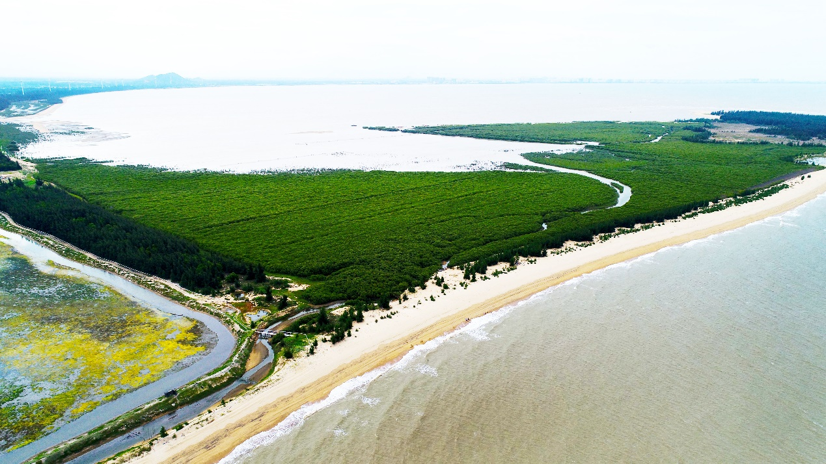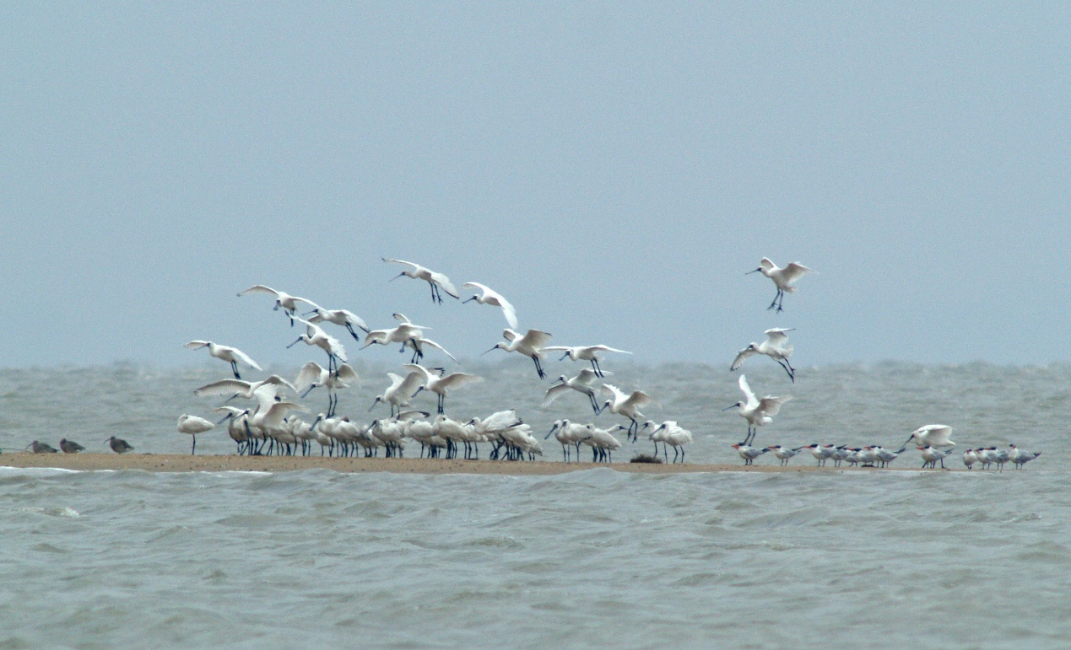

尖峰岭国家级自然保护区简介
海南尖峰岭国家级自然保护区地处海南岛西南部，位于东方市和乐东县境内，总面积20170.00hm²。保护区现为林业部门主管的自然保护区。保护区管理局为全民所有制事业单位，行政、保护管理业务、基本建设专项和其它专项计划、资金，直接受国家林业局和海南省林业厅管理。
尖峰岭保护区位于海南岛霸王岭—尖峰岭山系的南段，花岗岩梯级山地和海成阶地地貌。区内最高海拔1412.5m，最低海拔112.8m。
尖峰岭保护区处热带北缘，属热带季风气候。年平均气温24.5°C，年平均降雨量2265.8mm，年均相对湿度88.0%，年均日照时数1625h。
尖峰岭保护区分布有砖红壤、次红壤和黄壤三个土类。
尖峰岭保护区是多条河溪的发源地。东南向的南巴河，经昌化江汇流入海；南面的望楼河经长茅水库汇流入海；西南面的佛罗河、陀伦河—白沙溪、西及西北面的感恩河、南渡江、通天河等，均独流入海。
尖峰岭保护区植物区系的地理分布以热带成分为主，分为热带半落叶季雨林、热带常绿季雨林、热带北缘沟谷雨林、热带山地雨林和山顶苔藓矮林5个植被类型。区内维管植物2221种，国家重点保护野生植物31种，其中Ⅰ级3种，Ⅱ级28种。
尖峰岭保护区的陆生脊椎动物以东洋界成分为主。区内脊椎动物371种，昆虫2222种。国家重点保护野生动物42种，其中Ⅰ级5种，Ⅱ级37种。

尖峰岭国家森林公园简介
尖峰岭国家森林公园成立于1992年，是我省第一个国家级森林公园。位于海南岛西南部，跨乐东、东方两县市，距三亚市90公里，环岛高速依园而过、西环高铁联动山海。公园面积达447平方公里，有我国现存整片面积最大、保存最完好的热带雨林。从海滨到海拔1412米的主峰，垂直分布着八大植被类型，孕育了3000 多种植物和4700 多种动物（含昆虫，其中仅蝴蝶就达449种，超过了素有“蝴蝶王国”之美誉的台湾）。
尖峰岭有滨海有刺灌丛、热带稀树草原、热带半落叶季雨林、热带常绿季雨林、热带北缘沟谷雨林、热带山地雨林、热带山地常绿林和山顶苔藓矮林等八种完整的植被类型；有空中花园、绞杀、板根、独木成林等典型的雨林特征；有物种多样性指数高达6.3的混合森林群落。尖峰岭热带雨林因其植被类型的完整性、雨林特征的典型性和生物多样性的丰富性，2005年被《国家地理》杂志评为“中国最美十大森林”之一；2009年被美景中国被为中国最美的十大森林公园之一；2011年“森林碳通量测定学术研讨会”上，海南尖峰岭碳汇能力全球领先；2012年在国家林业局主办的中国森林公园发展30周年纪念大会上获得“最具影响力森林公园”；2015年“21世纪海上丝绸之路”电影节上被评为“海南十大最佳电影外景地”；同时也是我国热带雨林研究基地，并被列为全国首批9个环境监测点之一；2017年被评为中国森林康养试点建设单位；2018年被选为海南省中小学生研学旅游教育基地。
公园中心区年平均气温19.7℃，最高月平均22.9℃，最低月平均15.1℃，人称“热岛凉山”，空气中负氧离子含量高达5000～80000个/立方厘米，是一个天然大氧吧。大自然的鬼斧神工，造就了无数奇丽、独特的景点（区），已开放的有鸣凤谷、雨林谷、主峰、天池、沟谷雨林等。公园优良的原生态环境是度假观光、探险猎奇、休闲娱乐、健身养生、避暑避寒的理想场所。

鸣 凤 谷
热带山地雨林植被类型的典型代表，景区内古木参天，荟萃了大板根、绞杀、老茎生花、空中花园、滴水叶尖等雨林奇观，有逍遥桥、听泉、鸣凤石、鸟语林、石洞等奇景，是进行森林浴的理想场所。因孔雀雉、凤头鹰、黄嘴白鹭、原鸡等众多鸟类荟聚此地欢歌而得名。现修建有木栈道，环形栈道长1960米，正常游览时间1小时左右。

Jianfengling National Nature Reserve
Hainan Jianfengling National Nature Reserve is located in the southwest of Hainan Island, in the territory of Dongfang City and Ledong County, with a total area of 20170.00hm². The reserve is now a nature reserve under the authority of the forestry department. The reserve administration is a public-owned institution, whose administration, protection and management operations, capital construction projects and other special projects and funds are directly managed by the National Forestry and Grassland Administration and the Hainan Provincial Forestry Department.

The Jianfengling Nature Reserve is located in the southern section of the Bawangling-Jianfengling Mountains of Hainan Island, with granite cascades and sea-form terraces. The highest elevation in the zone is 1412.5m and the lowest elevation is 112.8m.

The Jianfengling Reserve is located on the northern edge of the tropics and has a tropical monsoon climate. The annual average temperature is 24.5℃, the annual average rainfall is 2265.8mm, the annual average relative humidity is 88.0%, and the average annual sunshine hours is 1625h.

The Jianfengling Reserve has three soil types: brick red soil, secondary red soil and yellow soil.

The Jianfengling Nature Reserve is the birthplace of many rivers and streams. The south-eastern Nanba River flows into the sea through the Changhua River; To the south, the Wanglou River flows into the sea through the Changmao Reservoir; The Folu River, the Toruhe River-Baisha River in the southwest, the Thanksgiving River in the west and the Nandu River and Tongtian River in the northwest, etc., all flow into the sea.

The geographical distribution of the flora of Jianfengling Nature Reserve is mainly composed of tropical components, including tropical semi-deciduous rainforest, tropical evergreen monsoon forest, tropical northern marginal gully rainforest, tropical mountain rainforest and mountaintop mossy forest. There are 2221 species of vascular plants in the region, and 31 species of wild plants are protected by the state, including 3 species of I and 28 species of II.

The terrestrial vertebrates in the Jianfengling Nature Reserve are mainly composed of oriental realm. There are 371 species of vertebrates and 2,222 species of insects in the area. And there are 42 species of wild animals protected specially by the state, including 5 species of grade I and 37 species of grade II.
Introduction to Jianfengling National Forest Park
Jianfengling National Forest Park was established in 1992 and is the first national forest park in our province. Located in the southwest of Hainan Island, across the Ledong and Dongfang counties, 90 kilometers away from Sanya City, the round-the-island expressway passes by the park, and the West Ring high-speed railway links the mountains and seas. With an area of 447 square kilometers, the park has the largest and best-preserved tropical rain forest in China. From the seashore to the main peak at 1412 meters above sea level, there are eight vegetation types vertically distributed, bred more than 3,000 kinds of plants and more than 4,700 kinds of animals (including insects, of which only 449 species of butterflies, surpassing the reputation of the "Butterfly Kingdom" Taiwan Island)

There are eight kinds of vegetation in Jianfengling National Forest Park, including complete thorny shrubs, savanna, tropical semi-deciduous rainforest, tropical evergreen monsoon forest, tropical northern marginal gully rainforest, tropical mountain rainforest, tropical mountain evergreen forest and mountaintop mossy forest. There are typical rainforest features such as sky gardens, strangulation, roots, and woods. Mixed forest community with a species diversity index of up to 6.3. Due to the integrity of its vegetation types, the typicality of rainforest characteristics and the richness of biodiversity, the Jianfengling Tropical Rainforest was named one of the “Top Ten Most Beautiful Forests in China” by National Geographic magazine in 2005. In 2009, it was rated as one of the ten most beautiful forest parks in China by Beauty China; in 2011. The “Study on Forest Carbon Flux Measurement”, Hainan Jianfengling carbon sink capacity is leading the world. In the "21st Century Maritime Silk Road" film festival in 2015, it was named "the top ten best film location in Hainan". In 2012, it won the “Most Influential Forest Park” at the 30th anniversary of the development of China Forest Park sponsored by the State Forestry Administration. At the same time, it is also the research base of tropical rain forests in China, and is listed as one of the first nine environmental monitoring points in China; in 2017, it was rated as the pilot unit of China's forest health conservation; in 2018, it was selected as the research and education base for primary and middle school students in Hainan Province.

The annual average temperature of the central area of the park is 19.7 °C, the highest monthly average is 22.9 °C, and the lowest monthly average is 15.1 °C. The person is called "Hot Island Cool Mountain ", and the negative oxygen ion content in the air is as high as 5000-80,000/cm3 which is a natural oxygen bar. Nature's ingenuity has created countless wonderful and unique attractions (districts), and has been opened to the Mingfeng Valley, Rainforest Valley, Main Peak, Tianchi, and Valley Rainforest. The park's excellent original ecological environment is an ideal place for vacation, adventure, recreation, fitness, health and summer.
Mingfeng Valley
Mingfeng Valley (meaning birds singing in the valley in Chinese), is given its name for various birds gathering here, such as Polyelectronic, Accipiter trivirgatus, Egretta eulophotes, and jungle fowl.

It is typical of the vegetation type of tropical montane rain forest. Tall ancient trees and different rainforest adventures can be seen here, such as plank buttresses root, strangler, cauliflory, sky gardens, and dripping tip.

With landscapes including Xiaoyao Bridge, Mingfeng Stone, Niaoyu Forest, and Stone Cavern, it is an ideal place for forest bathing.

