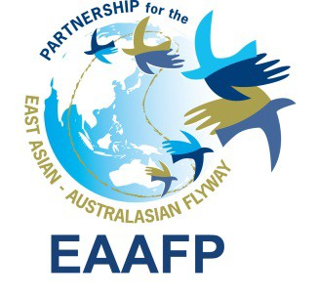East Asian - Australasian Flyway Partnership

EAAFP E-newsletter No.10 - MAY 2013

Subscribe/Unsubscribe Contact us Archive Flickr Facebook YouTube

PARTNERSHIP NEWS
• Wildlife Conservation Society Joins the EAAFP
• EAAFP welcomes Dr. Judit Szabo as new Science Officer on 1 March 2013
• Australia Designates Eighty-mile Beach and Roebuck Bay as FSN sites
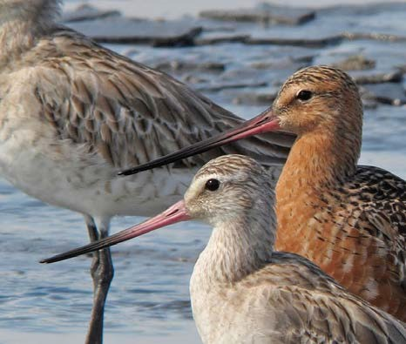• Celebrate World Migratory Bird Day 2013
• Incheon Waterbird Paradise (information brochure) published
• A Total of 2,725 Black-faced Spoonbills recorded in the 2013 Global Census, an Increase of 1.2% from 2012
• Black-faced Spoonbill Nest Event held at
Namdong Reservoir in Songdo, Incheon
• EAAFP Spoon-billed Sandpiper Task Force newsletter for No.9 February 2013 published
• 2012 Black-faced spoonbill festival, Songdo, Republic of Korea

RELATED NEWS
• Bohai Update, April 2013
• Sonadia Island given International Recognition for Wildlife
• Statement on H7N9 Avian Influenza in China, April 15th 2013

Bar-tailed Godwit © Dave Bakewell

• Apply for International Asia Workshop on Migratory Waterbird Protection and Wetland Management
• Restoring a Breeding Colony of Chinese Crested Tern
• New Wintering Site for Scaly-sided Merganser discovered in Chongqing, Southwest China
• Cambodia loses half its seasonal wetlands in 10 years
• World Wetlands Day Celebration in Auckland, New Zealand
• Malaysian Nature Society celebrates World Wetlands Day 2013
• Market trade is fuelling the killing of migratory birds in Northern China
• Ringed Red-crowned Cranes Observed in Haman, South Korea
• China Coastal Waterbird Census wins Ford Green Award
• Record number of Black-faced Spoonbill Birds Recorded in Census
• Fewer Ponds in Candaba mean Fewer Migrant Birds
• Fewer Black-faced Spoonbills in town
• Rongcheng, Safe Haven for Swans
• French Birdwatcher Calls for Bird Protection

• Malaysia Not Out of Stork
• Shorebird Trapping Threatens New Spoon-billed Sandpiper Wintering Site in China
• Wintering Grounds of Red-crowned Crane in Kangryong, Mundok and Anbyon, North Korea
• Sixth Edition of Ramsar Convention Manual Released

PARTNERSHIP NEWS

Wildlife Conservation Society Joins the EAAFP:

On 19 March, the Wildlife Conservation Society (WCS) became the 29th Partner of EAAFP, with the unanimous support of all Partners. During the application process, Partners warmly welcomed WCS and indeed many Partners already work collaboratively with WCS programmes, projects and staff in many countries of the Flyway. In addition to bringing in the knowledge and experience of conservation scientists in the region and beyond, WCS also offers a programme of field-based initiatives addressing threats and opportunities to
conserve key species and sites. For

example WCS scientists in the Russian Far East are already contributing valuable information and field work on priority waterbirds such as the critically declining Baer’s Pochard and Scaly-sided Merganser. By joining EAAFP we believe that WCS offers a great opportunity to integrate migratory waterbird conservation into its current and ongoing projects and help strengthen cooperation among existing Partners and we look forward to joint initiatives in the near future.
We at the Wildlife Conservation Society are excited to join the EAAFP as a Partner, and to begin to work collaboratively to protect key migratory places and help conserve at-risk bird species in this immense and important Flyway. We are a science-driven conservation organization, with country programs (and thus regional conservation capacity and expertise) throughout much of the Flyway. As such, we can assist the EAAFP in identifying priority areas for different migratory species and we also have the standing to help protect them. In my position as coordinator of bird conservation for WCS, I have the opportunity to bring together existing bird conservation efforts of WCS into larger and more coherent efforts for greater conservation impact.

We look forward to working with the Partnership and discovering how best to align our capacity with the group’s most important strategic interests. I will briefly highlight two starting points of potential importance here. In Cambodia at the vast Tonle Sap lake and associated flooded forests, WCS has worked in collaboration with ministry officials to protect nesting colonies of many

waterbird species (storks, pelicans, ibises, darters, etc.) from egg poaching, and has helped many of these species recover their populations. These birds migrate from throughout Asia to breed in this historic region. In Arctic Alaska, I have led efforts to study and protect huge numbers of breeding birds in the coastal plain. Our efforts there, together with others, recently resulted in the protection from development of some 11 million acres of habitat, much of that in the wetland complex surrounding Teshekpuk Lake where millions of breeding pairs of shorebirds, waterfowl, loons, and others occur. Species like Dunlin, Bar-tailed Godwit, and Yellow-billed Loon form part of the EAAF. We have collaborated in studies of Dunlin migration with use of geolocators, and so have a clear idea of where populations in areas we recently helped to protect spend the winter, primarily in and around the Yellow Sea. Studies like these are promising starting points for helping to conserve this and other species across the range of their impressive migrations.
I look forward to meeting partners and collaborators of the Partnership in the upcoming meetings in Alaska. There, we can begin discussions and planning of how best we at WCS can assist in protecting birds and their migratory habitats in this most important Flyway.
See the list of Partners

EAAFP welcomes Dr. Judit Szabo as new Science Officer on 1 March 2013:

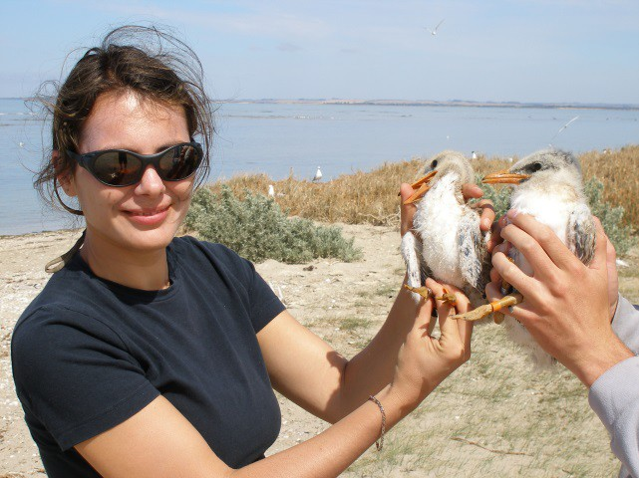Judit Szabo has been fascinated by birds since childhood, which she spend watching and ringing birds in the floodplains of the Danube River. She has a Master’s degree in Theoretical Ecology and completed her thesis studying nesting behaviour and migration of the Black Stork. She studied for a Doctoral degree in Environmental Toxicology at Texas Tech University in the United States of America and her research focussed on the effects of locust-control
pesticides on Australian birds in remote parts of the continent. During her academic career she has studied optimal monitoring of birds, including threatened species, such as the Plains Wanderer. She also worked extensively with volunteer-collected datasets looking for patterns and trends in bird distributions. Recently she has contributed to the Red List assessment of all Australian bird species and subspecies and co-authored the Action Plan for Australian Birds. She has contributed to capturing and marking shorebirds in various parts of Australia and has studied disturbances to migratory shorebirds in northern Australia. She also has extensive experience working with storks, raptors and passerines, and a keen interest in training the next generation of bird researchers in methods of bird capture and handling. Judit has lived in Europe, the Middle East, the USA and Australia and has travelled widely to observe and study birds around the world.

Australia Designates Eighty-mile Beach and Roebuck Bay as FSN sites:

Eighty-Mile Beach and Roebuck Bay are among the most important non-breeding and migratory stop-over areas for the hundreds of thousands of migratory shorebirds in the East Asian- Australasian Flyway. The sites are home to more than 300 species of birds including 50 species of shorebirds. For some species of migratory shorebird, the highest concentrations have been found at these sites. Both sites were designated as new additions to the Flyway Site Network (FSN) on 4
March 2013, bringing the total number of Australian sites to 19.

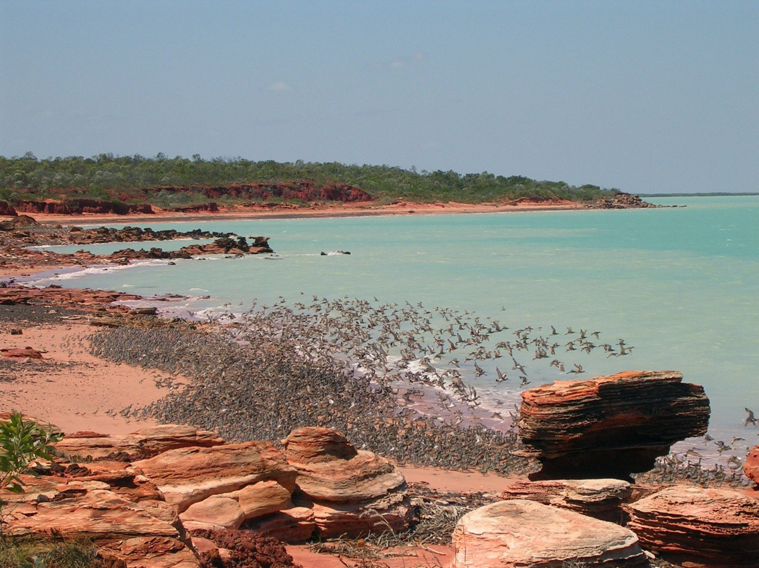

Eighty-Mile Beach is located in remote north-west Western Australia. This site is over 175,000 hectares and it consists of a 220-km section of coastline and adjacent mudflats, as well as inland marshland with two large ephemeral lakes and a series of springs. Eighty-Mile Beach is a designated Ramsar wetland as well as a Western Australia “Class A” Marine Park, listed in January
2013.

Eighty-mile Beach is the most important site in Australia for use by migrant shorebirds, particularly on their southward migration during August to November. Over 336,000 shorebirds were counted at Eighty-Mile Beach in November 1982, while 472,000 were present in November 2001. According to BirdLife Australia’s Shorebirds 2020 database and Rogers et al. (2011), nearly 3.5 million individuals were counted and numbers exceeded the 1% criterion level of the FSN in the case of 15 migratory shorebird species, Bar-tailed Godwit Limosa lapponica, Common Greenshank Tringa nebularia, Terek Sandpiper Xenus cinereus, Grey-tailed Tattler Tringa brevipes, Ruddy Turnstone Arenaria interpres, Great Knot Calidris tenuirostris, Red Knot Calidris canutus,

Sanderling Calidris alba, Red-necked Stint Calidris ruficollis, Curlew Sandpiper Calidris ferruginea, Greater Sand Plover Charadrius leschenaultii, Oriental Plover Charadrius veredus, Grey Plover Pluvialis squatarola, Eastern Curlew Numenius madagascariensis and Oriental Pratincole Glareola maldivarum.
The record of over 2.8 million Oriental Pratincoles by the NW Australia Wader and Tern Expedition in 2004 was extraordinary, as it vastly exceeds the previous estimated population in the whole East Asian – Australasian Flyway of just 75,000. Oriental Pratincoles are nomadic during the non- breeding season, moving around in response to the availability of food which is largely determined by rainfall. Therefore, it is likely that a combination of unusual weather and feeding conditions led to this concentration and that the population has always been much more numerous than previously supposed, with most occurring unrecorded in the vastness of remote and little-visited outback Australia.
The second site, Roebuck Bay covering an area of 34,119 ha, is considered to be the arrival and departure point for large proportions of the Australian populations of several migratory shorebird species, for instance the Bar-tailed Godwit Limosa lapponica. This species is believed to fly non- stop between continental East Asia and Australia. Roebuck Bay is also a rich feeding ground for other shorebird species, supporting an exceptionally high micro-invertebrate biomass, including many species yet to be formally described (G. Pearson, pers. comm.).

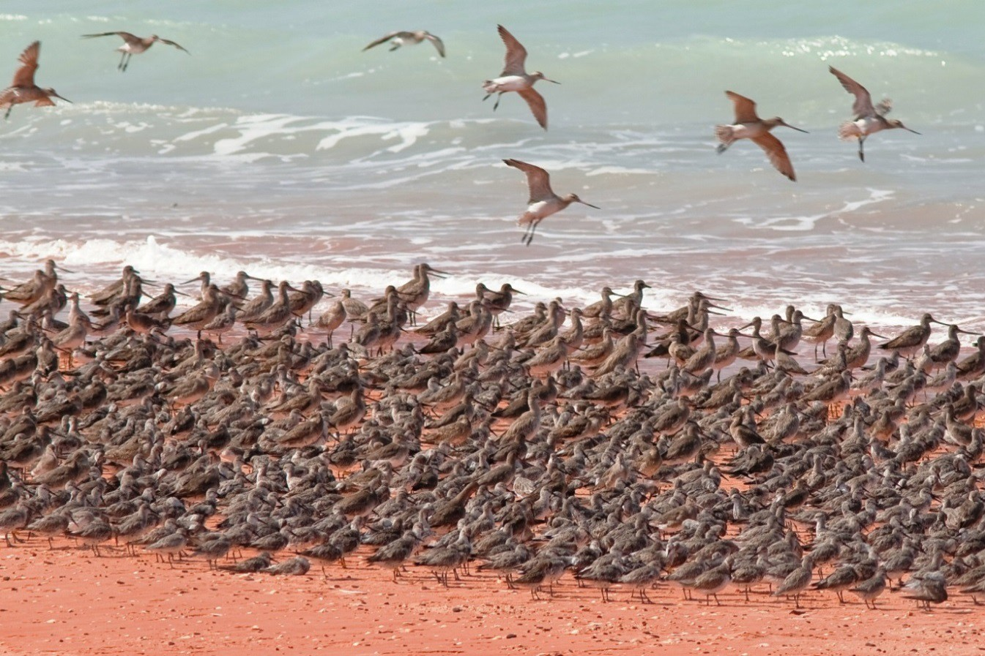

With extensive, highly biologically diverse intertidal mudflats, Roebuck Bay regularly supports over
100,000 migratory waterbirds. The highest number of shorebirds counted at the site was 170,900 in October 1983 and a total of over 88,000 shorebirds were counted at the site during the austral summer of 2009-2010. The site supports globally significant numbers of at least 18 migratory shorebird species, all of which occur in numbers well in excess of 1% of the flyway population;

Black-tailed Godwit Limosa limosa, Bar-tailed Godwit, Common Greenshank, Terek Sandpiper, Grey-tailed Tattler, Ruddy Turnstone, Great Knot, Red Knot, Sanderling , Red-necked Stint, Curlew Sandpiper, Greater Sand Plover, Oriental Plover, Grey Plover, Eastern Curlew, Whimbrel Numenius phaeopus variegatus, Asian Dowitcher Limnodromus semipalmatus and Oriental Pratincole. This area has been jointly managed by the Yawuru Traditional Owners and the Department of Conservation of Western Australia.
Migratory shorebirds from Roebuck Bay fly up to 10,000 km each year from Roebuck Bay to Arctic breeding grounds. However, they cannot undertake this long flight in one long haul. Many migratory shorebirds stopover at the Yellow Sea to feed before heading to Alaska or Siberia to mate and nest. Due to recent and accelerating loss of intertidal mudflats in the Yellow Sea as a result of industrialisation, these vital feeding grounds are disappearing. The result is major reductions in many species, particularly the Great Knot and Red Knot, the Curlew Sandpiper and several other species.
Since shorebirds have declined at Eighty-Mile Beach and Roebuck Bay over the last decade, Australia has investigated possible causes of declines observed in migratory shorebirds numbers, including whether any declines may be the result of habitat change at staging areas in the Yellow Sea.
A major program is underway at BirdLife Australia entitled ‘Shorebirds 2020’. The program is designed to reinvigorate and coordinate national shorebird monitoring in Australia and is a collaborative enterprise between BirdLife Australia and AWSG, through funding from the Australian Government’s Caring for our Country and WWF-Australia. The primary objectives of the program are to collect data on the numbers of shorebirds in a manner that can be utilised to aid their conservation and management, specifically long and short-term population trends, and explore what may be causing those changes.
Over the last year the Shorebirds 2020 team has been developing a monitoring program for shorebirds in Australia that will allow them to detect national population trends, mapping important shorebirds areas, and putting together a shorebird counters toolkit online. The main recommendation to come out of this work so far is that the team needs to count shorebirds at more sites – around 150 – in order to be able to detect population trends at the national level for the majority of shorebird species. For more information visit the Shorebirds 2020 website.
These new FSN sites can be searched on the following link where the FSN Site Information Sheets are placed. With these two designations Australia contributes to one of the EAAFP objectives contained in the Partnership Document and the Implementation Strategy 2012-2016, which is to achieve the target of 7-10 new sites per year. See Eighty-mile Beach and Roebuck Bay SISs

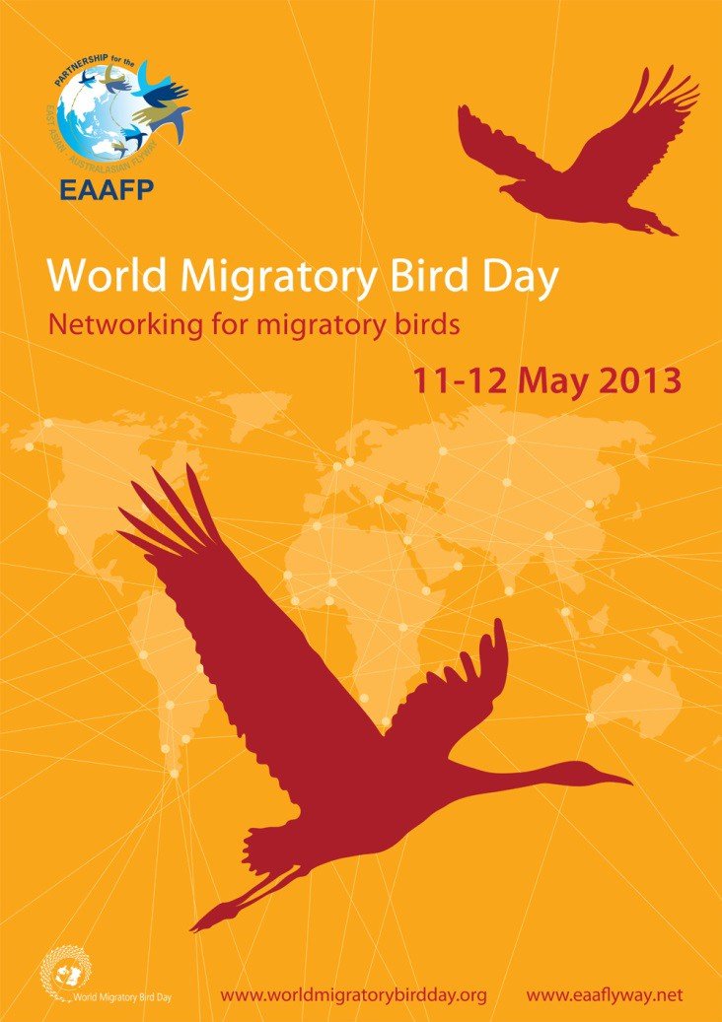Celebrate World Migratory Bird Day 2013:

Starting in 2006, the second weekend of May is celebrated as World Migratory Bird Day around the world. It is an opportunity for people to take action and organise public events such as bird festivals, education programmes and birdwatching excursions. WMBD 2013 is the biggest and most widely celebrated global day for positive action for the conservation of migratory birds. This year’s theme - Networking for migratory birds - highlights the importance of networks of sites for migratory birds along their migration routes. The EAAFP Secretariat encourages our partners along the 22 countries, the international community - governments, conservation organizations and dedicated people alike – to work together to conserve migratory birds around the world.
The 2013 World Migratory Bird Day Poster
highlights a few of the thousands of sites

important for bird migration. Migratory birds travel huge distances along their migration routes, sometimes tens of thousands of kilometres. These connected sites act like ‘stepping stones’ and are used by birds to migrate. They are important for resting, feeding, breeding and wintering. Download WMBD logo, posters, videos, statements of EAAFP Chief Executive and other materials to promote your activity. Visit to download
We welcome you to share your activity and join the global celebration of WMBD. The deadline for
receiving activity reports is 31st May 2013. There is no special form. For specific queries related to
WMBD, contact: wmbd@eaaflyway.net Visit WMBD web page

Incheon – Waterbird Paradise (Information Brochure) published:

Incheon Tidal Flat is critically important for a large number of migratory waterbirds using the habitat for feeding and recuperation during their long journeys, as well as being supporting important populations of breeding waterbirds dependent on the tidal flats. The EAAFP Secretariat has recently produced an information brochure, entitled Incheon – Waterbird Paradise increase awareness, raise the profile and highlight the importance of Incheon Tidal Flat. The Incheon Tidal Flat includes Ganghwado, Yeongjongdo, Songdo and other small rocky islands. It regularly supports over 20,000 shorebirds as a stopover site and endangered species of Black-faced Spoonbill, Saunders’s Gull and Chinese Egret as breeding site.

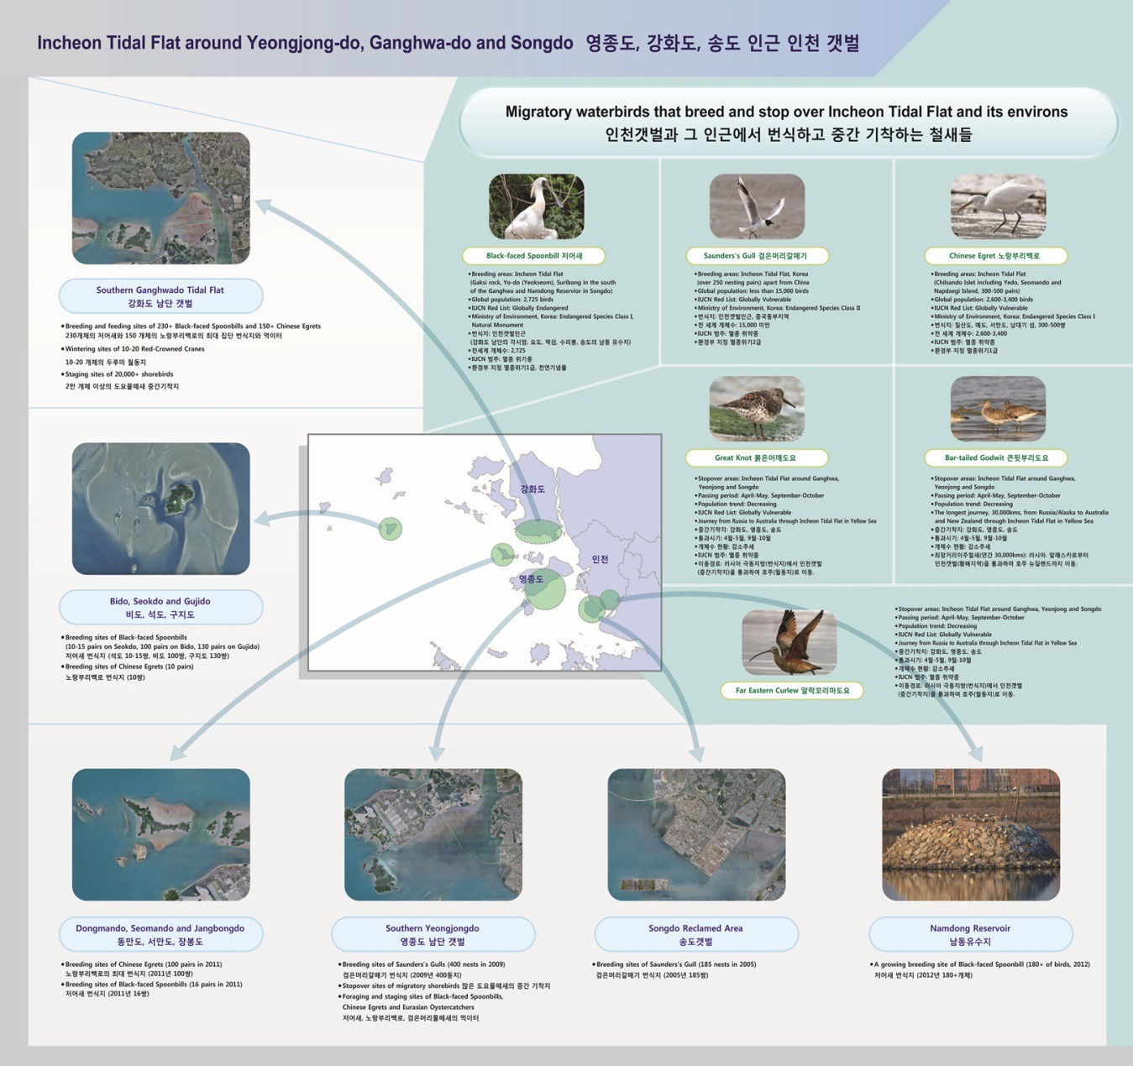

Since 2009, Black-faced Spoonbill has been breeding at Namdong Reservoir, inside of Songdo city, with over 100 pairs in 2012. Namdong Reservoir is an artificial island built in an area abandoned from mudflat reclamation. Despite the growing breeding population, their survival remains in question due to continuing reclamation of Songdo tidal flats, their principal feeding grounds.
Incheon Tidal Flat is also a globally important breeding for globally threatened Saunders’s Gull (its only breeding site in Korea), and Chinese Egret. It is also a critical stopover site for long-distance migratory shorebirds that depend on the tidal flats for a critical period of their migration in spring
and autumn. In order to download the electronic brochure, visit here

A Total of 2,725 Black-faced Spoonbills recorded in the 2013 Global Census, Accounting for an Increase of 1.2% from 2012:

Black-faced Spoonbill is a threatened bird species of global concern. It mainly inhabits East Asia. Over the last decade, the number of Black-faced Spoonbills had shown an upward trend with a record total of 2,725 birds this year, accounting for an increase of 1.2% from last year.

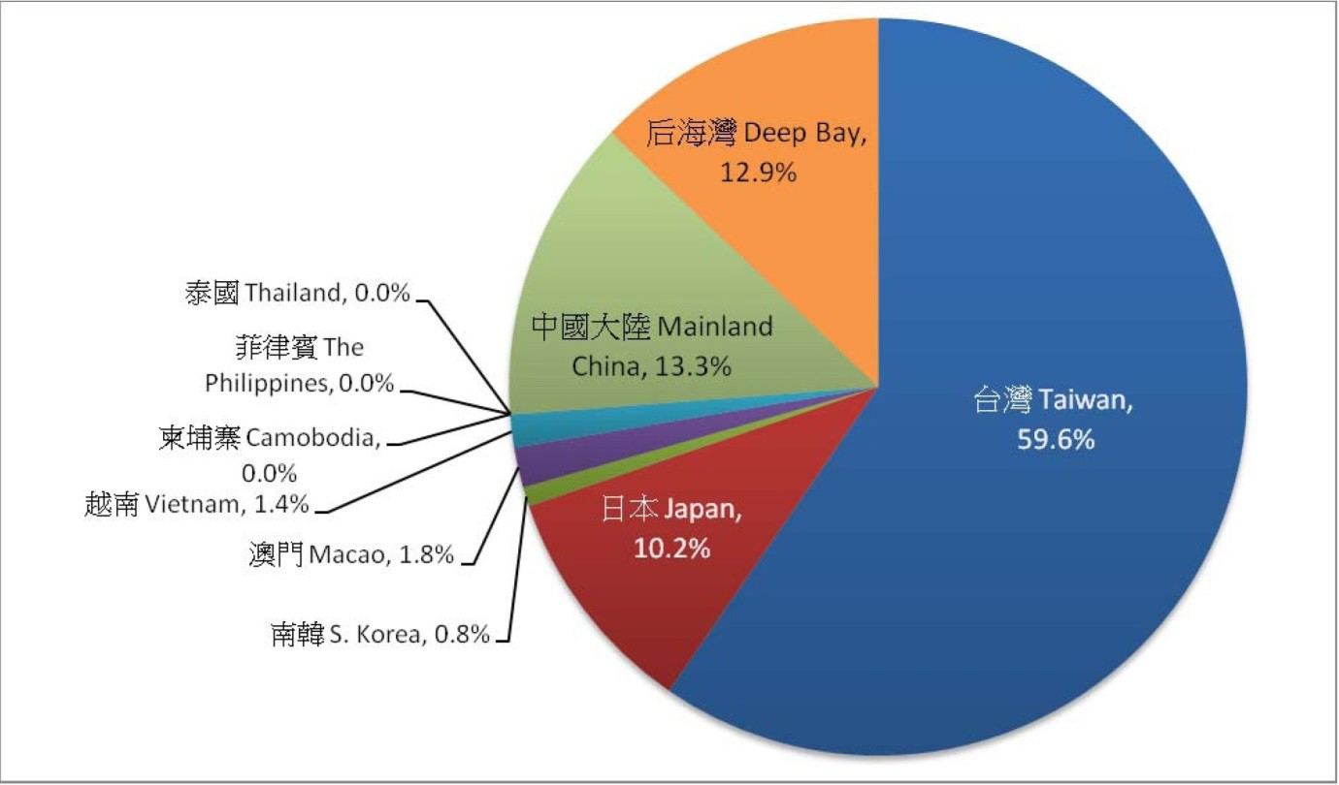
Proportion of wintering Black-faced Spoonbill at different locations to the global total in 2013 Global Synchronized Census
© Hong Kong Bird Watching Society

Mr. YU Yat-tung, Research Manager of the Hong Kong Bird Watching Society, says “The rise in the number of Black-faced Spoonbill is not significant this year and the total number remains steady. While numbers have dropped in Hong Kong, there is a continuing increase in both the number and proportion of the global population wintering in Taiwan. This is the result of Taiwan’s efforts in wetland conservation. However, we have been emphasizing in recent years that it is indeed a crisis for a large number of Black-faced Spoonbills to aggregate in a single location. It is uncertain why the number of Black-faced Spoonbill recorded in Hong Kong and Shenzhen has fallen in three consecutive years. In Hong Kong, conservation work for Black-faced Spoonbill has been implemented for some time to its maturity, but the number of Black-faced Spoonbill drops continuously. On the other hand, the number recorded in mainland China has been increasing. It is probably because the Black-faced Spoonbills, which originally travelled to Hong Kong, have recently changed their wintering habits.”
In addition to being a well-known star creature of the wetland in the eyes of the public in Hong Kong, the Black-faced Spoonbill is also a globally threatened species. To conserve this rare species, numerous conservation intermediaries and governments in the region have collaborated to conserve the habitats of Black-faced Spoonbill and to undertake various studies since 1990s. A conservation action plan of Black-faced Spoonbill was inaugurated in 1995 with revisions and updates made in 2010. Emphasis is on the establishment of more conservation areas, commissioning more detailed surveys in their breeding grounds and strengthening regional collaboration.
At present, habitat destruction and deterioration remain as the biggest threat to the survival of Black-faced Spoonbill. Development projects have been undertaken in many coastal areas, such as in South Korea, Macau, Fujian, Zhejiang and Hainan. Illegal poaching activities are still observed in

some locations. For instance, a total of 5 Black-faced Spoonbills were found and confiscated in a restaurant in northern Vietnam in December 2010. The Deep Bay area in Hong Kong is under huge pressure for development. As such, the conservation of Black-faced Spoonbill still has a long way to go to assure the future of the species.
Since 2003, the Hong Kong Bird Watching Society has coordinated the global population census of Black-faced Spoonbill. This year’s census was held on 11-13 January 2013 with the participation of over 100 volunteers, recording a total of 2,725 Black-faced Spoonbills, 32 more than last year’s total of 2,693 birds (a rise of 1.2%), reaching a new population high. In this census, Taiwan remained the largest wintering site for Black-faced Spoonbill with 1,593 birds recorded. While the numbers recorded in mainland China and Taiwan increased, those in Deep Bay area (between Shenzhen and Hong Kong) and Japan plummeted. A summary of the census results is appended below:

• A total of 2,725 birds were recorded in 2013 census, which is 32 birds more than 2,693 birds recorded in 2012, a rise of 1.2%, also an increase of 48.2% from 1,839 birds as recorded in
2011;
• The largest wintering population with 1,624 birds was found in Taiwan, accounting for 59.6% of the global population, 62 birds higher than the total in 2012, accounting for a rise of 4%, also a rise of 94.7% from 834 birds in 2011;
• Hong Kong and Shenzhen recorded 351 birds in total, which is 42 birds fewer than 393 birds in
2012, accounting for a fall of 10.7%, also 60 birds fewer than that in 2011, accounting for a fall of 14.6%;
• A rise in the number by 10.7% was noted in coastal area of mainland China, from 328 birds in
2012 to 363 birds in this year, a rise of 83.3% from 198 birds recorded in 2011;
• Increases were observed in mainland China, Taiwan and Vietnam, while decreases were noted in Deep Bay, Macau, Japan and South Korea.
Locations included in this census include South Korea, Japan, Shanghai, Zhejiang, Fujian, Guangdong, Hainan, Taiwan, Kong Kong & Shenzhen, Macau, Vietnam, the Philippines, Thailand and Cambodia.
This Society would like to take this opportunity to thank all regional organizations and volunteers for their participation in the census, contributing to the smooth conduct of this census throughout all years and therefore better conservation of Black-faced Spoonbill in the region. We are also indebted to Schmidt Marketing (HK) Ltd for sponsoring part of the expenses incurred.
Black-faced Spoonbill Nest Event held at Namdong Reservoir in Songdo, Incheon:

On 16 March, the Korea Federation of Environment Movement Incheon (KFEM Incheon) organised a Black-faced Spoonbill event to collect fallen woody branches and transport them to the artificial island in Namdong Reservoir to help the birds make their nests. It was also an opportunity

to remove trash from the edges of the reservoir and the vicinity of the island.

Over 200 participants including students, their parents, Incheon NGOs and Incheon government officials took part in the half day program. There were brief talks from Dr.Kisup Lee from Korea Wetland Network, Ms.Seon-jeong Nam, Incheon Teachers Moim, Mr. Hyeong-moon Kim, Black- faced Spoonbill Island People and Mr.Joo-won Seo and Ms.Hyeo-kyeong Lee, KFEM Incheon on breeding and wintering status and main threats to birds. Since Namdong Reservoir is only 5 kms away from the Secretariat office, EAAFP Secretariat staff also attended to support the initiative– mostly young students- and Spike Millington made a short speech on how geographically important the Songdo and Incheon sites are for Black-faced Spoonbill as breeding areas in the East Asian – Australasian Flyway and how national and international collaboration is needed to protect birds and conserve their habitats.
The Black-faced Spoonbill is designated as a globally endangered species under IUCN and nationally Vulnerable under Ministry of Environment Korea. It breeds on islets off the west coast of the Korean peninsula and Liaoning province in China. The most important breeding areas in Incheon are Incheon-Geonggi Tidal Flat including Gaksi rack, Yo-do (Yeokseom), Suribong in the south of the Ganghwa and Namdong Reservior in Songdo. These areas support almost 500 pairs. Apart from other breeding areas, Namdong Reservoir supports an annually increasing number of pairs: from 6 pairs in 2009 to 120 pairs in 2012. The tidal flats of Ganghwa, Yeongjong and Songdo are the principal feeding grounds. The total world population is estimated at about 2,700 birds now, which indicates how important the Incheon area is, with more than one third of the total population resident here in the summer months.
EAAFP Spoon-billed Sandpiper Task Force Newsletter for No.9 February 2013 published:

The EAAFP Spoon-billed Sandpiper Task Force (SBS TF) has been published its ninth newsletter in February 2013. In this newsletter, we present updates of autumn surveys in China including Rudong and winter update from South Korea and share some other actvities from Bangladesh, Myanmar, Sri Lanka and Russia.
The Spoon-billed Sandpiper Recovery Team (SBS RT) joined with the EAAFP to better coordinate the conservation activities along the entire flyway and was officially endorsed by the EAAFP as a species Task Force (SBS TF) under the Shorebird working group in December 2010.
2012 Black-faced Spoonbill Festival, Songdo, Republic of Korea:

The 2012 Black-faced Spoonbill Festival was held in Songdo, Incheon, Republic of Korea, on the
22nd of December 2012, organized by the Incheon Office of the Korean Federation for Environmental Movement and Yeonsu-gu Office. The festival was open to everyone, and attracted several hundred people. The Black-faced Spoonbill Festival aims at teaching youngsters some bird- watching basics while educating citizens about the conservation and importance of the Black- faced Spoonbill. The Incheon area supports over 90% of all breeding Black-faced Spoonbills, which are dependent on tidal flats in the Incheon area for feeding. The youth forum began in the morning and ended by noon. It was followed by participation sessions in the afternoon. There

were several interesting experience programs for citizens, for examples making Black-faced Spoonbill eco-bags, making cookies, folding papers into the shape of a black-faced spoonbill, fitting together puzzle pieces, taking pictures with Black-faced Spoonbill models, etc. The EAAFP Secretariat was invited to the event, set up a booth, and promoted its efforts in the conservation of the Black-faced Spoonbills and its leadership in international cooperation of the twenty-two countries that make up the East Asian – Australasian Flyway, including Australia, East Asian countries, New Zealand, Russia and the United States.

The EAAFP Secretariat encourages Partners to voluntarily produce translated versions of the EAAFP newsletter so that EAAFP activities and issues can be widely disseminated to a broader audience. This helps raise awareness of EAAFP at national level that can foster national partnerships to conserve migratory waterbirds, their habitats and the livelihood of people dependent upon them. Visit to download in word this newsletter in MS word format for translation (http://www.eaaflyway.net/eaafp-newsletters )
For further information and contact:

EAAFP Secretariat

1905 Gae-Pearl Tower, 12 Gaetbeol-ro, Yeonsu-gu, Incheon 406-840 The Republic of Korea

Tel: +82 32 260 3000~5, 3010

Fax: +82 32 260 3009

Email: secretariat@eaaflyway.net Website: www.eaaflyway.net Facebook: www.facebook.com/eaafp Flickr: www.flickr.com/eaafp
YouTube: http://www.youtube.com/user/EAAFPS All rights reserved.

